Policy Villages 2: Distributing Growth across the Rural Areas
C.270 The Local Plan must set out an approach for identifying the development of new sites for housing across the rural areas to meet local needs in sustainable locations and to meet the strategic targets set in ‘Policy BSC 1: District Wide Housing Distribution’.
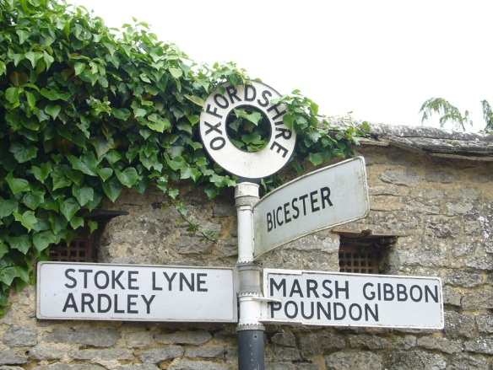
C.271 The Housing Trajectory shows that the District already has a substantial housing supply from rural areas:
Completions (2011-2014):
DLO Caversfield | 85
Rural Areas (including Kidlington) (10 or more dwellings) | 247
Rural Areas including Kidlington (less than 10 dwellings) | 196
Total | 528

Planning Permissions at 31/3/14:
Former RAF Upper Heyford | 761
DLO Caversfield | 111
Rural Areas (including Kidlington) (10 or more dwellings) | 888
Total | 1760
(excludes permissions for sites of less than 10 to avoid duplication with a future windfall allowance)

C.272 In the interests of meeting local housing need in rural areas, an allocation is also being made to enable the development of some new sites (for 10 or more dwellings) in the most sustainable locations. A further 750 dwellings will be developed in the rural areas including Kidlington. Sites for 10 or more dwellings that have received planning permission after 31 March 2014 will contribute in meeting these requirements. Additionally, a realistic windfall allowance of 754 homes is identified for sites of less than 10 dwellings for the period (2014-2031). In total, some 5,392 homes will be delivered across the rural areas from 2011 to 2031.
Policy Villages 2: Distributing Growth across the Rural Areas
A total of 750 homes will be delivered at Category A villages. This will be in addition to the rural allowance for small site ‘windfalls’ and planning permissions for 10 or more dwellings as at 31 March 2014.
Sites will be identified through the preparation of the Local Plan Part 2, through the preparation of Neighbourhood Plans where applicable, and through the determination of applications for planning permission.
In identifying and considering sites, particular regard will be given to the following criteria:
- Whether the land has been previously developed land or is of lesser environmental value
- Whether significant adverse impact on heritage or wildlife assets could be avoided
- Whether development would contribute in enhancing the built environment
- Whether best and most versatile agricultural land could be avoided
- Whether significant adverse landscape and impacts could be avoided
- Whether satisfactory vehicular and pedestrian access/egress could be provided
- Whether the site is well located to services and facilities
- Whether necessary infrastructure could be provided
- Whether land considered for allocation is deliverable now or whether there is a reasonable prospect that it could be developed within the plan period
- Whether land the subject of an application for planning permission could be delivered within the next five years
- Whether the development would have an adverse impact on flood risk.

