Policy ESD 1: Mitigating and Adapting to Climate Change
B.177 The 2009 UK Climate Projections (UKCP09) set out some key projections of climate change across the UK over the 21st Century. Projected changes by the 2080s, based on a 50% probability level, include:
- increases in summer mean temperatures, particularly in southern England where increases of 3.9 degrees are projected
- decreases in summer precipitation, again particularly in southern England where decreases of 23% are projected
- increases in winter precipitation in southern England of 22%.
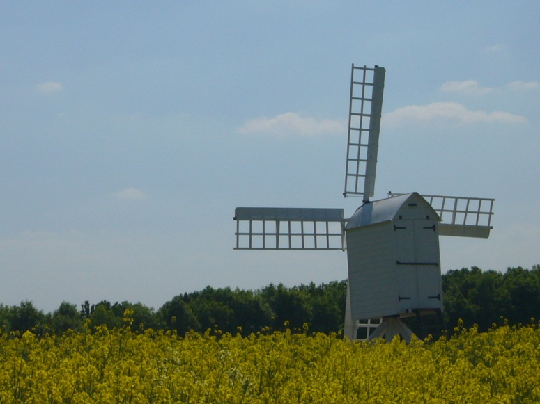
B.178 Changes as small as a 2°C global temperature rise will have serious impacts:
- rising sea levels
- extreme events such as droughts and heavy rainfall, leading to disruption to natural and man-made habitats
- communities across the UK may struggle to cope with the effects of warmer summers and wetter winters.
B.179 A Local Climate Impacts Profile (LCLIP) has been undertaken to better understand the impact of extreme weather in Cherwell and on the Council itself. The LCLIP reviewed extreme weather events experienced over a five year period (2003 – 2008), finding that within Cherwell flooding was by far the most significant event, with significant flooding occurring 6 times in a 5 year period, 2 of the events being serious and widespread (2003 and 2007). Heatwaves were found to have been infrequent in that 5 years period, but if they were to recur on the scale of 2003 this would have significant impacts on health, biodiversity and infrastructure (including damage to buildings by tree and drought related subsidence, roads, drainage systems and business closures).
B.180 There is increasing recognition that reducing carbon emissions is important in reducing and adapting to the impacts of climate change. The Climate Change Act 2008 has an objective of an 80% reduction (from a 1990 baseline) in carbon dioxide emissions by 2050. This can be achieved by, for example, reducing dependence on private cars and locating new development in sustainable, accessible, locations, increasing energy efficiency, or by increasing the use of renewable or low carbon energy sources. It is particularly important to reduce carbon emissions from dwellings and business through increasing energy efficiency. Similarly it is important to ensure that we adapt to the inevitable changes to future climate. This applies to the built development, its location, design, layout and proposed land uses, as well as the natural environment, by seeking to reduce exacerbated habitat fragmentation by increasing landscape permeability and connectivity (see 'Policy ESD 10: Protection and Enhancement of Biodiversity and the Natural Environment', 'Policy ESD15 Built and Historic Environment' and 'Policy ESD 17: Green Infrastructure').
B.181 Mitigating and adapting to the impacts of climate change are an important priority for the District and have been recognised in the following:
- the Cherwell Sustainable Community Strategy ‘Our District Our Future’
- the Council’s Low Carbon Environmental Strategy
- the Council’s signing of the Nottingham Declaration
- Eco Bicester: seeking to deliver sustainable building standards across the town.
B.182 Consequently this Local Plan and its strategic objectives are focused on delivering sustainable development. Specifically, Strategic Objective 10 (see Section Strategy for Development in Cherwell) relates to climate change mitigation and adaptation (to reduce the intensity of climate change and to adapt to its effects) and this will be achieved through policies ESD 1 - 7.
B.183 The most sustainable locations for growth in the District are considered to be Banbury, Bicester and the larger villages as identified in Policies Villages 1 and Villages 2 as these settlements have a range of services and facilities, reducing the need to travel by car. Well designed and connected schemes which promote pedestrian movement can also assist in meeting this objective. (see 'Policy ESD 15 The Character of the Built and Historic Environment'). The Council will develop a sustainability checklist to aid the assessment of the sustainability of development proposals, which will be included in the Sustainable Buildings in Cherwell SPD.
Policy ESD 1: Mitigating and Adapting to Climate Change
Measures will be taken to mitigate the impact of development within the District on climate change. At a strategic level, this will include:
- Distributing growth to the most sustainable locations as defined in this Local Plan
- Delivering development that seeks to reduce the need to travel and which encourages sustainable travel options including walking, cycling and public transport to reduce dependence on private cars
- Designing developments to reduce carbon emissions and use resources more efficiently, including water (see Policy ESD 3 Sustainable Construction)
- Promoting the use of decentralised and renewable or low carbon energy where appropriate (see Policies ESD 4 Decentralised Energy Systems and ESD 5 Renewable Energy).
The incorporation of suitable adaptation measures in new development to ensure that development is more resilient to climate change impacts will include consideration of the following:
- Taking into account the known physical and environmental constraints when identifying locations for development
- Demonstration of design approaches that are resilient to climate change impacts including the use of passive solar design for heating and cooling
- Minimising the risk of flooding and making use of sustainable drainage methods, and
- Reducing the effects of development on the microclimate (through the provision of green infrastructure including open space and water, planting, and green roofs).
Adaptation through design approaches will be considered in more locally specific detail in the Sustainable Buildings in Cherwell Supplementary Planning Document (SPD).

