- Application Site and Locality

The application site comprises a stone barn/store which lies to the front of the main stone building known as Bishops End. The site lies near the centre of the village of Burdrop which is located to the south of Sibford Gower and within the open countryside. The stone building is two storey in form and has a mono-pitch roof covered with natural slate. The building is set into the bank which means at the rear the building is single storey with a door leading out onto a higher ground level. The stone building is attached to the main building at the south west corner, although there is no direct link internally between the two buildings. At the front of the building there is a gravelled area used for parking and to the rear a small area of the pub car park has been enclosed by timber fence to form a small yard. At the time of my site visit the works were complete.

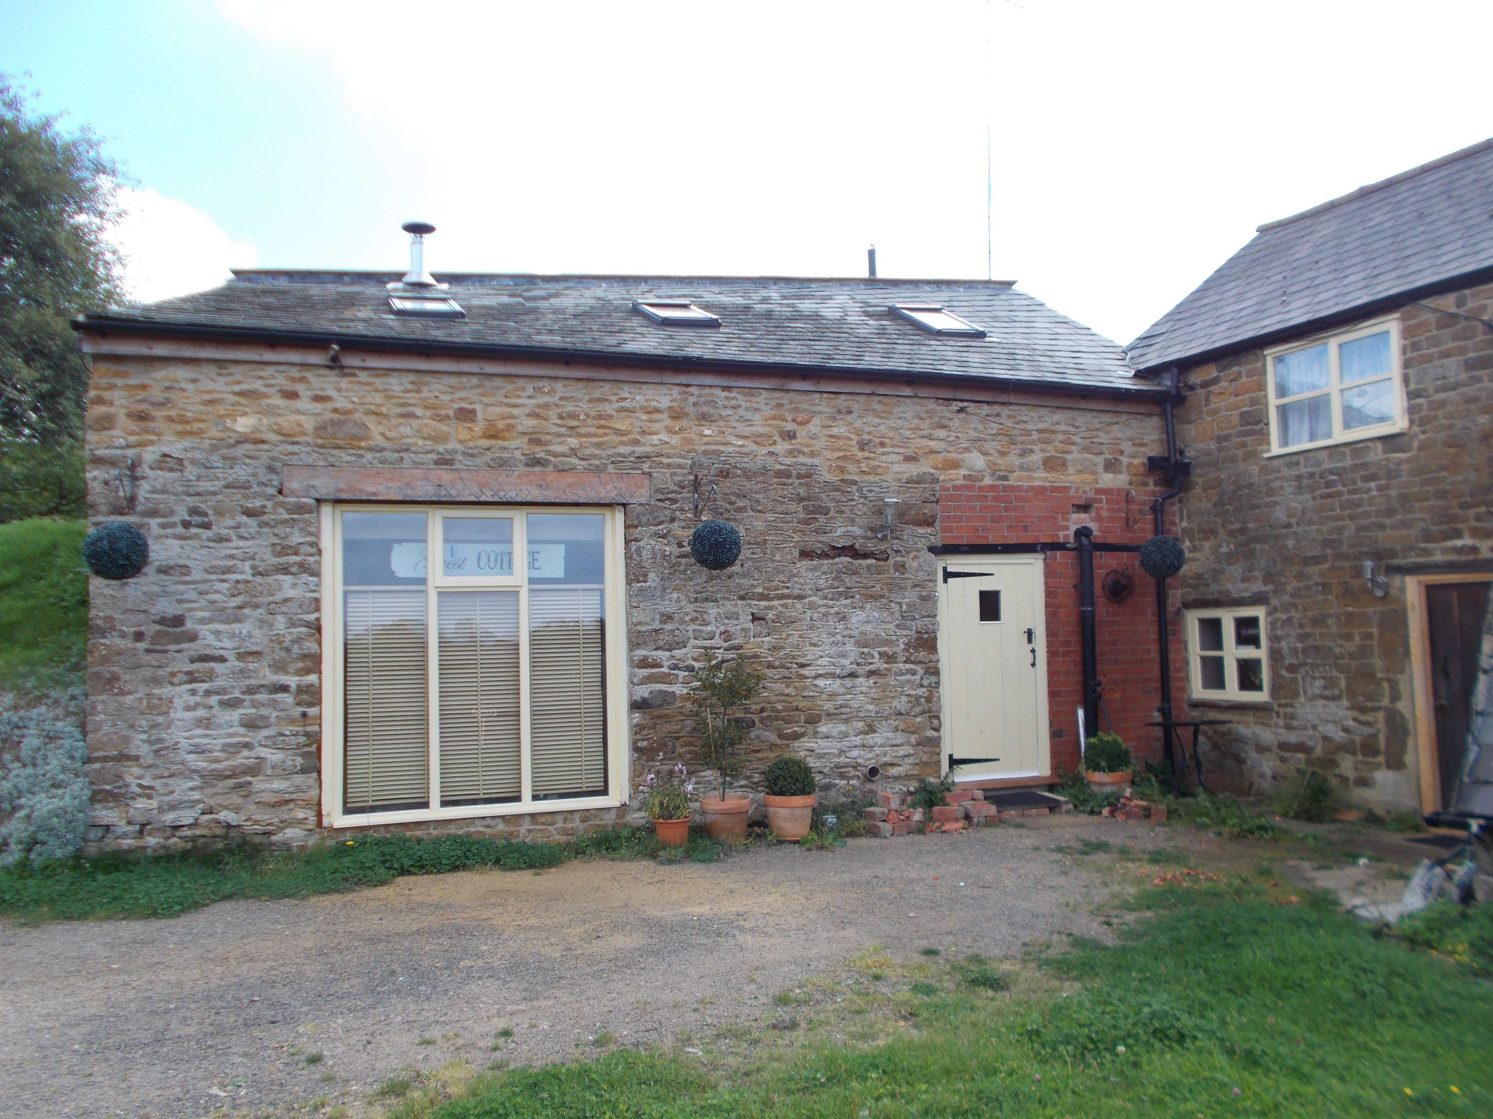

- Description of Proposed Development

This application seeks planning permission to vary condition numbers 3 and 4 of 13/00781/F by removing these conditions to allow occupation of the building as a separate dwelling.

Condition 3 reads as follows:
The building shall be used for holiday lets only and remain ancillary to the property ‘Bishops Blaize/Bishops End’. The building shall not be used for any purpose including those within Class C of Schedule 2 to the Town and Country Planning (Use Classes) (Amendment) (England) Order 2005.

Condition 4 reads as follows:
The holiday letting unit hereby approved shall not be let to or be occupied by any person, or connected group of persons for a period exceeding eight weeks in any calendar year.

- Publicity

The application was publicised by way of a press notice, neighbour notification letters and a notice displayed near to the site. The comments raised by third parties are summarised as follows:

Bishop Blaize Support Group – The holiday flat should be part of the Bishop Blaize pub. In the event that the pub does re-open it is the view of the BBSG that it is wholly unrealistic for the appellant to expect someone paying rent for the flat as a separate dwelling as opposed to a holiday flat to accept the noise and disturbance of the pub in such close proximity on a long term basis.
The application documents indicate that the cottage now has a garden. The garden are does not benefit from planning permission.
The proposal would reduce car parking for the public house if the existing car park is used. Furthermore, the use of the car parking area to the front of the pub is not currently in residential use so would need a change of use. It is specified by the Planning Inspector that one space should be provided to the front of the holiday let.
The argument put forward that the holiday let is difficult to run because the adjacent building cannot be occupied can be easily overcome by bringing the pub back in to use.
The property is not located in Sibford Gower it is located in Burdrop.
The application has stated that there is a pub in sibford gower. The holiday let is an integral part of the pub, other local pubs in Sibford are Gastro pubs, the Bishops Blaize fulfils a different function to the Sibford Gower pub.
The holiday flat is in an area of outstanding natural beauty and conservation area which is why these conditions were imposed. Had planning permission been sought for a separate dwelling planning permission would not have been granted.
Have the other conditions applied by the inspector been conformed to by the application?
There is a current valid enforcement notice relating to the car park area. We are told a further application cannot be considered until the conditions of the enforcement notice have been met.
The current use of the holiday cottage does not confirm with the planning permission. It appears there is a business being run from the property and occupation of the building as a separate dwelling.

20 objections received from third parties:
- The holiday let must remain part of the public house
- That the current owners do not wish to run it as a pub is entirely their own decision.
- There are many iterations in pursuit of having this building classified as residential and as many denials, including court cases and enquiries.
- Here we are yet again with a further chipping away at the decisions already made.
- To change the tiny bottle store into a separate dwelling seems ridiculous. The proverbial cat would suffer greatly and we all know that no one could possibly live there long term with the pub in full swing right next door.
- I urge you to deny this clever attempt to remove the conditions which will inevitably lead to further appeals and applications for the whole of Bishops End to be turned into residential use thereby yielding a huge profit for the current owners.
- I also note with some degree of alarm that the nearby Bell public house in Hook Norton was granted residential use in a bizarre decision with the result that the property is currently up for sale at a huge profit.
- Clearly such large profits attract ambition and attention for the fortunate few and their advisors, whilst I would just like to see Bishop Blaize restored to its former profitable use as our community pub.
- The Bishop Blaize was taken over and, in my opinion, deliberately run down by the Noquets, their aggressive behaviour towards the pubs customers drove us away. Having made the pub unviable they sought change of use to a dwelling which would turn them a handsome profit. They seem to believe that if they persist with their planning applications and appeals they will eventually get their way, I therefore wish the council to stand firm and not permit anything that could in any way create an opportunity for the Noquets to find a way to circumvent the planning rules. I object to the removal of conditions 3 & 4 of APP/C3105/A/13/2203382 ‘Bishops End’, Burdrop, Banbury, Oxfordshire, OX15 5RQ.
- The Bishop Blaize was taken over and, in my opinion, deliberately run down by the Noquets, their aggressive behaviour towards the pubs customers drove us away. Having made the pub unviable they sought change of use to a dwelling which would turn them a handsome profit. They seem to believe that if they persist with their planning applications and appeals they will eventually get their way, I therefore wish the council to stand firm and not permit anything that could in any way create an opportunity for the Noquets to find a way to circumvent the planning rules. I object to the removal of conditions 3 & 4 of APP/C3105/A/13/2203382 ‘Bishops End’, Burdrop, Banbury, Oxfordshire, OX15 5RQ.
- There is no allocated garden and only one parking space for the cottage which is sited on Burdrop on a steep narrow hill with no room for on road parking.
- Parking is a major problem in Burdrop. Any further reduction in parking at the site would affect the viability of the public house.
- There would be no economic benefit from this proposal, reopening the pub would bring more economic benefit.
- There are better sites in the area for further residential development.
- The previous application which was granted for the holiday let was supported as it would help the viability of the public house.
- The conditions were attached to ensure that the use of the building is not separated from the main planning unit due to close proximity and lack of amenity space and parking. Moreover, to ensure the building did not become permanent residential accommodation.
- If this becomes a separate dwelling this could affect the highway safety within the locality as it could lead to further on street parking.
- It would be totally unsuitable as a permanent home so close to licensed premises which may be in separate ownership, in the future.
- Many holiday cottages in the U.K are owned and let from overseas. So the present owner's choice to live a few miles from Burdrop is not a valid reason for relaxation of the conditions.
- This could set a precedent for anyone in this Conservation Area to obtain permission on any garden structure as a holiday home, then after a very short time, change this to a permanent residential dwelling.

- Response to Consultation

Sibford Gower Parish Council: Over the long planning history of this application, Sibford Gower Parish Council has held consistent position. This can be seen from our attached response to application number 13/00116/F. If retrospective planning permission was to be granted to this deliberate conversion of part of the curtilage of the Bishop Blaize public house in contravention of planning regulations, then it was essential to impose a condition that the building not be separable from the working of the public house, but continue to function as an important asset by providing ancillary holiday accommodation. In particular we would reaffirm our view in one of the concluding paragraphs:

The previous planning history of this property suggests a continuing attempt to develop the curtilage of the property in ways incompatible with its position within the conservation area or Sibford Gower. If Cherwell District Council is minded after investigation to grant retrospective planning permission, it should require a section 106 agreement, to the effect that the stone building be used solely in relation to activities connected with the use of the main building.

This view was accepted by Cherwell District Council, and imposed by the subsequent appeal decision APP/C3105/A/13/2203382.

Since then two public inquiries and the criminal conviction of the owners in the crown court for illegal occupation of the public house as a separate dwelling have all proceeded on the premise agreed by all parties that the car park and bottle store/holiday let were in the curtilage of the intrinsic parts of the suspended operation of the public house.

It follows that granting this application would frustrate the entire planning procedures so engaged in and the subsequent court judgement entered against the applicants. Sibford Gower Parish Council therefore wises to object to this application.

Sibford Ferris Parish Council:
The Parish Council objects to the above planning application for the following reasons:

The lawful use of the Bishop Blaize is as a public house although the owners have chosen to close this valued community amenity.

The conversion of the bottle store to holiday let accommodation (13/00781/F) was granted on the conditions that it be used for holiday lets only, remain ancillary to the Bishop Blaize and should only be let to the same person/s for a period of up to 8 calendar weeks in any one year.

It is the continuing view of Sibford Ferris Parish Council that these conditions should be upheld so that the building remains within the curtilage of the public house and its car park in order to provide a viable asset to the working public house.

Sibford Ferris Parish Council support Sibford Gower Parish Council in objecting strongly to this current planning application by the owners.

Cherwell District Council:

Conservation Officer - The removal of conditions 3 and 4 of planning permission 13/00781/F is firmly resisted.

Bishops End (formerly The Bishop Blaze PH) is a building probably of C18 original and as such is a non-designated heritage asset. The building and its intimately associated outbuildings form a traditional group. Consent for guest accommodation use was granted to aid the trading potential of the public house. No consent has been granted to convert the building to alternative uses and the relaxation of conditions would be detrimental to the relationship between buildings and the functioning of the complex of buildings as a whole.

Recommend refusal.
Contrary to Policy
NPPF
#135

The Cherwell Local Plan (Jan 2014 Submission draft)
ESD16 - the proposal would harm the contribution the non-designated heritage asset make to the character and appearance of the area due to the increase in the paraphernalia associated with habitation. The proposal would impact on the significance of the buildings.

Environmental Health Officer: If the holiday let turned dwelling is very close to the continued use of the main building as a pub there may be noise concerns I should consider. Similarly if there are wood burning stove chimneys on either property that may give rise to smoke nuisance I should consider such.

Oxfordshire County Council:

Highways Liaison Officer – No objections subject to details of parking and access.

Other External Consultees:

None

- Relevant National and Local Planning Policy and Guidance

Development Plan Policies

The Cherwell Local Plan 2011-2031 - Part 1 was formally adopted by Cherwell District Council on 20th July 2015 and provides the strategic planning policy framework for the District to 2031. The Local Plan 2011-2031 – Part 1 replaced a number of the ‘saved’ policies of the adopted Cherwell Local Plan 1996 though many of its policies are retained and remain part of the development plan. The relevant planning policies of Cherwell District’s statutory Development Plan are set out below:

Cherwell Local Plan 2011 - 2031 Part 1

Policy ESD 15: The Character of the Built and Historic Environment.

Cherwell Local Plan 1996 (Saved Policies)

Policy H19: Conversion of buildings in the countryside.
Policy S29: Loss of existing village services
Policy C28: Layout, design and external appearance of new development.
Policy C30: Design Control and standards of amenity

Other Material Planning Considerations

National Planning Policy Framework (NPPF)
Section 3 Paragraph 28 – supporting a prosperous rural economy
Section 8 paragraph 70 – Promoting healthy communities
Section 11 paragraph 123 – Conserving and enhancing the natural environment

Planning Practice Guidance (PPG)

- Appraisal

The key issues for consideration in this case are:
- Planning history and background
- Principle of a separate dwelling
- Removal of condition 3
- Removal of condition 4
- Other matters

Planning History and background
Planning permission was previously granted under application reference 13/00871/F for the conversion of the stone bottle store to a holiday let. Permission was granted on appeal through a non-determination appeal. It was established thought his appeal that the building which is located within the countryside was capable of conversion and the principle of conversion was acceptable and in accordance with saved policy H19.

In granting permission the Planning Inspector applied two conditions to restrict the use of the building to a holiday let only (no other purpose within Class C) to remain ancillary to the property Bishops End/Bishops Blaize and furthermore, restricting the use to not be let to or occupied by any person, or connected group of persons for a period exceeding eight weeks in any calendar year. These restrictions were applied to ensure the holiday let remained ancillary to the public house use of the attached building to ensure the viability of the public house was not jeopardised and furthermore, to avoid establishing an unrelated residential use which would be likely to be harmed in terms of residential amenity of any future residents by the attached public house use.

History relating to Main Building Bishops Blaize Public House
It is also worth mentioning here the history relating to the main building, Bishops End/Bishops Blaize. There is a long and complex planning history involving a number of planning applications seeking a change of use of the main building from a public house (A4) to a dwelling house (C3) and successful enforcement action.

A number of planning applications were refused for change of use from public house to dwelling between 2006 and 2012.

The building was occupied as a dwelling and the Local Planning Authority issued an enforcement notice in March 2012 to seek the residential use to cease. This notice was appealed and the notice was upheld seeking compliance by February 2013. The notice was not complied with and a successful prosecution was issued against the occupiers.

The latest application 12/00678/F for change of use of a vacant public house to C3 residential was refused and upheld at appeal in August 2013 for the following reason:

The proposal would result in the loss of a village service which on the basis of the application and the contributions received is not conclusively demonstrated as being no-longer viable. As such, the loss of the service would lead to an unacceptable impact on the character of the area and the local community and would therefore be contrary to Policy S29 of the adopted Cherwell Local Plan 1996, Policy S26 of the non-statutory Cherwell Local Plan 2004, Policy BE5 of the South East Plan 2009 and government advice on supporting a prosperous rural economy and promoting healthy communities contained within the National Planning Policy Framework.

Principle of a separate dwelling

The application seeks to remove condition 3 which would allow the building to be an independent separate dwelling within Class C3 of the Town and Country Planning Use Class Order. It also seeks to remove condition 4 which restricts the use to a period not exceeding eight weeks of occupation by any person or groups of persons in any calendar year, which would allow it to be occupied continuously.

The principle of a separate dwelling on this site within the building to the front which currently has an authorised use as a holiday let is not considered acceptable. The building the subject of this application has historically and in recent times always been associated with the use of the public house. When the public house was still in use this building was used as a storage area to support the public house. The recent conversion of this building to a holiday let remains ancillary to the public house by the use of planning conditions and furthermore is considered to be a use which would support the viability of the public house through the generation of visits to the area and the generation of business for the adjacent public house.

This application seeks to establish an unrestricted C3 residential use in this building which would remove an authorised holiday let use thereby removing a commercial element of the site which would be considered to affect the viability of the public house. The previous appeal inspector concluded that in principle the use of the building as a holiday let accords with the National Planning Policy Framework which supports sustainable rural tourism and the expansion of rural businesses and enterprise especially through the conversion of rural buildings and further more seeks to guard against the loss of valued facilities and services. The loss of the holiday let to a separate dwelling would remove the opportunity for the use of the attached building to support the existing business and I therefore conclude that the use proposed would prejudice the use of the main building as a public house and is therefore considered to be contrary to the saved Policy S29 of the Cherwell Local Plan 1996 and Government guidance contained within the National Planning Policy Framework at paragraph 28 and paragraph 70.

In addition, this building being brought into a separate residential use which is unrelated to the public house would lead to future problems caused to the residential amenity of the occupants of the new dwelling due to noise disturbance from the attached public house use and possible impact from cooking fumes. The close relationship of the existing public house and the proposed separate dwelling could introduce harmful noise and smell impacts which could lead to a poor living environment for the occupiers and to restrictions on the public house use which could also affect the viability of the public house. A separate dwelling in this location is not considered to provide a suitable level of amenity for future occupants and could introduce conflict between residential amenity and viability of the adjoining business and is therefore considered contrary to saved Policy C30 of the Cherwell Local Plan 1996 and Government guidance contained with the National Planning Policy Statement at paragraph 123.

Other matters
The use of this building as an independent separate dwelling would require car parking which could be provided either to the front of the public house or within the public house car park as this area of land is within the applicants control. The inspector applied a condition which sought parking details prior to occupation and it is considered that this condition can be applied again to ensure suitable parking arrangements could be provided for the unit. Furthermore, car parking could be provided within the existing car park for the public house, this would limit the available parking in the public house car park, however, such a small unit is only likely to need one space and the reduction in available parking by one space is not considered to be harmful to the future viability of the public house.
The use of this building as an independent single dwelling introduces the requirement for private amenity space. An area of land to the east of the building which forms part of the car park of the public house has been enclosed with timber fencing to provide a small yard area for use by the building. The area is small and would be overlooked from the car park however it does provide an area for hanging out washing and being able to access outside space which would improve the residential amenity of the occupiers of this building. This enclosure of the land and use as a residential garden area would be a material change of use of the land which does not benefit from planning permission. I have passed this suspected breach of planning control on to the Local Planning Authorities Enforcement Team who will investigate. This area of land would further decrease the available parking with the car park for the public house which along with the additional parking for the holiday let could harm the future viability of the public house.

- Conclusion

In conclusion, the removal of conditions 3 and 4 of 13/00781/F to allow the building to be used as a single independent dwelling would be considered to prejudice the viability of the public house due to the loss of the holiday let use which is a use that supports sustainable rural tourism and the expansion of rural businesses and enterprise through the conversion of an existing building. The loss of the holiday let to a separate dwelling would remove all possibilities to improve rural tourism and generate business for the public house, I therefore conclude that the use proposed would prejudice the use of the main building as a public house and is therefore considered to be contrary to the saved Policy S29 of the Cherwell Local Plan 1996 and Government guidance contained within the National Planning Policy Framework at paragraph 28.

Statement of Engagement

In accordance with the Town and Country Planning (Development Management Procedure) Order 2015 and paragraphs 186 and 187 of the National Planning Policy Framework (March 2012), this decision has been taken by the Council in a timely and efficient way.

- Recommendation: REFUSE

Reason:

- The proposal to remove conditions 3 and 4 of 13/00781/F would allow the building to be used as a single independent dwelling and lead to the loss of a holiday letting use which supports sustainable rural tourism and the expansion of an existing rural business and valued village facility. The proposed use due to the loss of the holiday letting use would prejudice the use of the main building as a public house and is therefore considered to be contrary to the saved Policy S29 of the Cherwell Local Plan 1996 and Government guidance contained within the National Planning Policy Framework at paragraph 28 and 70.
- An independent dwelling in this location is not considered to provide a suitable level of amenity for future occupants due to noise and smell from the adjoining public house use and the proposed use could introduce conflict between residential amenity and viability of the adjoining business and is therefore considered contrary to saved Policy C30 of the Cherwell Local Plan 1996 and Government guidance contained with the National Planning Policy Statement at paragraph 123.

SIGNED: DATED: 19 August 2015

AGREED: DATED:

Delegated Authority: Y / N

