Policy ESD 6: Sustainable Flood Risk Management
B.203 The risk of flooding from rivers and watercourses across the District is high, with large extensive floodplains a feature of our rural landscape. The District falls within three major river catchments. The River Cherwell forms part of the larger Thames catchment, which comprises about 80% of the District's total area covering much of the urban and rural development in the District. During flood conditions the River Cherwell also largely co-joins with the adjacent Oxford Canal. The Great Ouse catchment covers approximately 15% of the District's total area and the Warwickshire Avon catchment approximately 5%. Groundwater and sewer flooding have also occurred at various locations in the District. Flooding events are detailed in the Council's Level 1 Strategic Flood Risk Assessment (SFRA) and further information is also provided in the Council's Local Climate Impacts Profile (LCLIP) (See Appendix 3: Evidence Base).
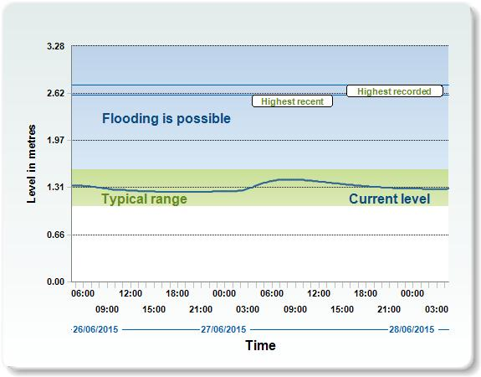
B.204 Properties at risk of flooding are dispersed across the District but there are clusters of properties at risk in Banbury and Kidlington (more than 100 properties in total). The SFRA also highlights that some rural settlements are potentially affected by fluvial flooding.
B.205 Construction work commenced in February 2011 on a Flood Alleviation Scheme for Banbury to protect the town centre and surrounding businesses from flooding and the scheme is now complete. The project was funded by the Environment Agency supported by Cherwell District Council and contributions from local landowners.
B.206 The Flood and Water Management Act 2010 assigns local authorities with a responsibility for managing flood risk. In Cherwell District, Oxfordshire County Council is the Lead Local Flood Authority (LLFA), with the District Council having an important supporting role to play as a Risk Management Authority. The probability of flooding can be reduced through the management of land, river systems and flood defences, and the impact reduced through influencing the type of development located in flood risk areas. The following policy will be used to manage and reduce flood risk in the District.
Policy ESD 6: Sustainable Flood Risk Management
The Council will manage and reduce flood risk in the District through using a sequential approach to development; locating vulnerable developments in areas at lower risk of flooding. Development proposals will be assessed according to the sequential approach and where necessary the exceptions test as set out in the NPPF and NPPG. Development will only be permitted in areas of flood risk when there are no reasonably available sites in areas of lower flood risk and the benefits of the development outweigh the risks from flooding.
In addition to safeguarding floodplains from development, opportunities will be sought to restore natural river flows and floodplains, increasing their amenity and biodiversity value. Building over or culverting of watercourses should be avoided and the removal of existing culverts will be encouraged.
Existing flood defences will be protected from damaging development and where development is considered appropriate in areas protected by such defences it must allow for the maintenance and management of the defences and be designed to be resilient to flooding.
Site specific flood risk assessments will be required to accompany development proposals in the following situations:
- All development proposals located in flood zones 2 or 3
- Development proposals of 1 hectare or more located in flood zone 1
- Development sites located in an area known to have experienced flooding problems
- Development sites located within 9m of any watercourses.
Flood risk assessments should assess all sources of flood risk and demonstrate that:
- There will be no increase in surface water discharge rates or volumes during storm events up to and including the 1 in 100 year storm event with an allowance for climate change (the design storm event)
- Developments will not flood from surface water up to and including the design storm event or any surface water flooding beyond the 1 in 30 year storm event, up to and including the design storm event will be safely contained on site.
Development should be safe and remain operational (where necessary) and proposals should demonstrate that surface water will be managed effectively on site and that the development will not increase flood risk elsewhere, including sewer flooding.
B.207 The above policy reflects government planning guidance on sustainable flood risk management set out in the NPPF and NPPG. The suitability of development proposals will be assessed according to the sequential approach and where necessary the exceptions test as set out in the NPPF and NPPG. Defended areas should be sequentially tested as though the defences are not there. Applications will also be assessed against the Environment Agency’s standing advice on flood risk.
B.208 The Council's Level 1 SFRA (see Appendix 3: Evidence Base) provides the framework for applying the sequential and exception tests in the District. The SFRA identifies and maps the risk of flooding across the District based on a range of data and taking into account predicted climate change impacts, and is a useful source of information in undertaking site specific flood risk assessments particularly in relation to specific locations across the District. The SFRA also highlights the biodiversity opportunities associated with the use of sustainable flood risk management techniques, for example in enhancing or creating priority habitats such as grazing marsh, wet grassland, wetlands and aquatic habitats (particularly so in the Conservation Target Areas - see 'Policy ESD 11: Conservation Target Areas').
B.209 Level 2 SFRAs have also been carried out to assess the level of flood risk for strategic site allocations in more detail (see Appendix 3: Evidence Base). The assessments provide site specific guidance for flood risk assessments, policy recommendations and Sustainable Drainage Systems (SuDS) guidance. The findings of the assessments will be taken into account in the final determination of planning applications at the strategic sites.
B.210 Site specific Flood Risk Assessments (FRAs) will be required in accordance with the NPPF and NPPG. The FRA should identify and assess the risks of all forms of flooding to and from the development and demonstrate how these flood risks will be managed, taking climate change into account. Fluvial flood events up to and including the 1 in 100 year event with an allowance for climate change should be considered. For major developments in Flood Zone 1, the FRA should identify opportunities to reduce the probability and consequences of flooding. The FRA should also include investigation of the use of sustainable drainage systems (see 'Policy ESD 7: Sustainable Drainage Systems' (SuDS)).
B.211 Briefly, there are 3 levels of FRA, as follows:
- Level 1 - Screening: identify if a development site has flood risk issues
- Level 2 - Scoping: qualitative assessment to determine how flood sources affect the site and options available for mitigation
- Level 3 - Details: where the quality and/or quantity of information is insufficient to enable a robust assessment of the flood risks, further investigation will be required potentially involving hydraulic modelling.
B.212 An FRA does not need to go through every stage (i.e. if it is known that detailed modelling will be required, just a Level 3 FRA can be carried out). The Council’s SFRA makes the following recommendations for FRAs undertaken in particular locations across the District, as follows:
Location | Site Specific FRA Requirement
Wherever applicable | Where a site is in close proximity of the Oxford Canal, the Level 3 FRA should include breach analysis.
Wherever applicable | Flood defended areas will require a FRA to include assessment of risk from catastrophic failure of defences.
Banbury | A detailed level 3 FRA is required for development within the River Cherwell Floodplain to include flood compensation.  Groundwater risk to be highlighted at Crouch Hill.
North East Biceser | A level 2 FRA using existing data can be applied.
South East Bicester | A level 3 FRA including hydraulic modelling will be required in the vicinities of these watercourses.
Kidlington | Where EA modelled data is available a level 2 FRA can be completed using existing modelled flood levels. Where no data is available a Level 3 FRA including hydraulic modelling may be required for sites in close proximity to the Rowell Brook or the River Cherwell.  A level 2 FRA to include detailed assessment of groundwater flood risk should be included at all sites.
Rural Areas | There are village specific recommendations contained in the SFRA

B.213 Additional recommendations are included in the Level 2 SFRAs for the proposed strategic site allocations.
B.214 We will work actively with the Environment Agency, the Local Lead Flood Authority, other operating authorities and stakeholders to ensure that best use is made of their expertise and so that spatial planning supports existing flood risk management policies and plans, River Basin Management Plans and emergency planning.

