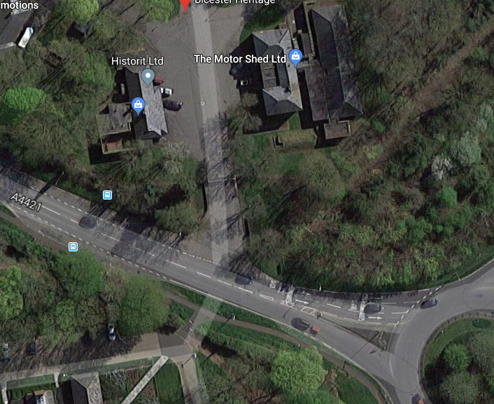

Aerial map of Sorbus tree to be felled.
Bicester Heritage, Buckingham Rd, Bicester, OX26 5HA.

