Our Core Assets
Policy ESD 8: Water Resources
B.220 In considering development proposals, the Council will use Policy ESD 8 together with 'Policy ESD 3: Sustainable Construction', 'Policy ESD 6: Sustainable Flood Risk Management' and 'Policy ESD 7: Sustainable Drainage Systems' (SuDS) to reduce the impact of development on the water environment, maintain water quality, ensure adequate water resources and promote sustainability in water use. This will assist in contributing to the objectives of the Water Framework Directive which seeks to protect and enhance the quality of water bodies, and indicates that development should not result in any deterioration in the status of surface water bodies. Some development can remediate contaminated land which may be having an adverse impact on controlled water and human health. These policies together with Policy ESD 8 are also intended to help deliver the actions contained in the Thames River Basin Management Plan. These actions highlight the importance of development proposals contributing to an improved water environment, through the use of sustainable design and construction techniques for water efficiency, water quality and sustainable flood management, and the incorporation of appropriate green infrastructure and biodiversity improvements.
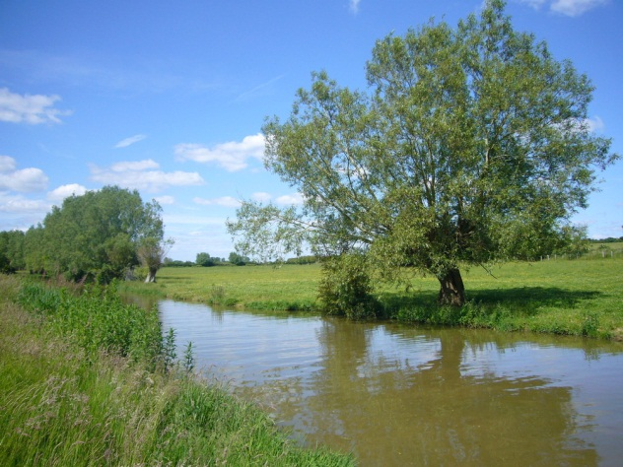

B.221 Research carried out by the Environment Agency and set out in the Catchment Abstraction Management Strategies (CAMs) shows that Cherwell District lies within an area of serious water stress and the Upper Cherwell area (including Banbury) has been over abstracted. Policy ESD 8 will be used to ensure that new development is located in areas where adequate water supply can be provided from existing and potential water supply infrastructure. In addition 'Policy ESD 1: Mitigating and Adapting to Climate Change' and 'Policy ESD 3: Sustainable Construction' will ensure new development incorporates water efficiency measures, reducing demand.
Policy ESD 8: Water Resources
The Council will seek to maintain water quality, ensure adequate water resources and promote sustainability in water use.
Water quality will be maintained and enhanced by avoiding adverse effects of development on the water environment. Development proposals which would adversely affect the water quality of surface or underground water bodies, including rivers, canals, lakes and reservoirs, as a result of directly attributable factors, will not be permitted.
Development will only be permitted where adequate water resources exist, or can be provided without detriment to existing uses. Where appropriate, phasing of development will be used to enable the relevant water infrastructure to be put in place in advance of development commencing.

Protection and Enhancement of Biodiversity and the Natural Environment
B.222 Conserving biodiversity is an important element of sustainable development. Government guidance in the NPPF and NPPG indicates that in delivering sustainable development local authorities should enhance as well as protect biodiversity and natural habitats. It is also recognised that the distribution of habitats and species will be affected by climate change. This reinforces the importance of considering climate change impacts in seeking to avoid habitat fragmentation. Following an initiative in the Natural Environment White Paper 2011, a Local Nature Partnership for Oxfordshire ('Wild Oxfordshire') was set up with the aim of encouraging all sectors to consider the natural environment in decision making and recognise the wider social and economic benefits biodiversity brings. The Council will have regard to the views of 'Wild Oxfordshire' in ensuring sustainable development.
B.223 Cherwell District contains many areas of high ecological value including sites of international and national importance, as outlined below. While the District is predominantly rural, its urban centres, parks and open spaces are just as much part of the local environment and provide important habitats for wildlife. The policies to protect and enhance the natural environment and biodiversity in urban and rural areas are set out below.
B.224 Cherwell contains one site of European importance; part of Oxford Meadows Special Area of Conservation (SAC) located in the south west corner of the District (indicated on the Cherwell District Policies Map (Appendix 5: Maps). The SAC receives statutory protection under the Habitats Directive (Directive 92/42/EEC), transposed into national legislation in the Conservation of Habitats and Species Regulations 2010 (the Habitats Regulations).
B.225 The proposals in this document have been informed by Habitats Regulations Assessments undertaken in accordance with Regulation 21 of the Habitats Regulations. An HRA was carried out to determine whether the proposals in the Core Strategy Options for Growth paper (2008) were likely, either alone or in combination with other plans and projects, to have a significant effect upon European sites An HRA of the Draft Core Strategy (February 2010) was also undertaken. Copies of both assessments are available on the Council's website (see Appendix 3: Evidence Base).
B.226 Appropriate measures as recommended by the HRA have been incorporated to avoid or minimise the effect of the plan proposals on the SAC in relation to water quality, natural groundwater flow, air quality and recreational use. A revised HRA was undertaken (2012) to accompany the Proposed Submission Local Plan to ensure that the plan proposals will not result in adverse effects on the SAC. Addendums to the HRA were published to accompany the focused consultation on proposed changes to the Plan in March 2013 and the Submission Local Plan in October 2013 which confirmed that there would be no likely significant effects on any Natura 2000 Sites as a result of the proposals within the Plan. A HRA (Stage 1 Screening) re-affirming these conclusions accompanied the proposed modifications to the Plan.
B.227 Paragraph B.95 indicates that if Oxford is unable to accommodate the whole of its new housing requirement for the 2011-2031 period within its administrative boundary, the Council will continue to work jointly with the other Oxfordshire local authorities to assess all reasonable spatial options of how any unmet need could be met. The consideration of all reasonable options would include undertaking a Habitats Regulations Assessment to assess the alone and in combination effects on sites of European importance.
B.228 However, as the proposals in the Local Plan are strategic by nature, any more detailed proposals that are identified in the Local Plan Part 2 will also be subject to a Habitats Regulations Assessment to determine if they are likely to have a significant impact. Similarly, if a proposed development submitted as a planning application could have a likely significant effect on Oxford Meadows SAC then consideration and assessment would need to be undertaken (see 'Policy ESD 9: Protection of the Oxford Meadows SAC' and 'Policy ESD 10: Protection and Enhancement of Biodiversity and the Natural Environment').
B.229 One of the recommendations arising from the HRA was the need to ensure groundwater flows and water quality at the SAC are not affected by development. Policy ESD 9 will be used to ensure that this is the case.

