Policy SLE 3: Supporting Tourism Growth
B.62 Given the growing role that tourism has to play in the local economy, developments in this sector will be supported, especially new attractions and new hotels at the two towns to reinforce their central role as places to visit and stay. We will support new tourism provision that can demonstrate direct benefit for the local ‘visitor’ economy and which will sustain the rural economy.
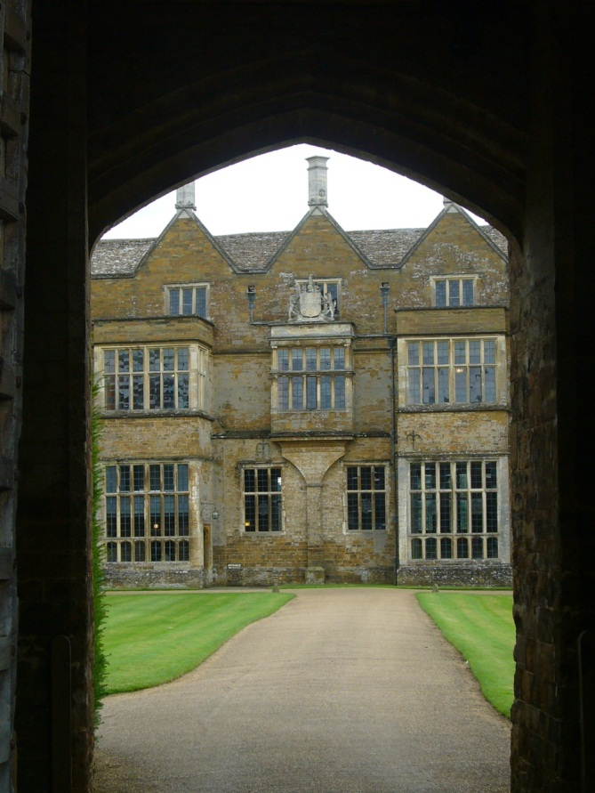
B.63 We will support an increase in high quality accommodation available in our towns to meet the needs of visitors and to end the current under provision. Valuable expenditure associated with overnight stays is potentially being lost, meaning that tourism has scope to play a significant wealth-creating role for the District.
B.64 Tourism can help support local services and facilities, provide employment, promote regeneration and help preserve the natural and historic environment. It can include day visits by local people through to visits from overseas. Tourism is a vital component in the make-up of the national economy. Currently tourism is worth over £300 million in Cherwell District and makes a significant contribution towards the development of a sustainable local economy. 1.2 million people live within a 30 minute drive time of the District boundary.
B.65 A tourism study was completed for the District in August 2008 in order to assist the Council in gaining a broad understanding of tourist activity and trends in Cherwell District and nearby. It highlighted that tourism was not as great a part of the local economy as for some locations, but that initiatives to further encourage tourism could be considered. The following observations and issues were identified:
- the District will not attract the level of tourists who visit surrounding destinations but should make the most of its proximity to these destinations and its good transport links
- the 58km of Oxford Canal in Cherwell is a resource that is not used to its full potential and access should be improved to promote green and sustainable leisure opportunities – using the towpath for walking and cycling as well as the water for boating
- business tourism is important to Cherwell’s economy
- Cherwell's villages are attractive and distinctive and many have places of interest
- Banbury's historic town centre is somewhere to visit and also to stay if visiting popular destinations nearby such as Oxford or Stratford. It also acts as one of the main retail destinations in the area
- Bicester Village is the District's most visited tourist destination
- that Former RAF Bicester and Former RAF Upper Heyford represent potential new tourism developments
- the opportunity for a Cold War Visitor Centre at Former RAF Upper Heyford
- there are mixed trends in terms of the occupancy of tourist accommodation which is often below average but hotels are also turning away guests on other occasions
- a large new hotel was completed in Banbury, near the M40, in 2008. A new hotel has been built near Bicester and further such investment is planned. Demand for hotel and other overnight accommodation continues.
B.66 Other policies in other sections of this Local Plan will contribute towards addressing these issues and encouraging sustainable tourism development; for example by:
- the regeneration of Banbury Canalside (‘Policy Banbury 1: Banbury Canalside’)
- the development of the Spiceball Development Area in Banbury (‘Policy Banbury 9: Spiceball Development Area’)
- maintaining village services and facilities
- the preservation and enhancement of the historic environment in both towns and villages.
B.67 The Local Plan Part 2 will also support tourism by including polices encouraging new accommodation and the allocation of smaller sites for tourism related development.
B.68 There are other factors which are beyond the scope of the Local Plan which are important to drawing visitors to Cherwell’s towns, villages and countryside. The Council, working with partners, already undertakes marketing, but to increase the number of visitors to Cherwell and to compete nationally, this will need to be maintained and enhanced.
Policy SLE 3: Supporting Tourism Growth
The Council will support proposals for new or improved tourist facilities in sustainable locations, where they accord with other policies in the plan, to increase overnight stays and visitor numbers within the District.

