Planning Application 18/00220/F comments

Mon 26/02/2018 16:23

Dear Mr Feehily

Ball Colegrave have received a neighbour notification for the Planning Application 18/00220/F to change the use of agricultural land to sport/recreation and community use.

We would like to make a few comments to be taken into consideration with this application.

When Ball Colegrave Ltd (was then Colegrave Seeds Ltd) first established in 1962, the plant growing facilities on the Milton Road were particularly chosen for the safe distance from light pollution which can have potentially disastrous results on the development of the plants growing in our nursery, changing their mode and timing of flower. Also the location gave the growing structures (predominantly glass) safe distance for security and from damage by straying balls and stones. With the development of the land adjacent to our property, we do express concern to the potential physical and financial damage from particularly flood lighting and ball games. The loss or damage to the plants in our Trial Grounds and International Breeding Trials could have far reaching effects and consequential damage to our business.

I would like to draw your attention to a document emailed to the Adderbury Parish Council on 2nd July 2014 by Jonathan Durley, previously outlining our concerns for the development of the land.

Also in our comments, Ball Colegrave would like to request permission for the continued use of the access track and gate to the side of the new Parish Council land and Ball Colegrave boundary on Milton Road. The gate and track was put in by the Colegrave family to allow for the safe exit of vehicles from the Ball Colegrave property onto the Milton Road. We have used this track for at least the past 30 years by kind permission of the previous owners, David Colegrave and then Jeff Colegrave. The track is used on a one-off annual basis in order to safely run a Public Charity Open Evening for the local community. I cannot see that it will in any way hinder the plans for the development of the land, especially as it is on an annual one-off basis.

I hope you will give these comments your consideration in the above application. If I can be of any further assistance, please do not hesitate to contact me.

Kind Regards

Stuart Lowen
Marketing Manager
____________________________________
Ball Colegrave Ltd
Milton Road, West Adderbury, Banbury

Re - The development of the land to the East of Ball Colegrave’s head office on the Milton Road, West Adderbury OX17 3EY.
Ball Colegrave respectfully asks for the following:-
- Access for machinery and vehicles adjacent to the Ball Colegrave boundary to the gate at the bottom of the field, please see Fig 1 - No 1 on the picture below,
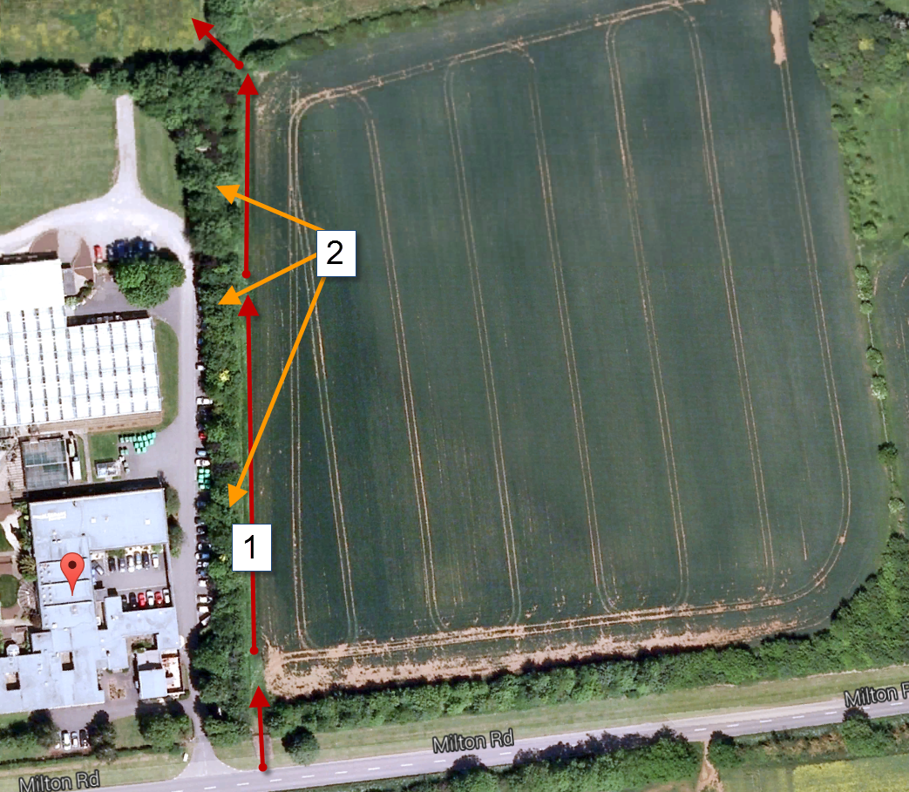
Fig 1
This Access has been open to Ball Colegrave for many years while under the ownership of the Colegrave family, this access is used for farm machinery and to allow in and out traffic lanes for large events/open days to prevent traffic build up on the Milton road.
- That a secure high fencing along to the east of the access track be erected (see Fig 2), this should be suitable to protect our greenhouses and cars parked along the hedge line (our main car park). These greenhouses are critical to our operations here in West Adderbury.
- That the existing coppice hedgerow be kept and maintained, this was planted by the Colegrave family to act as a windbreak for the Ball Colegrave trial grounds and offices, see Fig 1 - No 2 on the picture above.
- Beyond (East of) the fence a sympathetic planting of indigenous species to screen the fence and blend into the surrounding country side. (Please see Fig 2).
- That you stipulate and enforce that no Golf balls to be used on the land.
- To be consulted on any changes to the land drainage for the proposed development.
- To be consulted if any flood lighting is to be used. We are doing light sensitive trials in the greenhouses and any artificial light will affect the results.
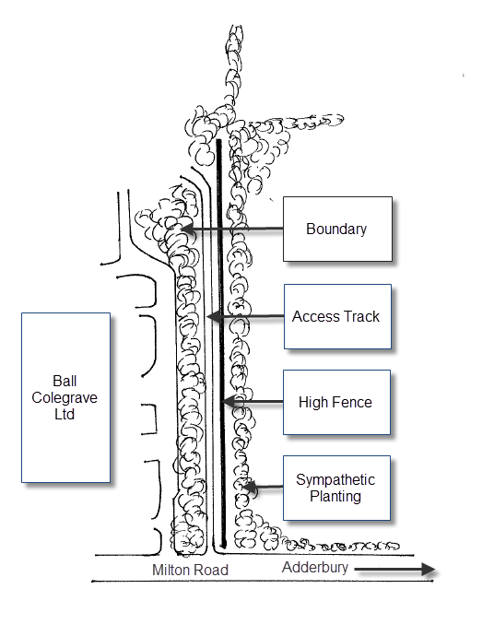
Fig 2

