- APPLICATION SITE AND LOCALITY

  - The Lion is a Grade II listed building situated on the south east side of Main Street, Wendlebury. The detached property is situated within the centre of the village and dates back to the 18th Century. The building is situated across the road from two other listed buildings (Elm Tree House and Willow Cottage).

  - The building is constructed from coursed limestone rubble under a tile and slate roof. Two extensions protrude from the rear of the main body of the building, one of which is single storey, flat roofed and accommodates the kitchen and the other of which is 1 ½ storey and accommodates a store.

  - The site is used as a public house and restaurant. The building has been refurbished and extended to now include a formal dining area, outside seating area and most recently has received permission for the removal of a building and proposed replacement with a detached accommodation block (ref 15/00185/F & 15/00186/LB refers). A large tarmac car park is situated to the west of the pub with a small beer garden beyond the tiled dining area.

- DESCRIPTION OF PROPOSED DEVELOPMENT
2.1 Full consent is now being sought for the retention of two extractor units on the roof of the kitchen extension which have been installed without planning permission. An application for listed building consent accompanies this application (ref 16/2580/LB).

2.2 As part of the enforcement investigation, pre-application advice has been given to the applicants both in writing and at a meeting. This application (and its partner one for listed building consent) is one of a series of applications to be submitted following this investigation.

- RELEVANT PLANNING HISTORY
APP NUMBER | DESCRIPTION | DECISION
14/01026/F & 14/01027/LB | Single storey rear extensions, internal alterations and extension to parking area | APPROVED
15/00172/F & 15/0007/LB | Amendments to application 14/01026/F | APPROVED
15/00185/F | Detached accommodation block | APPROVED
15/00186/LB | Removal of curtilage listed building | APPROVED
16/01430/F | Proposed accommodation block - Alteration to approval 15/00185/F | APPROVED
16/01876/F & 16/01877/LB | Retrospective amendments to previous consent | APPROVED
16/02581/F & 16/02582/LB | Erection of external stone hearth with chimney | REFUSED
16/02584/F & 16/02585/LB | Amendments to the approved application for retention of permeable paving | REFUSED

- PRE-APPLICATION DISCUSSIONS
- Given that this application has come about through an enforcement generated investigation, some informal pre-app has already been given. The culmination of this advice was in the form of a detailed letter to the owners dated 22 July 2016 and this advice were further emphasised at a meeting at these offices on 09 August 2016.

- This advice clearly outlined that the retention of the extractor units is not something which the Council would consider as appropriate development and have been resisted on other listed buildings in the District. However an application for planning permission and listed building would need to be submitted should the applicants wish to retain them.

- RESPONSE TO PUBLICITY
5.1 This application has been publicised by way of a site notice displayed near the site, by advertisement in the local newspaper, and by letters sent to all properties immediately adjoining the application site that the Council has been able to identify from its records.
5.2 The comments raised by third parties are summarised as follows:
- The extractor fans are noisy
- At times it is smelly within the customer car park and in our garden
5.3 The comments received can be viewed in full on the Council’s website, via the online Planning Register
- RESPONSE TO CONSULTATION

6.1 Below is a summary of the consultation responses received at the time of writing this report. Responses are available to view in full on the Council’s website, via the online Planning Register.
STATUTORY CONSULTEES

PARISH/TOWN COUNCIL
6.2 Wendlebury Parish Council has considered the applications, reference 16/02579/F and 16/02580/LB, for the ‘Installation of 2no. Extractor units on the roof of the kitchen extension (retrospective)’ at The Lion Main Street and has concerns regarding the smell and noise emanating from them which would particularly affect the near neighbours.
CHERWELL DISTRICT COUNCIL ENVIRONMENTAL PROTECTION OFFICER:
6.3 Does not object to the application but makes the following comments:
• I believe that the noise levels as given should not cause an issue at the nearest residential property.
• I still have concerns that the best practice has not been followed with regards to odour as the extractor is pointing downwards into a courtyard which may well retain the odour rather than it being pointed upwards and being dispersed in the atmosphere as recommend in the DEFRA Guidance on the Control of Odour and Noise from Commercial Kitchen Exhaust Systems. I would also like to point out that it is not my role to come forward with alternative schemes as suggested in the design and access statement but comment on the schemes that are presented to me. As this is a retrospective scheme it might have been useful to seek the advice of the planning department and/or environmental protection department before the system was installed - I would therefore like to see the installation engineers reasoning as to why the extractor is pointing down and not up the roof and how this would affect the impact of the odour on the area before I make a final decision on whether to object to the scheme.
CHERWELL DISTRICT COUNCIL CONSERVATION OFFICER:

6.4 Objects to the application:
In the last few years The Lion has undergone a major overhaul. I appreciate that the kitchen at The Lion is a working kitchen where modern hygiene and health and safety regulations must be met. However, the kitchen is a new build addition to a listed building and the requirement for extractor fans should have been built into the original design.
The current arrangement where the two ventilation/extractor fan stacks appear to have been added as an after-thought is a visual intrusion as the visitor views the listed building from the north. The impact of the current arrangement is not only harmful to the visual aesthetic of the building but also detrimental to the significance of the listed building.
My view is that the current arrangement is totally and wholly unacceptable and should not be accepted as the de facto solution to the requirement for ventilation for the modern kitchen just because it is currently in place.
A solution which incorporates the ventilation shafts into the roofspace with an outlet located in a less obtrusive position should be sought. Such a compromise was found for The Red Lion in Islip (16/01159/LB). It should therefore be possible to find an alternative solution here.
Recommend refusal as contrary to both national and local policy.
NON-STATUTORY CONSULTEES
6.5 None consulted
- RELEVANT PLANNING POLICY AND GUIDANCE

- Planning law requires that applications for planning permission must be determined in accordance with the development plan unless material considerations indicate otherwise.

- The Cherwell Local Plan 2011-2031 - Part 1 was formally adopted by Cherwell District Council on 20th July 2015 and provides the strategic planning policy framework for the District to 2031. The Local Plan 2011-2031 – Part 1 replaced a number of the ‘saved’ policies of the adopted Cherwell Local Plan 1996 though many of its policies are retained and remain part of the development plan. The relevant planning policies of Cherwell District’s statutory Development Plan are set out below:

CHERWELL LOCAL PLAN 2011 - 2031 PART 1 (CLP 2031 Part 1)

- ESD15: The Character of the Built and Historic Environment

CHERWELL LOCAL PLAN 1996 SAVED POLICIES (CLP 1996)

- C28: Development Control Design
- C30: Development Control Amenity
- ENV1: Pollution control

- Other Material Planning Considerations

- National Planning Policy Framework (NPPF)
- Planning Practice Guidance (PPG)

- APPRAISAL

- The key issues for consideration in this case are:

- Visual amenity and Heritage Impact
- Impact on neighbours

Visual amenity and Heritage Impact

- Government guidance contained within the NPPF attaches great importance to the design of the built environment and states that good design is a key aspect of sustainable development, is indivisible from good planning, and should contribute positively to making places better for people.

- Saved Policy C28 of the adopted Cherwell Local Plan seeks to control new development to ensure that it is sympathetic to the character of its context.

- Government guidance contained within the NPPF requires LPA’s to take account of the desirability of sustaining and enhancing the significance of heritage assets and putting them to viable uses consistent with their conservation, and this guidance is echoed in Policy ESD15 of the Cherwell Local Plan 2011-2031 Part 1.

- The application seeks retrospective consent for the installation of two extractor units in the roof of the kitchen. The kitchen is a recent addition (approved through one of the earlier applications) but the extractors were not shown on the approved plans for this extension:

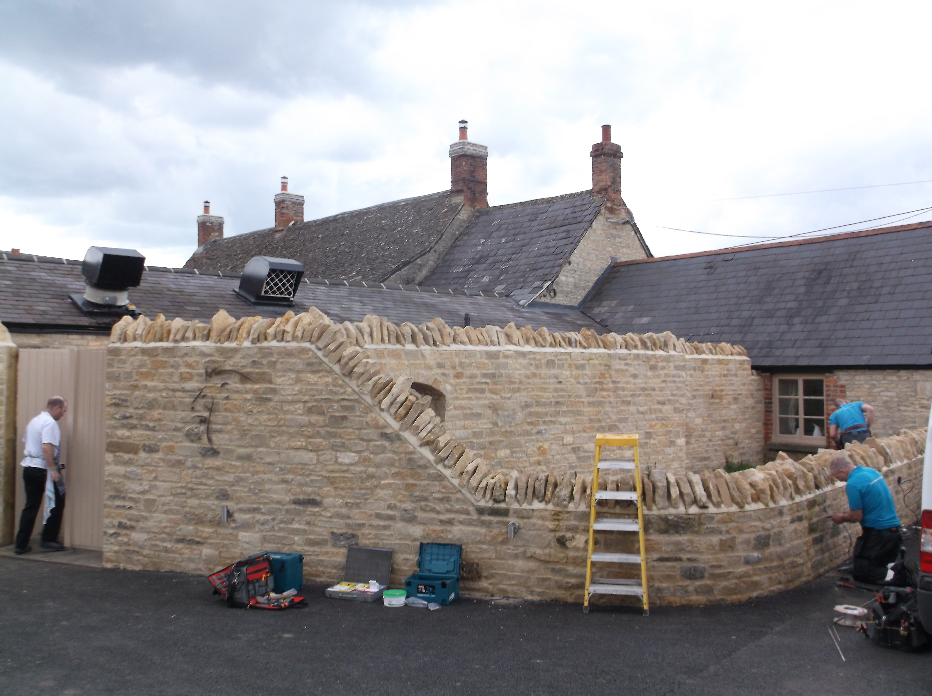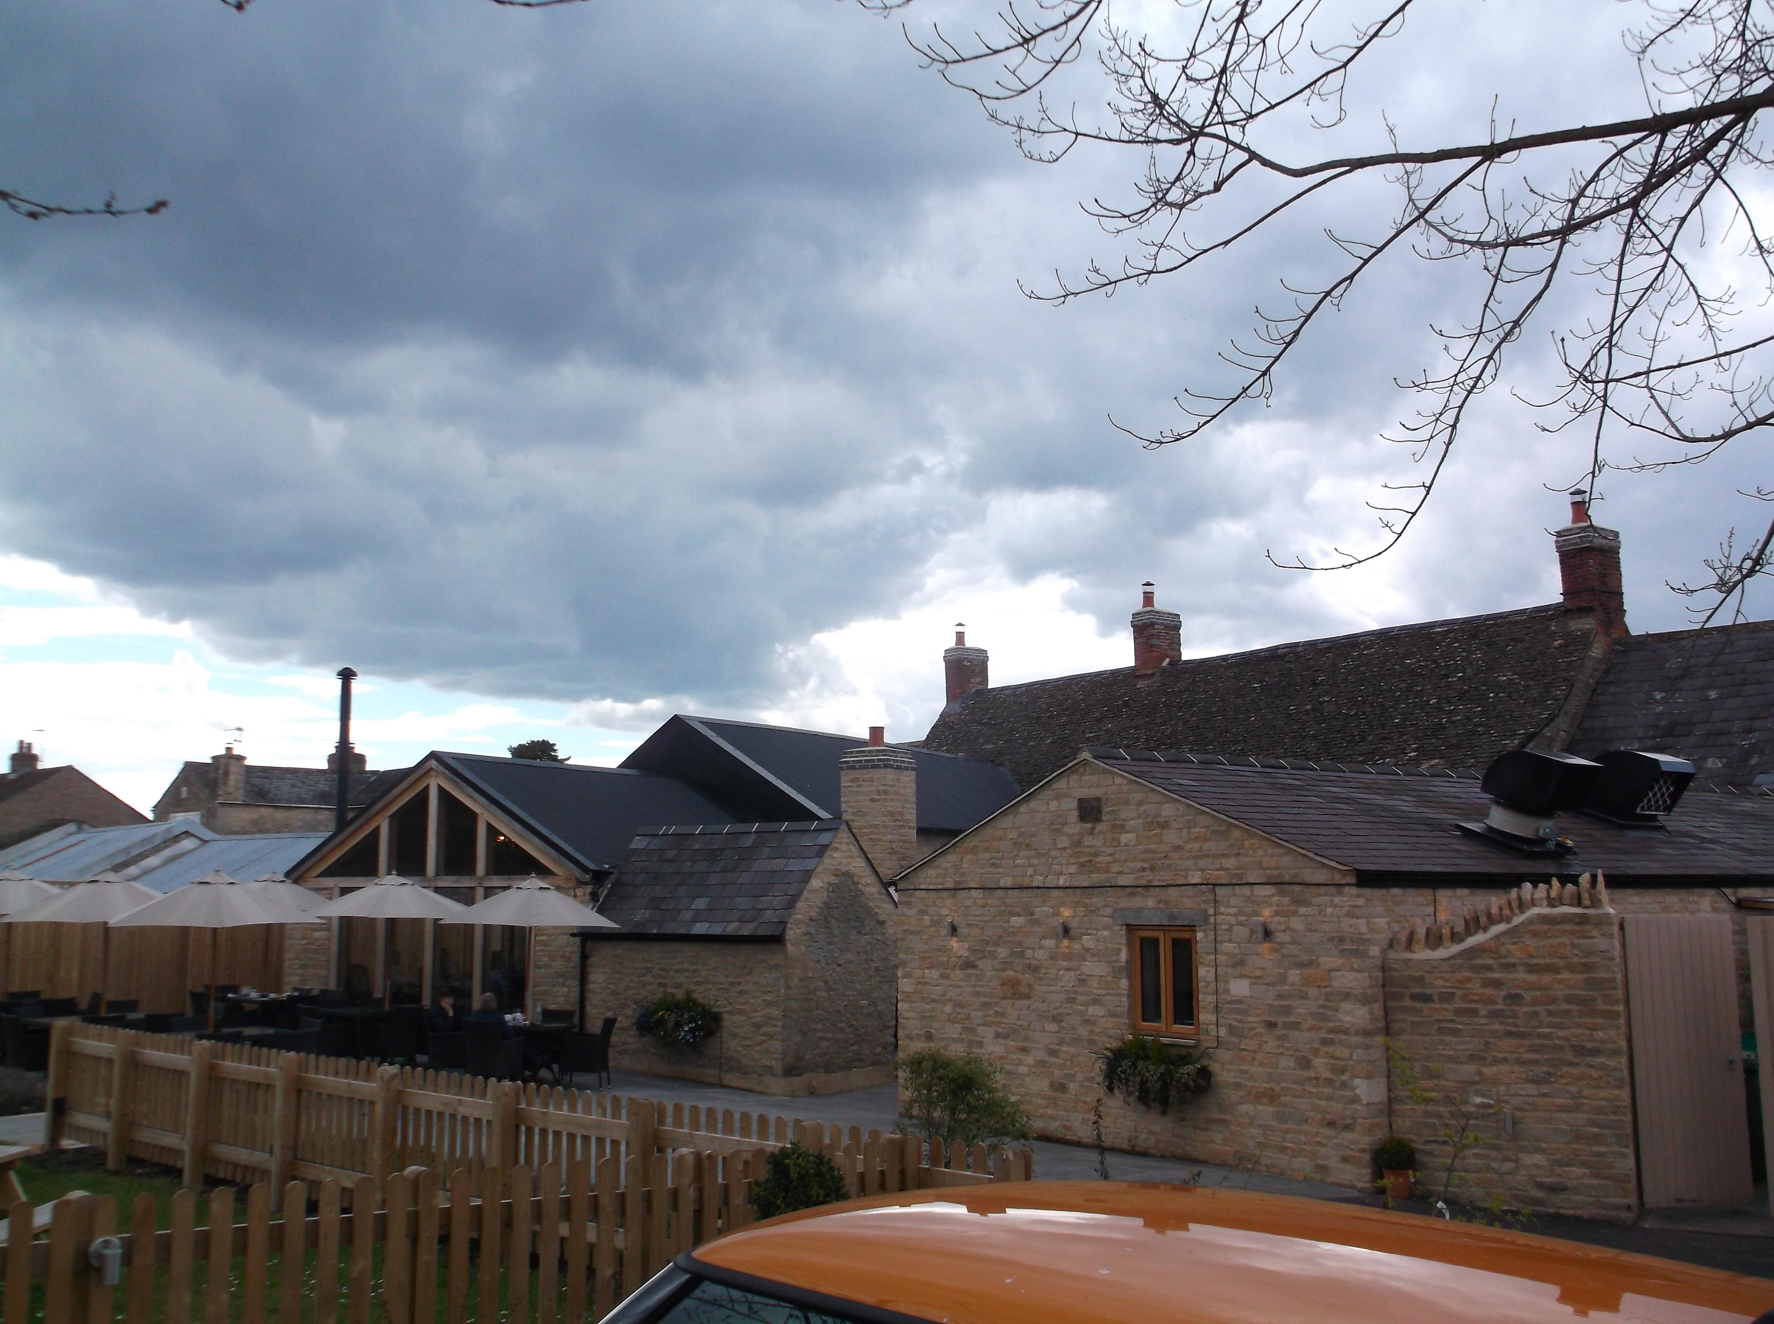
Extractor units Extractor units
- The units are located within the rear courtyard, almost adjacent to the car park. They are sited in the slate roof of the kitchen building which is a modern extension attached to the rear of the existing pub building. The units are very large and painted black. They sit proud of the roof and are sited on the east elevation of the kitchen. The units are considered to be necessary for the ventilation of the kitchen. Whilst not being directly attached to the fabric of the original listed building, they are considered to have a significant visual impact on the listed building.

- It has already been outlined that the pub is a Grade II Listed Building and by definition therefore a Designated Heritage Asset. The NPPF Paragraph 132 states that: “When considering the impact of a proposed development on the significance of a designated heritage asset, great weight should be given to the asset’s conservation. The more important the asset, the greater the weight should be. Significance can be harmed or lost through alteration or destruction of the heritage asset or development within its setting. As heritage assets are irreplaceable, any harm or loss should require clear and convincing justification.”

- Paragraph 134 advises that where a development proposal will lead to less than substantial harm to the significance of a designated heritage asset, this harm should be weighed against the public benefits of the proposal.

- Policy ESD 15 of the CLP is consistent with the advice and guidance within the NPPF with regard to the conservation of the historic environment and looks for development to:

  - Contribute positively to an area’s character and identity by creating or reinforcing local distinctiveness;
  - Conserve, sustain and enhance designated and non-designated Heritage Assets, including their settings, ensuring that new development is sensitively sited and integrated;
  - Respect the traditional pattern of routes, spaces, blocks, plots, enclosures and the form, scale and massing of buildings.

- The Council’s Conservation Officer objects to the proposals (see para 4.4 for full comments). In particular there is a significant issue with the visual impact of these extractor units and this is outlined in her comments that “…the two ventilation/extractor fan stacks appear to have been added as an after-thought (and are) a visual intrusion as the visitor views the listed building from the north. The impact of the current arrangement is not only harmful to the visual aesthetic of the building but also detrimental to the significance of the listed building.”

- Whilst the extractor units are on site to facilitate the use of the kitchen and to allow for the production of hot food, the Environmental Protection Officer does raise queries as to the position which the units have been placed on the roof. No further details have been provided by the applicants to support their positioning. It has also not been demonstrated that there are not alternative, more sensitive, means of ventilating the kitchen and it is noted that the Conservation Officer has made reference to a more sensitive solution that has been used elsewhere in the District. Whilst the extractor units support the pub use and its ability to serve hot food, this must still be weighed against the harm resulting from the retention of the extractor units and on balance it has been concluded that this ventilation/extractor solution is not at all beneficial to the appearance of the heritage asset and would detract from its setting and significance.

- The extractor units are overly large and prominent and appear as modern industrial features significantly out of keeping with the traditional character, detailing and appearance of the listed building. The addition of extractor units are an alien feature in an already considerably altered building. They are not sympathetic to the context, detracting from the visual amenities of the existing building and its setting within the surrounding area. It is considered that any public benefits would not be so significant that they outweigh the harm caused to the historic environment in this instance, and could be achieved by less harmful means.

- The proposal is considered to be at odds with Government Guidance contained within the National Planning Policy Framework, Policies C28 of the Cherwell Local Plan 1996 (Saved Policy) and Policy ESD15 of the Cherwell Local Plan 2011-2031 Part 1.

Impact on neighbouring properties

- Both local and national planning policy seeks to ensure that development does not cause undue harm to the amenity of existing neighbours, including by way of loss of outlook, noise, nuisance or loss of light.

- The Council’s Environmental Protection Officer (EPO) has been consulted on the application and has also had sight of the objection that has been made by the neighbouring property. He has noted that the units are not positioned in the way he would have expected them to be but does not believe that this is a significant issue. Although no further mechanical details about the extractor units have been submitted, the EPO does not believe they are ineffective to the point that smoke or odour would cause a statutory nuisance. Furthermore, whilst they do have an audible noise level, this has to be balanced against the ambient noise of the pub itself as well as the main road.

- Being mindful of the objection that has been received from a neighbouring property, whilst the EPO does not consider there to be enough of a nuisance to warrant a statutory nuisance, saved Policy ENV 1 Cherwell Local Plan 1996 clearly states:

DEVELOPMENT WHICH IS LIKELY TO CAUSE MATERIALLY DETRIMENTAL LEVELS OF NOISE, VIBRATION, SMELL, SMOKE, FUMES OR OTHER TYPE OF ENVIRONMENTAL POLLUTION WILL NOT NORMALLY BE PERMITTED

- The EPO Officer does acknowledge that there is a noise from the extractors and there is a smell from outside the site and this together with the lack of mechanical information could result in the neighbour being detrimentally affected by the retention of the extractor units. Notwithstanding this view, I am of the opinion that there is not enough evidence to suggest that the extractors result in significant and unacceptable odour and noise impacts to neighbours, such that a reason for refusal could be justified in this regard. Furthermore, separate environmental legislation exists to regulate any statutory nuisance that results from the operation of the extractors.

- CONCLUSION
9.1 The two extraction units are unacceptable additions to this building. They have a clear and demonstrable impact upon the visual integrity and setting of the listed building and in accordance with advice in the NPPF affect the significance of the building to such a degree as to warrant the refusal of permission. Whilst the public benefit for their retention is noted, there will be alternative schemes which are less detrimental to the building. The impact that these units have is considered to be significant enough to outweigh the benefits identified due to the unacceptable impact on the character, setting and appearance of the building. As such the application is contrary to planning policy and should therefore be refused.

- RECOMMENDATION
That permission is refused, for the following reason:

The kitchen extractor units, by virtue of their size, prominent siting, massing and industrial design, appear at odds with the traditional character, simple vernacular detailing and appearance of the Grade II listed The Lion Public House, and cause harm to the significance of the listed building and its setting. It is considered that the harm identified is less than substantial but is not outweighed by the environmental and financial benefits of the kitchen extract, which could be provided by other, less harmful, means. The proposal is therefore contrary to Government guidance contained within the National Planning Policy Framework, saved Policy C28 of the Cherwell Local Plan 1996 and Policy ESD15 of the Cherwell Local Plan 2011-2031 Part 1.

CASE OFFICER: Nathanael Stock | DATE: 30.03.17
CHECKED BY: Paul Ihringer | DATE: 12.04.17

