From: Claydon with Clattercote Parish Council
Sent: 29 April 2019 08:57
To: Clare O'Hanlon
Subject: RE: Proposed Marina amended plans 18/00904/F

Dear Clare,

Please see attached the response from Claydon with Clattercote Parish Council.

Please could you confirm receipt of this?

Regards

Kirsty Buttle
Clerk/RFO
Claydon with Clattercote Parish Council

18/00904/F: Glebe Farm, Boddington Road, Claydon.

Claydon with Clattercote Parish Council object to this proposal for the following reasons:

Despite the reduction in the number of moorings in the amended plans the proposal will still create a significant increase in general traffic volume on the local network. The Parish Council are concerned about the impact this will have on the roads in the village which already have issues with large vehicles attempting to drive through the village and getting stuck. On the Fenny Compton Road large vehicles ignore the weight limit on the railway bridge which has resulted in damage to the bridge. These issues have been raised numerous times with the County and District Councillors and they are looking into the different options to try to alleviate this. Clearly adding such a large development to the area will be counterproductive

There are only three narrow lanes into the village with limited passing places. One of these passing places is a parishioner’s driveway which we do not believe should be considered a passing place as it is their land and they have every right to block this space should they wish, therefore the long term availability of this passing place is not guaranteed. Another passing place is not an official passing place and has been created over time by vehicles having to pull over to the left before the bridge when leaving the village to allow enough room for vehicles coming into the village over the bridge to pass. This ‘passing place’ is regularly used by fishermen as a parking space therefore is not available as a passing space for most of the year. The road is so narrow it is difficult for cyclists to pass cars travelling in the opposite direction so the road is clearly not wide enough to accommodate the additional traffic that would be created by this application.

The ‘proposed access arrangement with visibility splays’ document states that the width of the track is 2.4m whereas in the Transport Statement (pg 6, paragraph 3.1) it states that the track is 3m wide. We have measured the width at various points of the track and believe it to be 2.75m wide.

The proposal shows a new entrance being created for the use of construction vehicles and marina users. We do not see why an additional entrance is required when the existing farm has an entrance which is suitable for use by vehicles (Please see photo below of existing entrance).

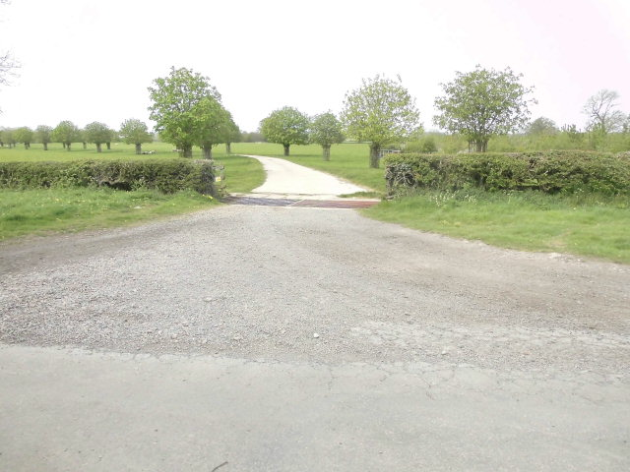
Although we hope that the application will not be approved, if it is approved we believe the following will be required to remedy the problems caused to the local roads:

- That the Lower Boddington Road would be properly surveyed, its structure analysed and its capacity examined and repaired and/or reconstructed where necessary to take the up-to-date predicted usage by all forms of traffic during and after construction for a period of five years.
- That the route of the construction traffic through the applicants’ farm be appraised as to its suitability as the permanent route of all transport and other traffic to and from the marina, thus making sure that conflicts with pedestrians and vehicles on the Lower Boddington Road are avoided and that Claydon is not on the exit route from the marina.
- If that is not agreed by the applicants, that safe routes then will be provided for pedestrians and cyclists. The applicant also will ensure that all marina residents and travellers will give priority, and give way, to pedestrians and cyclists on the Lower Boddington Road.
- That all routes into and through Claydon will be inspected for their suitability for the passage of whatever vehicles will be used to construct and supply and maintain the marina. Where unsuitable, the applicants will ensure that vehicle sizes will be modified to ensure no risk of damage, etc. to people or property will occur. Where this is not possible, or damage or injury occurs, relevant compensation will be payable firstly to the Parish Council or then as relevant. Where amendments to the roads within Claydon or a structure, property or service is unavoidably altered, compensation will be sought to carry out any necessary works, etc. The applicant will therefore carry public liability insurance as agreed with the local authority.

We would also like to highlight the following points:
- Para 2.7 quotes saved policy TR1 which requires the Council (CDC) to be satisfied that highway improvement works will be provided before the proposals are accepted.
- Para 2.8 quotes saved policy TR7 which states that development that would attract large commercial vehicles or large numbers of cars onto unsuitable minor roads will not normally be permitted. Although the applicant may argue that the number of vehicles may not be large, they cannot deny that there would be large commercial vehicles delivering to the site as they have stated in para 6.8 "There will be very little HGV traffic".
- Para 2.12 quotes policy TR4 requires mitigation measures such as highway improvements to be identified with an implementation programme before proposals are permitted.

The area of this application is roughly ¾ the size of the existing village. We believe this would be considerable overdevelopment and unsustainable development in this rural setting. Due to the height of the proposed development and associated planting/bunds the landscape would be greatly changed and will take away some of the pleasant views currently enjoyed by parishioners and visitors to the area.

Planning permission was not approved for an extension to the nearby Cropredy Marina due to there already being a considerable oversupply of moorings in the central Midlands so we do not believe there is a need/demand for further moorings in this area.

The parish council cannot see any benefit to the community, particularly as the application states that the public will not be allowed access to the marina. If the application is approved we believe that the following conditions should be included to provide some small benefit to the parishioners:

- That the applicants and any subsequent owners of the farm and marina in their entirety will agree to free public access to the marina by residents of Claydon. They will also confirm compliance to this free access in the future by the owners and any subsequent owners of the marina, its buildings, facilities, etc., and that any security requirements made for the marina residents, employees, etc. do not affect the rights of the people of Claydon when visiting the site.
- That the proposed footpath that is to connect with PROW 170/6/20 will be maintained in perpetuity for use by local walkers, etc. and by villagers from Claydon.
- Some funding should be provided to the parish to allow the creation of a village hall (potentially by conversion of an existing building within the parish) with suitable facilities for disabled access which the village currently lacks.

The proposal is detrimental to the setting, character and appearance of the canal conservation area. Claydon is currently a very rural village with no street lighting. There will of course be a need for lighting at the proposed marina which will create light pollution and will dramatically change the character of the area. Also, with the lack of street lighting in Claydon and there being only one footpath in the village, the additional traffic will increase the danger posed to parishioners walking in the village as in most places they have to walk on grass verges or on the road which is particularly dangerous at night time. Should the application be approved we ask that the following be included as a condition:

- That all lighting will be designed to ensure that the dark night sky of this area is not affected and that all lighting that is not required for safety will be extinguished by a time agreed with the local authority, appropriate to the relevant season.

