13 Bignolds Close
Claydon
Banbury
OX17 1ER
29th April 2019
Clare O’Hanlon
Planning Department
Cherwell District Council
Bodicote House
Banbury
Ox15 4AA
Dear Ms O’Hanlon
Re. Planning Application 18/00904/F
18/00904/F: Glebe Farm, Boddington Road, Claydon.
I object to this planning application because it is an unnecessary industrialisation of a rural setting.
On 5/10/2018 the committee refused application 18/00582/F for the following reasons:-
REASONS FOR REFUSAL
- The proposed dwelling constitutes residential development in the open countryside, beyond the built up limits of the nearest settlement, for which it has not been demonstrated that there is an essential need. In its proposed location the dwelling would therefore be an unjustified and unsustainable form of development. As such the proposal is considered to be contrary to saved Policy H18 of the Cherwell Local Plan 1996 and Government guidance contained within the National Planning Policy Framework.
- The proposed development would result in the unjustified creation of a new employment use in a geographically unsustainable location contrary to the Council's employment strategy contained in Policy SLE1 and ESD1 of the Cherwell Local Plan Part 1 and Government guidance contained within the National Planning Policy Framework. There are not considered to be any material considerations which would outweigh this conflict.

Because 18/00582/F was just the other side of the road from the site of this application then the same criteria must surely apply.

18/00904/F is for a much larger development which will generate more traffic in the area so would have a much larger effect.

Google Maps directs traffic going to the site, coming from the directions of Oxford, Stratford and Southam, through the village via the Mollington Road or Fenny Compton Road and then the Boddington Road. If the marina proposal is approved then all traffic to it, both during construction and subsequently must be routed via the farm and not through the village.
The access roads to the site are barely adequate to support the existing traffic and to add further traffic will overload them, creating safety issues for the people who live in the village and the adjoining areas.
The absence of street lighting in the village and the lack of pavements on the routes to the site pose an obvious danger to pedestrians, cyclists and others.
Mollington Road itself is a series of blind summits and bends and in several places not wide enough for two vehicles to pass without extreme caution or one getting off the road.
The following You Tube video shows some of these problems
https://youtu.be/DZX-QbUB9-I
The junction of Mollington Road with the main road (A423) is in a dip approached in both directions of the A423 over blind summits. This has caused numerous accidents because vehicles turning or waiting to turn into Mollington Road can only be seen by the traffic on the A423 a few seconds before they arrive at the accident. This photos shows the spot where the Claydon sign was before it was destroyed a few months ago. It has not yet been replaced.

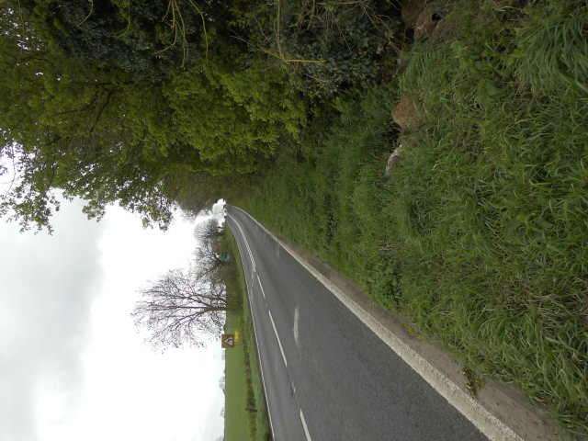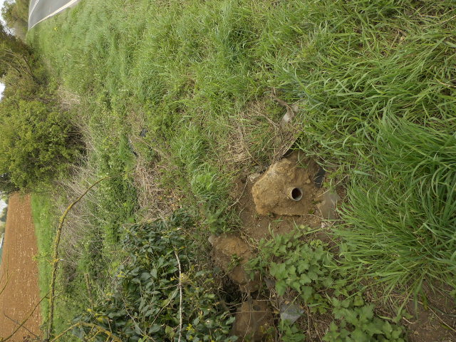
You sit with your heart in your mouth waiting to turn off the A423 onto the Mollington Road hoping that a string of cars or vans travelling at 50 or 60 mph will not be coming over the crest behind you before you are able to complete the manoeuvre. The Mollington Road is on a steep rise as it joins the A423. This means that vehicles are travelling slowly as they do so and hence create an obstruction.
The following You Tube videos show some of the activities associated with maintenance of narrow boats.
https://www.youtube.com/watch?v=VZB_tSR7bm4 Blacking
https://www.youtube.com/watch?v=7gUm6zdmiCY Engine room maintenance
As there are to be nearly 200 boats, assuming a 4 year cycle for ‘Blacking’ that means that nearly 50 boats a year will be having this activity performed on them. Assuming the boats will be used for cruising during the spring to autumn months, the logical time to do this will be during the winter months and it is reasonable to assume that this will need to be done under cover so a large barn will be needed for this. This together with the crane for lifting the boats from the water will ruin the rural nature of the site.
The plan has accommodation for a ‘Marina Master’. Will this be a 9 am to 5 pm Monday to Friday post or will there be somebody continuously on duty to safeguard the site? How many people will be required to provide this? A site with nearly 200 boats and/or cars is an obvious target for thieves which will be bring extra crime into the area. This may well spill over into the village. Because the car parking is behind the bund the cars will be hidden from the rest of the site.
The number of occupants of the boats will roughly equal the number of people living in the village so would in a matter of months double the population of the village putting a strain on local services. If the marina was granted planning permission, together with the number of people already living on the canal, it would create another village of about the same size. Ribbon development along the road linking the villages should not be allowed.
The mobile phone reception in the area is not good so the increased number of users would make this matter worse and the public phone box was removed from the village last year.
The pressure of the domestic water supply in the village already comes under strain at times will the system be able to cope with extra demands?
For all these reason this planning application should be rejected!
If any member of the Planning Committee is thinking of approving this plan I ask them to visit the site because artist’s impressions on paper do not always convey the real situation.
Yours sincerely
Robert Jones
Copied to:-
Cllr. Phil Chapman
Cllr. Douglas Webb
Cllr. George Reynolds

