Application 22/03385/DISC - Construction traffic management plan
AMENDED FOLLOWING COMMENTS RECEIVED FROM TRANSPORT PLANNING, 22 MARCH 2023 and 13 APRIL 2023.

This is the construction management plan for a single property to be constructed in the grounds of The Beeches, Heyford Rd, Steeple Aston. The property will remain in the ownership of the developer for the duration of the construction work, after which the developer will occupy the property. The following appendices are attached:

Appendix A – location map, Appendix B – aerial view, Appendix C – survey, Appendix D – images, Appendix E – site layout

Contact details:
- Primary contact: Vincent Stokes: 07860 824661. Close residents will be informed of deliveries/ traffic and records kept of issues and resolutions.
- Demolition site supervisor: Paul Cox, Cox’s Building Services: 07787 515050
- Site supervisor for groundworks: tbc (out for tender; council will be advised)
- Site supervisor for main build: Henry Northover, Oakwrights: 07494 117720

The site is currently a set of garages and workshop and contains reasonable working space including a separate free standing triple garage which will be retained and available to the builder for storage and welfare.

The site is accessed from an existing private driveway to The Beeches, which comes off Heyford Road with good visibility in both directions. An existing postcode will enable vehicles to navigate to the site and signs clearly indicating the site entrance will also be erected. The private driveway is laid with tarmac, with significant hard standing on the development site, including an existing driveway for the new single dwelling. Due to this and the build taking place in summer months, no mud or debris is expected to transfer from the site onto adjacent public highways and the private driveway will be swept daily. A jet-powered washer will be available in case required to clean vehicles’ wheels.

During the course of demolition, groundworks and the main build, the following vehicles will access the site:
- Demolition and groundworks: An 4-8 tonne rubber tracked excavator, delivered to site on a flat-bed low-loader will be used to demolish the garages/workshop and remove existing foundations and will remain on site until this work is complete. Unwanted material will be disposed of using an 8-wheeled tipper truck or roll on-roll off skip. An 8-wheeled cement mixer will be used for final stages of the foundations. These vehicles will reverse up the private driveway, guided by site crew provided by the builder.

- Build: The property is being constructed from oak frame and pre-fabricated timber wall units which will be put together on site. Due to the build method and materials used, the number of deliveries from large vehicles will therefore be relatively low (around six or seven) and focused around the first few weeks of construction. There is turning space for large articulated trailers which is currently used to move railway engines and carriages for The Beeches Light Railway. However, rear-steered articulated lorries used for the frame and wall/roof encapsulation will reverse onto site from the existing driveway. Deliveries for this part of the construction will arrive between 0900-1000 and site crew supplied by the builder will safely bank such vehicles onto site and vehicles will not reverse into Heyford Road.

A 40-tonne mobile crane will be used to construct the frame and external fabric of the house. The crane will arrive on site at 0900 and remain on site overnight during consecutive days it is used. This means that over a seven-week period, the crane will arrive and depart seven times, guided by the builder’s site crew.

Vehicles will access the site from the B4030 and then Heyford Road, avoiding Steeple Aston and a local school. The site (‘The Beeches’ on map below) is situated 0.7 miles from the school (Dr Radcliffe’s C of E Primary School), at the opposite end of the village and primary populated area.

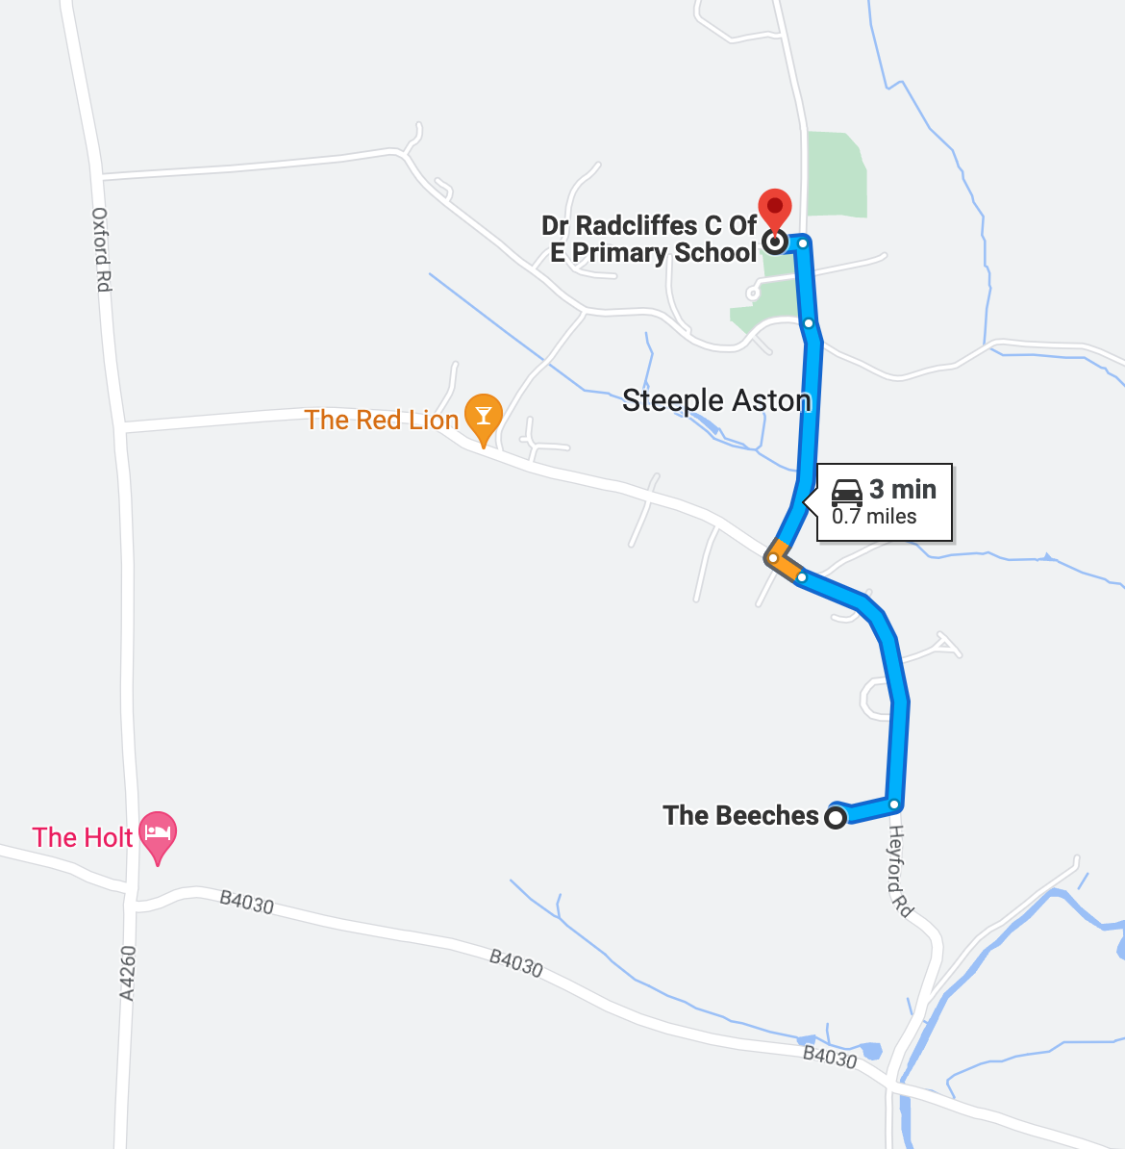

With due consideration having been given to the distance from the school and primary populated areas, deliveries of materials, plant and equipment to the site are planned to take place during the following hours:
- Monday – Friday: 0900-1500, 1530-1630
- Saturday, Sunday or public holidays: no deliveries or construction traffic.

There is a suitable lay-by south of the site entrance on Heyford Road noted on location map Appendix A. The pedestrian pathway on Heyford Road is on the opposite side of the road and raised about 1.5m above the road level, safely away from the road.

Proposed site layout is shown in Appendix E. This includes parking for three contractor vehicles. The existing hard standing plus the triple garage that is being retained provide adequate space for the storage of materials. After the building has been made wind and watertight, all other construction traffic will be of modest size, with the site adequately able to accommodate vehicles safely turning into and out of the driveway as normal, and with adequate space remaining around the site for storing materials.
