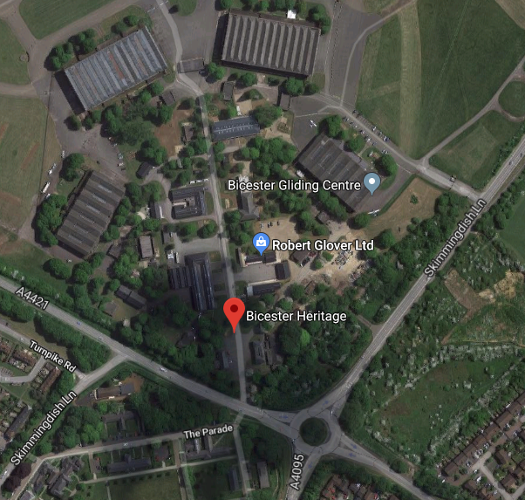
Red – To remove 2 x Dead trees.

