**EXISTING GATE**

**NEW BARN**

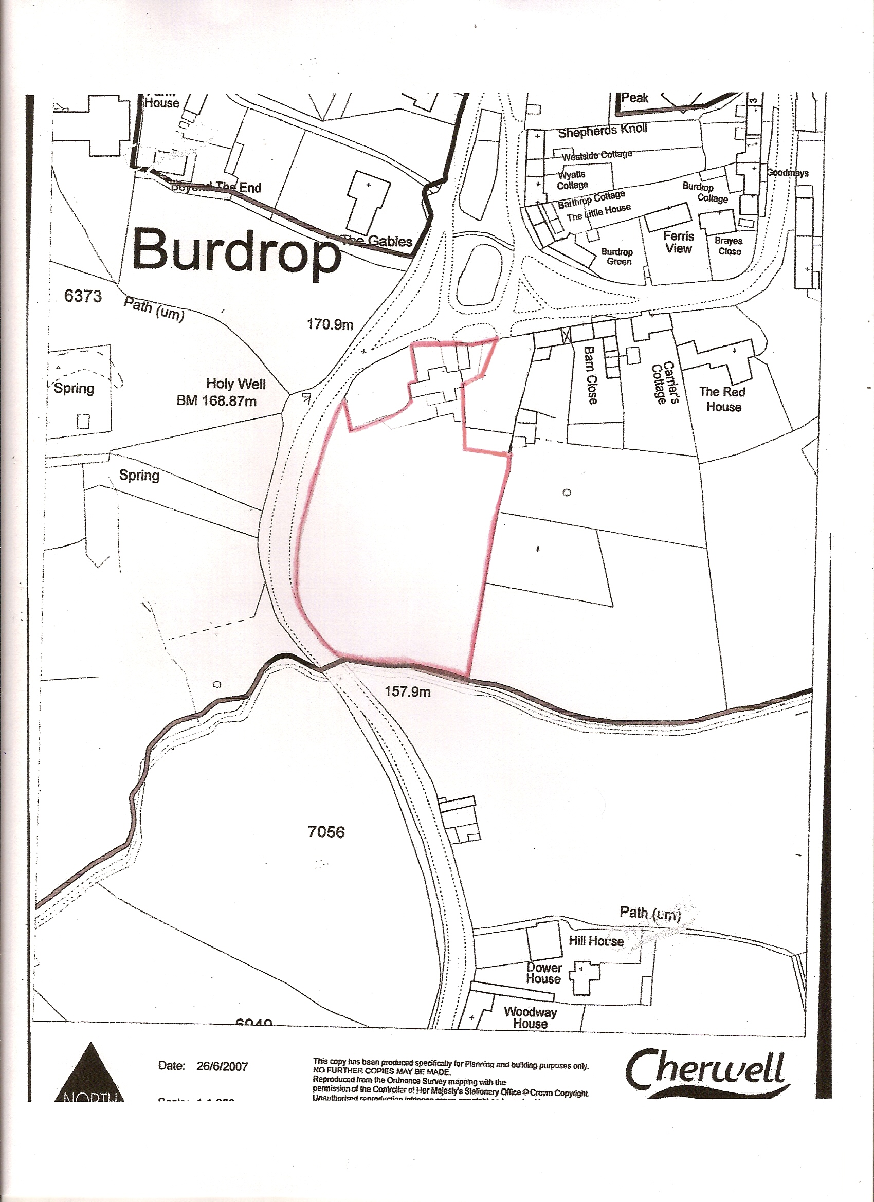

BLAZE-INN SADDLES

SIBFORD GOWER

OXFORDSHIRE

OX15 5RQ

SCALE : 1:1250

A4 PAPER

N

BISHOPS END