**From:** Chris Dunn   
**Sent:** 30 April 2019 22:29  
**To:** DC Support; Clare O'Hanlon  
**Cc:** Councillor George Reynolds; Councillor Douglas Webb  
**Subject:** My opposition for planning consent - 18/00904/F: Glebe Farm, Boddington Road, Claydon.  
**Importance:** High

Dear Clare,

I hope this email find you well.

**I strongly oppose the planning application of a new marina**

18/00904/F: Glebe Farm, Boddington Road, Claydon.

I moved to Claydon with my partner and then 9 month old daughter 5 years ago for the peace and serenity that Claydon offers. Previously, I lived and worked in London for 18 years and after the birth of our daughter and my partners deteriorating health, we embarked on a wide search of all the villages in the area.  We chose the rural village Claydon to resettle our family for the precise reason that it was small, quiet but also had a sense of community, and crucially didn’t have much traffic, as with no pub or shop, the main traffic to and from the village would be from residents.

After living in South London, this was an absolute must for me, in order to give my daughter and partner (who has congenital heart disease) the best possible environment for my family to live a stress free life and flourish. 5 years on we are super happy with our choice, integrated nicely, invested significantly in our home: turning our then bungalow into a house, and our daughter has settled into school and local clubs.

I hope you can see my huge concern and disappointment with regard to the proposed marina that will decimate Claydon’s idyllic environment with absolutely no real tangible benefit for the residents of Claydon.

Not only do **we already have two large marinas serving the canal in the local area** (Cropredy and Fenny Compton), the proposed location is absolutely crazy and ill thought out. This is a conservation area and it’s right at the beginning of the Claydon 5 lock flight; a notoriously already busy part of the canal.  The proposed footprint of the marina is to be ~75% of the size of the entire existing Claydon village, with access from roads that are just not suitable for a scheme of this scale and size. I’m immensely worried how this will affect my family and my neighbours wellbeing, impact their daily lives and put huge scar on the idyllic, rural landscape we have.

**In short it’s inconceivable how a scheme of this size, with little to no benefit to our village, its residents, nor the immediate environment and its wildlife, with an obviously huge detriment to the local setting, character and appearance will be allowed and I will be strongly objecting!**

I’ve highlighted my concerns in more detail below.

1. 192 births will certainly **increase the road traffic through Claydon significantly to dangerous levels**, creating unnecessary risk to:
   1. My partner or I walk our daughter to the bus stop twice a day (and other parents for that matter), there are no footpaths in the village.
   2. Horse riders of the village and discourage them from riding, changing the environment. We love the fact the village is quiet enough to have regular horse traffic!
   3. Cyclists; the village attracts many Cyclists and numerous events which pass through Claydon often, with drinking station at our Church Hall.
   4. All Claydon residents, be it be parents, dog walkers, cyclists or motorists – it’s clear this will be at our detriment and added risk.

1. Has anyone from the decision making executive recently **driven down and inspected Boddington Road?** I’m truly perplexed here as any reasonable person would:
   1. Immediately see the state of repair is truly awful. My partner has had no less than 2 immediate tyre deflations from the potholes on this stretch of road in the last 2 years.
   2. Not only is it pothole ridden (another issue entirely) is it very narrow (wide enough for 1 car only and in places only ~2m wide) with a number of 90 degree **blind bends** from the village to the proposed site, any increase in traffic here is most certainly going cause greater risk to residents who Walk, Drive, Cycle and Ride Horses down this stretch of road.
   3. The hump-back bridge is super steep and has a blind crest, again adding a unnecessary level of risk to residents who use the stretch of road for their daily lives. My partner for example uses it at least four times a week for my daughters after school clubs and often we do a circular walk around the village and down the tow path of the canal.
   4. Furthermore, for Mollington Road any more traffic will pose increased risk of an accident, which is already hazardous with the notorious blind dip bend and under the railway bridge both of which is only wide enough for 1 car.

1. **Increase pressure on local services** which are already struggling:
   1. I know for a fact the Cropredy marina, although not meant to be residential, is being used that way. Cropredy marina residents have children at my daughters school and use the services of Cropredy doctors surgery. This non-residential element is clearly not being enforced, so this proposed marina will almost certainly add yet more pressure on the local services.
   2. The hospital is already earmarked for closure and trying to get an **ambulances or** **fire engines** over that really steep hump back bridge will be hugely problematic.

1. **Environment, water, noise and light pollution** 
   1. There is no denying the scar this scheme will leave on the immediate environment (see pictures below).
   2. Being an avid walker of the canal tow path, I’ve got to meet the Canal and Riverside trust representative on numerous occasions over the last few years, actually locking the Claydon’s 5 locks early and restricting use to only between 10am - 3pm in summer months, due to lack of water. Essentially preventing boat traffic to prevent further loss of water (each time the lock is used, water is lost).  If this is currently a problem, what chance do we have with 192 births?  The marina will both be taking water in the first place and then massively increasing boat traffic on the Claydon flight of 5 locks. I see no provision for this issue within their application and that alone is of great concern.
   3. We do, from time-to-time receive noise at excess levels from moored boaters, where sound travels across the fields into the village. I recount one evening last year, during which we actually though it was youths vandalising the kids playground again, but on closer investigation by some villagers it turned out it was a holiday boater moored up for the evening. Their music wasn’t particularly loud at source but it travelled and we could hear the lyrics word for word in bed. Now with 192 birth marina, this takes this risk to another level and not the odd holiday maker, thus increasing the potential of noise issues and further detriment to our lifestyle and wellbeing.
   4. Our village is currently a dark village with no street lighting whatsoever, so night light pollution is another reason why we moved to Claydon for this idyllic, tranquil, picturesque village. I understand there is significant lighting planned for the marina, again at the detriment to the village and local wildlife alike.
   5. Finally, with the significant increase of boats in the area, I have no doubt the flora and fauna will suffer and I see no provisions being set out to protect this.

Your sincerely,

Chris Dunn

16 Bgnolds Close  
Claydon  
OX17 1ER

Below is a *plan view of the proposed marina, superimposed on a Google Maps satellite view of Claydon,*

*showing the size and position of the development. As you can see this is not a small thing for our village to just accept.*

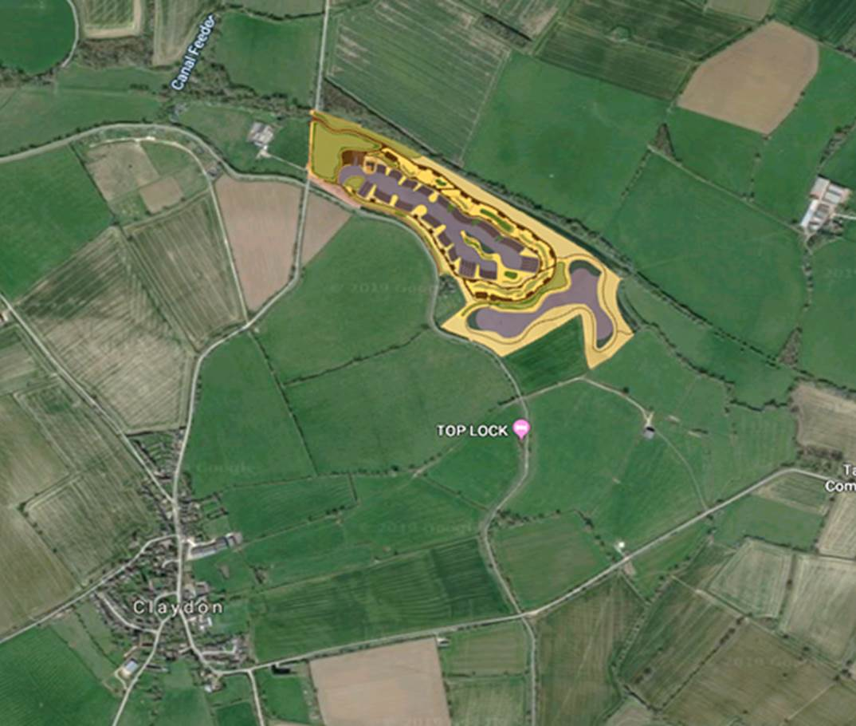

*Below is a Google Map image of North Kilworth Marina, owned by the developer behind the proposed Claydon Marina.*

*This one is 220 rather than 192 berths but you can get an good picture of the scale.* ***The important thing to note is the***

***A4303 yes an A Road is the access for this marina and existing industrial use of the immediate areas around the development.***

*Further highlighting my issue with how inconceivable the Claydon scheme is with our tiny roads, rural setting, character*

*and appearance.*

