**From:** Adam Peck [<mailto:Adam.Peck@thameswater.co.uk>]   
**Sent:** 18 September 2018 15:42  
**To:** Maria Philpott  
**Subject:** RE: Comments made in relation to 18/01333/F

HI Maria,

Let me know if the attached is okay.

Regards,

Adam Peck

Developer Services – Development Planner

Landline 020 3577 8360   Extension 88360

[Adam.Peck@thameswater.co.uk](mailto:Adam.Peck@thameswater.co.uk)

Maple Lodge STW, Denham Way, Rickmansworth, WD3 9SQ

Find us online at [developers.thameswater.co.uk](https://developers.thameswater.co.uk/)

         [cid:image003.png@01D3FE6D.13AA61E0](http://www.thameswater.co.uk/preplanning)

**From:** Maria Philpott [<mailto:Maria.Philpott@cherwellandsouthnorthants.gov.uk>]   
**Sent:** 18 September 2018 15:05  
**To:** Adam Peck  
**Subject:** RE: Comments made in relation to 18/01333/F

Apologies for missing your call.  The whole of the red section (condition) didn’t read right.  If you could email me your revised condition for me to look at then I can check it is now OK.

Maria

**Maria Philpott** BA (Hons.), Dip UP, Dip Hist. Cons MRTPI

**Principal Planning Officer, Development Management**

**Place and Growth Directorate**

**Cherwell & South Northamptonshire Councils**

Tel: 01327 322261

Email [maria.philpott@cherwellandsouthnorthants.gov.uk](mailto:maria.philpott@cherwellandsouthnorthants.gov.uk)

[www.cherwell.gov.uk](http://www.cherwell.gov.uk/) or [www.southnorthants.gov.uk](http://www.southnorthants.gov.uk/)

*\*Please note that I only work on Tuesdays, Wednesdays and Thursdays*

Find us on Facebook [www.facebook.com/cherwelldistrictcouncil](http://www.facebook.com/cherwelldistrictcouncil)  or [www.facebook.com/southnorthantscouncil](http://www.facebook.com/southnorthantscouncil)

Follow us on Twitter @CherwellCouncil or @SouthNorthantsCouncil

**From:** Adam Peck [<mailto:Adam.Peck@thameswater.co.uk>]   
**Sent:** 18 September 2018 14:08  
**To:** Maria Philpott  
**Subject:** RE: Comments made in relation to 18/01333/F

Hi Maria,

I just tried to ring. I have changed the wording slightly so it no longer refers to housing where it previously did, within the area you have highlighted which part in particular is an issue?

Regards,

Adam Peck

Developer Services – Development Planner

Landline 020 3577 8360   Extension 88360

[Adam.Peck@thameswater.co.uk](mailto:Adam.Peck@thameswater.co.uk)

Maple Lodge STW, Denham Way, Rickmansworth, WD3 9SQ

Find us online at [developers.thameswater.co.uk](https://developers.thameswater.co.uk/)

         [cid:image003.png@01D3FE6D.13AA61E0](http://www.thameswater.co.uk/preplanning)

**From:** Maria Philpott [<mailto:Maria.Philpott@cherwellandsouthnorthants.gov.uk>]   
**Sent:** 18 September 2018 12:43  
**To:** Adam Peck  
**Cc:** Planning  
**Subject:** RE: Comments made in relation to 18/01333/F

Adam,

Please can you advise what you have changed, as the attached still refers to a condition that is inappropriate to this development the same as your earlier comments?

The development is not for housing – but commercial development and therefore your suggested condition does not relate to the proposal – I’ve highlighted this in the attached in red.

Please can you advise of a more suitably worded condition?

Thanks,

Maria

**Maria Philpott** BA (Hons.), Dip UP, Dip Hist. Cons MRTPI

**Principal Planning Officer, Development Management**

**Place and Growth Directorate**

**Cherwell & South Northamptonshire Councils**

Tel: 01327 322261

Email [maria.philpott@cherwellandsouthnorthants.gov.uk](mailto:maria.philpott@cherwellandsouthnorthants.gov.uk)

[www.cherwell.gov.uk](http://www.cherwell.gov.uk/) or [www.southnorthants.gov.uk](http://www.southnorthants.gov.uk/)

*\*Please note that I only work on Tuesdays, Wednesdays and Thursdays*

Find us on Facebook [www.facebook.com/cherwelldistrictcouncil](http://www.facebook.com/cherwelldistrictcouncil)  or [www.facebook.com/southnorthantscouncil](http://www.facebook.com/southnorthantscouncil)

Follow us on Twitter @CherwellCouncil or @SouthNorthantsCouncil

**From:** Adam Peck [<mailto:Adam.Peck@thameswater.co.uk>]   
**Sent:** 18 September 2018 12:14  
**To:** Maria Philpott  
**Cc:** Planning  
**Subject:** RE: Comments made in relation to 18/01333/F

Dear Maria,

Apologies for the error made I have attached an updated copy.

Regards,

Adam Peck

Developer Services – Development Planner

Landline 020 3577 8360   Extension 88360

[Adam.Peck@thameswater.co.uk](mailto:Adam.Peck@thameswater.co.uk)

Maple Lodge STW, Denham Way, Rickmansworth, WD3 9SQ

Find us online at [developers.thameswater.co.uk](https://developers.thameswater.co.uk/)

         [cid:image003.png@01D3FE6D.13AA61E0](http://www.thameswater.co.uk/preplanning)

**From:** Maria Philpott [<mailto:Maria.Philpott@cherwellandsouthnorthants.gov.uk>]   
**Sent:** 12 September 2018 12:05  
**To:** Adam Peck  
**Subject:** Comments made in relation to 18/01333/F

Adam,

I’ve received your comments in relation to the above planning application.

I note you say there is no ability in the foul sewage system at present and you recommend a condition.  However the condition that you have recommended relates to housing developments but the proposed development is commercial.

Could you take another look at your comments please and advise if there are more appropriate conditions that need to be imposed that are more site specific and relevant to this proposal as a commercial development?

I’d be grateful if you could respond to me please by next Tuesday 18th September.

Many thanks,

Maria

**Maria Philpott** BA (Hons.), Dip UP, Dip Hist. Cons MRTPI

**Principal Planning Officer, Development Management**

**Place and Growth Directorate**

**Cherwell & South Northamptonshire Councils**

Tel: 01327 322261

Email [maria.philpott@cherwellandsouthnorthants.gov.uk](mailto:maria.philpott@cherwellandsouthnorthants.gov.uk)

[www.cherwell.gov.uk](http://www.cherwell.gov.uk/) or [www.southnorthants.gov.uk](http://www.southnorthants.gov.uk/)

*\*Please note that I only work on Tuesdays, Wednesdays and Thursdays*

Find us on Facebook [www.facebook.com/cherwelldistrictcouncil](http://www.facebook.com/cherwelldistrictcouncil)  or [www.facebook.com/southnorthantscouncil](http://www.facebook.com/southnorthantscouncil)

Follow us on Twitter @CherwellCouncil or @SouthNorthantsCouncil

This e-mail (including any attachments) may be confidential and may contain legally privileged information. You should not disclose its contents to any other person. If you are not the intended recipient, please notify the sender immediately.

Whilst the Council has taken every reasonable precaution to minimise the risk of computer software viruses, it cannot accept liability for any damage which you may sustain as a result of such viruses. You should carry out your own virus checks before opening the e-mail(and/or any attachments).

Unless expressly stated otherwise, the contents of this e-mail represent only the views of the sender and does not impose any legal obligation upon the Council or commit the Council to any course of action.

______________________________________________________________________  
This email has been scanned by the Symantec Email Security.cloud service.  
For more information please visit <http://www.symanteccloud.com>  
______________________________________________________________________

Visit us online [www.thameswater.co.uk](http://www.thameswater.co.uk) , follow us on twitter [www.twitter.com/thameswater](http://www.twitter.com/thameswater) or find us on [www.facebook.com/thameswater](http://www.facebook.com/thameswater). We’re happy to help you 24/7.  
  
Thames Water Limited (company number 2366623) and Thames Water Utilities Limited (company number 2366661) are companies registered in England and Wales, both are registered at Clearwater Court, Vastern Road, Reading, Berkshire RG1 8DB. This email is confidential and is intended only for the use of the person it was sent to. Any views or opinions in this email are those of the author and don’t necessarily represent those of Thames Water Limited or its subsidiaries. If you aren’t the intended recipient of this email, please don’t copy, use, forward or disclose its contents to any other person – please destroy and delete the message and any attachments from your system.

This e-mail (including any attachments) may be confidential and may contain legally privileged information. You should not disclose its contents to any other person. If you are not the intended recipient, please notify the sender immediately.

Whilst the Council has taken every reasonable precaution to minimise the risk of computer software viruses, it cannot accept liability for any damage which you may sustain as a result of such viruses. You should carry out your own virus checks before opening the e-mail(and/or any attachments).

Unless expressly stated otherwise, the contents of this e-mail represent only the views of the sender and does not impose any legal obligation upon the Council or commit the Council to any course of action.

______________________________________________________________________  
This email has been scanned by the Symantec Email Security.cloud service.  
For more information please visit <http://www.symanteccloud.com>  
______________________________________________________________________

Visit us online [www.thameswater.co.uk](http://www.thameswater.co.uk) , follow us on twitter [www.twitter.com/thameswater](http://www.twitter.com/thameswater) or find us on [www.facebook.com/thameswater](http://www.facebook.com/thameswater). We’re happy to help you 24/7.  
  
Thames Water Limited (company number 2366623) and Thames Water Utilities Limited (company number 2366661) are companies registered in England and Wales, both are registered at Clearwater Court, Vastern Road, Reading, Berkshire RG1 8DB. This email is confidential and is intended only for the use of the person it was sent to. Any views or opinions in this email are those of the author and don’t necessarily represent those of Thames Water Limited or its subsidiaries. If you aren’t the intended recipient of this email, please don’t copy, use, forward or disclose its contents to any other person – please destroy and delete the message and any attachments from your system.

This e-mail (including any attachments) may be confidential and may contain legally privileged information. You should not disclose its contents to any other person. If you are not the intended recipient, please notify the sender immediately.

Whilst the Council has taken every reasonable precaution to minimise the risk of computer software viruses, it cannot accept liability for any damage which you may sustain as a result of such viruses. You should carry out your own virus checks before opening the e-mail(and/or any attachments).

Unless expressly stated otherwise, the contents of this e-mail represent only the views of the sender and does not impose any legal obligation upon the Council or commit the Council to any course of action.

______________________________________________________________________  
This email has been scanned by the Symantec Email Security.cloud service.  
For more information please visit <http://www.symanteccloud.com>  
______________________________________________________________________

Visit us online [www.thameswater.co.uk](http://www.thameswater.co.uk) , follow us on twitter [www.twitter.com/thameswater](http://www.twitter.com/thameswater) or find us on [www.facebook.com/thameswater](http://www.facebook.com/thameswater). We’re happy to help you 24/7.  
  
Thames Water Limited (company number 2366623) and Thames Water Utilities Limited (company number 2366661) are companies registered in England and Wales, both are registered at Clearwater Court, Vastern Road, Reading, Berkshire RG1 8DB. This email is confidential and is intended only for the use of the person it was sent to. Any views or opinions in this email are those of the author and don’t necessarily represent those of Thames Water Limited or its subsidiaries. If you aren’t the intended recipient of this email, please don’t copy, use, forward or disclose its contents to any other person – please destroy and delete the message and any attachments from your system.

This e-mail (including any attachments) may be confidential and may contain legally privileged information. You should not disclose its contents to any other person. If you are not the intended recipient, please notify the sender immediately.

Whilst the Council has taken every reasonable precaution to minimise the risk of computer software viruses, it cannot accept liability for any damage which you may sustain as a result of such viruses. You should carry out your own virus checks before opening the e-mail(and/or any attachments).

Unless expressly stated otherwise, the contents of this e-mail represent only the views of the sender and does not impose any legal obligation upon the Council or commit the Council to any course of action.

______________________________________________________________________  
This email has been scanned by the Symantec Email Security.cloud service.  
For more information please visit <http://www.symanteccloud.com>  
______________________________________________________________________

Visit us online [www.thameswater.co.uk](http://www.thameswater.co.uk) , follow us on twitter [www.twitter.com/thameswater](http://www.twitter.com/thameswater) or find us on [www.facebook.com/thameswater](http://www.facebook.com/thameswater). We’re happy to help you 24/7.  
  
Thames Water Limited (company number 2366623) and Thames Water Utilities Limited (company number 2366661) are companies registered in England and Wales, both are registered at Clearwater Court, Vastern Road, Reading, Berkshire RG1 8DB. This email is confidential and is intended only for the use of the person it was sent to. Any views or opinions in this email are those of the author and don’t necessarily represent those of Thames Water Limited or its subsidiaries. If you aren’t the intended recipient of this email, please don’t copy, use, forward or disclose its contents to any other person – please destroy and delete the message and any attachments from your system.

This e-mail (including any attachments) may be confidential and may contain legally privileged information. You should not disclose its contents to any other person. If you are not the intended recipient, please notify the sender immediately.

Whilst the Council has taken every reasonable precaution to minimise the risk of computer software viruses, it cannot accept liability for any damage which you may sustain as a result of such viruses. You should carry out your own virus checks before opening the e-mail(and/or any attachments).

Unless expressly stated otherwise, the contents of this e-mail represent only the views of the sender and does not impose any legal obligation upon the Council or commit the Council to any course of action.

Cherwell District Council Planning & Development Services Bodicote House Bodicote, Banbury Oxon OX15 4AA 31 August 2018 Our DTS Ref: 58812 Your Ref: 18/01333/F

Dear Sir/Madam

Re: BICESTER HERITAGE, BUCKINGHAM ROAD, BICESTER, OXFORDSHIRE, OX26

Waste Comments

Following initial investigations, Thames Water has identified an inability of the existing foul water network infrastructure to accommodate the needs of this development proposal. Thames Water have contacted the developer in an attempt to agree a position for foul water networks but have been unable to do so in the time available and as such Thames Water request that the following condition be added to any planning permission. No business units shall first be bought into use until confirmation has been provided that either:- all wastewater network upgrades required to accommodate the additional flows from the development have been completed; or- an infrastructure phasing plan has been agreed with Thames Water to allow additional business units to first be bought into use. Where an infrastructure phasing plan is agreed no use of the business units shall take place other than in accordance with the agreed infrastructure phasing plan. Reason - The development may lead to sewage flooding and network reinforcement works are anticipated to be necessary to ensure that sufficient capacity is made available to accommodate additional flows anticipated from the new development. Any necessary reinforcement works will be necessary in order to avoid sewer flooding and/or potential pollution incidents.” The developer can request information to support the discharge of this condition by visiting the Thames Water website at thameswater.co.uk/preplanning. Should the Local Planning Authority consider the above recommendation inappropriate or are unable to include it in the decision notice, it is important that the Local Planning Authority liaises with Thames Water Development Planning Department (telephone 0203 577 9998) prior to the planning application approval.

The application indicates that surface waters will NOT be discharged to the public network and as such Thames Water has no objection, however approval should be sought from the Lead Local Flood Authority. Should the applicant subsequently seek a connection to discharge surface water into the public network in the future then we would consider this to be a material change to the proposal, which would require an amendment to the application at which point we would need to review our positon.

Water Comments

On the basis of information provided, Thames Water would advise that with regard to water network infrastructure capacity, we would not have any objection to the above planning application. Thames Water recommend the following informative be attached to this planning permission. Thames Water will aim to provide customers with a minimum pressure of 10m head (approx 1 bar) and a flow rate of 9 litres/minute at the point where it leaves Thames Waters pipes. The developer should take account of this minimum pressure in the design of the proposed development.

Supplementary Comments

There are easements and wayleaves to the north of the Site shown by yellow dashed lines. These are Thames Water Assets. The company will seek assurances that it will not be affected by the proposed development.

The applicant should contact Thames Water to discuss their proposed development in more detail. All enquiries from developers in relation to proposed developments should be made to Thames Waters Developer Services team. Their contact details are as follows:

Thames Water Developer Services

Reading Mail Room

Rose Kiln Court

Rose Kiln Lane

Reading

RG2 0BY

Tel: 0800 009 3921

Email: [developer.services@thameswater.co.uk](mailto:developer.services@thameswater.co.uk)

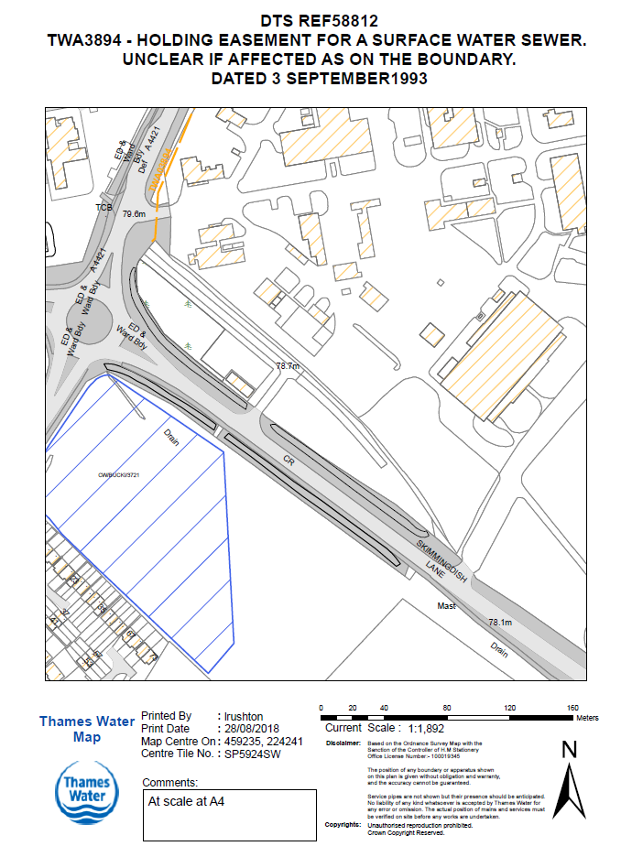

Wastewater: Thames Water requests that the programme of the development and proposed pump rates be provided to enable us to plan any future network reinforcement that may be required.

Yours faithfully

Development Planning Department

Development Planning, Thames Water, Maple Lodge STW, Denham Way, Rickmansworth, WD3 9SQ Tel: 020 3577 9998 Email: devcon.team@thameswater.co.uk