Richard Court Designs Ltd

7 PHILCOTE STREET

DEDDINGTON

OX15 0TB

Planning Services
Cherwell DC
Bodicote House
Bodicote
OX15 4AA

Date: 13th November 2018

Site location: Wendelbury Lodge, Church Lane, Wendlebury

Design & Access Statement:

Listed building consent is being sought for the sub-division of existing second floor bedroom to provide two smaller children’s rooms.

The proposed works are all internal and do not affect the external appearance. The proposed partitions have been located as not to interfere with any existing structure, including the existing A frame. The partitions would be lightweight timber stud, with acoustic insulation between studs and plasterboard lining either side. The two smaller rooms are sought to meet the current owner’s family needs, but could be readily removed in the future with very little remedial work if required.

The proposed work would not cause damage to the building and does not harm a current Listed Heritage Asset.

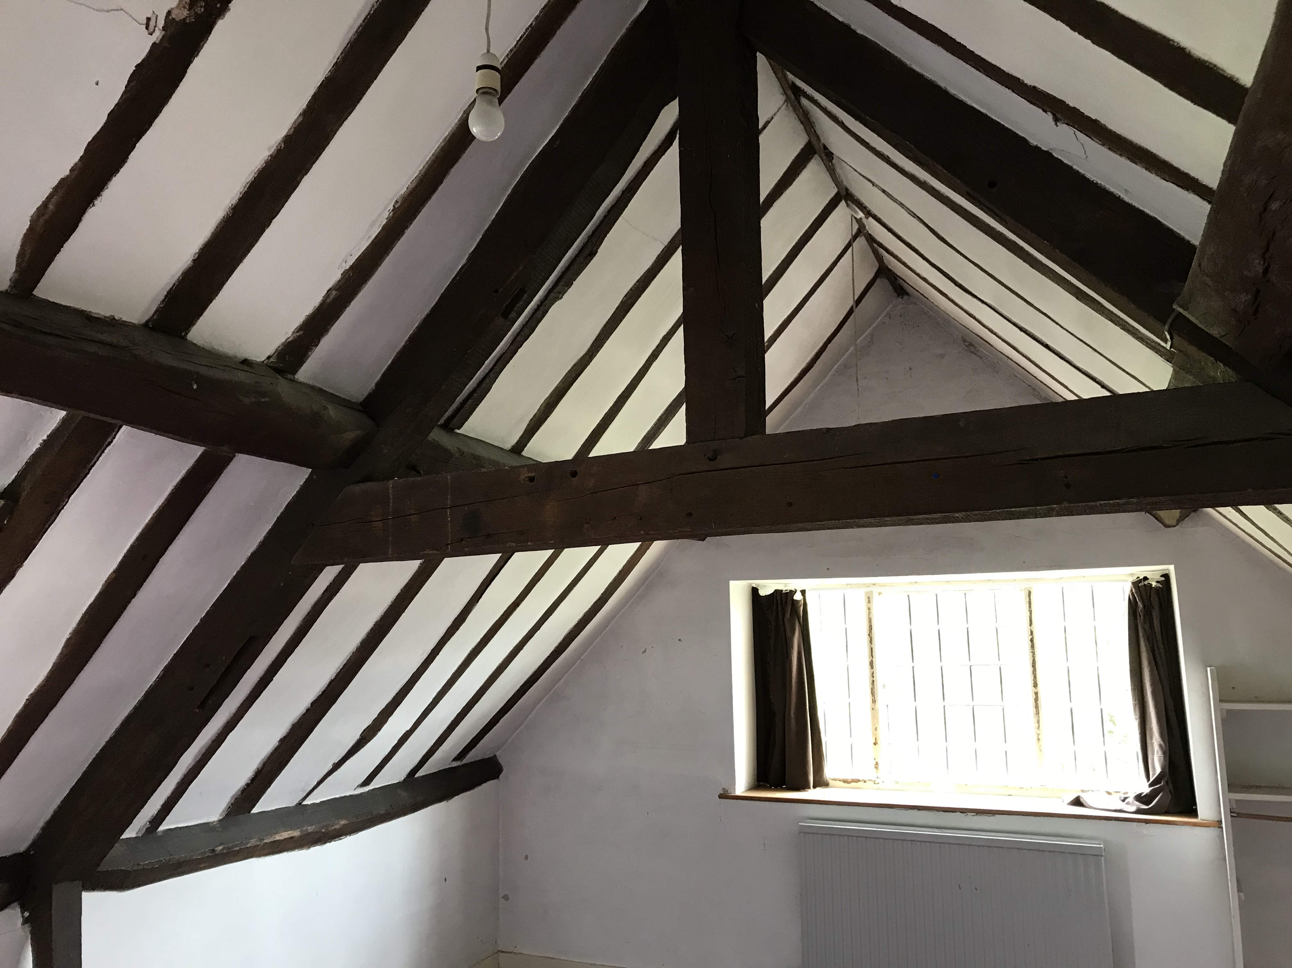

Internal view of Bedroom and existing A Frame

Richard Court RI Dipl
Tel: 07795313850
E-mail: richardcourtdesigns@gmail.com
Registered Co No. 05280600

