**From:** Randall, Tracey - Communities [<mailto:Tracey.Randall@Oxfordshire.gov.uk>] **On Behalf Of** Planning Consultations - E&E  
**Sent:** 04 February 2019 13:02  
**To:** James Kirkham; Planning Consultations - E&E  
**Subject:** RE: Oxfordshire County Council’s response to 18/02147/OUT Stone Pits Hempton Road Deddington

Hi James

Thank you for your email.

Archaeology were consulted on this application however did not have any comments to make.

I will forward your queries on to the relevant officers and ask them to respond directly.

Regards

**Tracey**

Tracey Randall

Major Planning Applications Officer

Planning Process Team

County Hall

New Road

Oxford.

OX1 1ND

[www.oxfordshire.gov.uk](http://www.oxfordshire.gov.uk/)

We value your comments. Please click here to leave feedback

Save money and paper - do you really need to print this email

**From:** James Kirkham [<mailto:James.Kirkham@cherwellandsouthnorthants.gov.uk>]   
**Sent:** 04 February 2019 12:36  
**To:** Planning Consultations - E&E <[PlanningConsultations@Oxfordshire.gov.uk](mailto:PlanningConsultations@Oxfordshire.gov.uk)>  
**Subject:** RE: Oxfordshire County Council’s response to 18/02147/OUT Stone Pits Hempton Road Deddington

HI

Thank you for your comments on this application.   Please see my queries below:

Did the County Archaeologist have any comments on the application?

Also the parish council had requested contribution towards local libraries but I note not comments in this respect are provided by the County?

I also have queries for the highway engineer and education officer.

Highways

I have been on site and the proposed footpath connection (shown on drawing number 20172-01 Rev B) does not appear to extend as far as the existing footpath.  I assume that you would want it to connect up to this?  Furthermore the redline does not include the area of the proposed footpath.   Are you satisfied that the footpath can be accommodated on land in the redline and the highway limits?

Do you also require the requested traffic calming measures to be shown on the plans as ‘access’ is not a reserved matter?

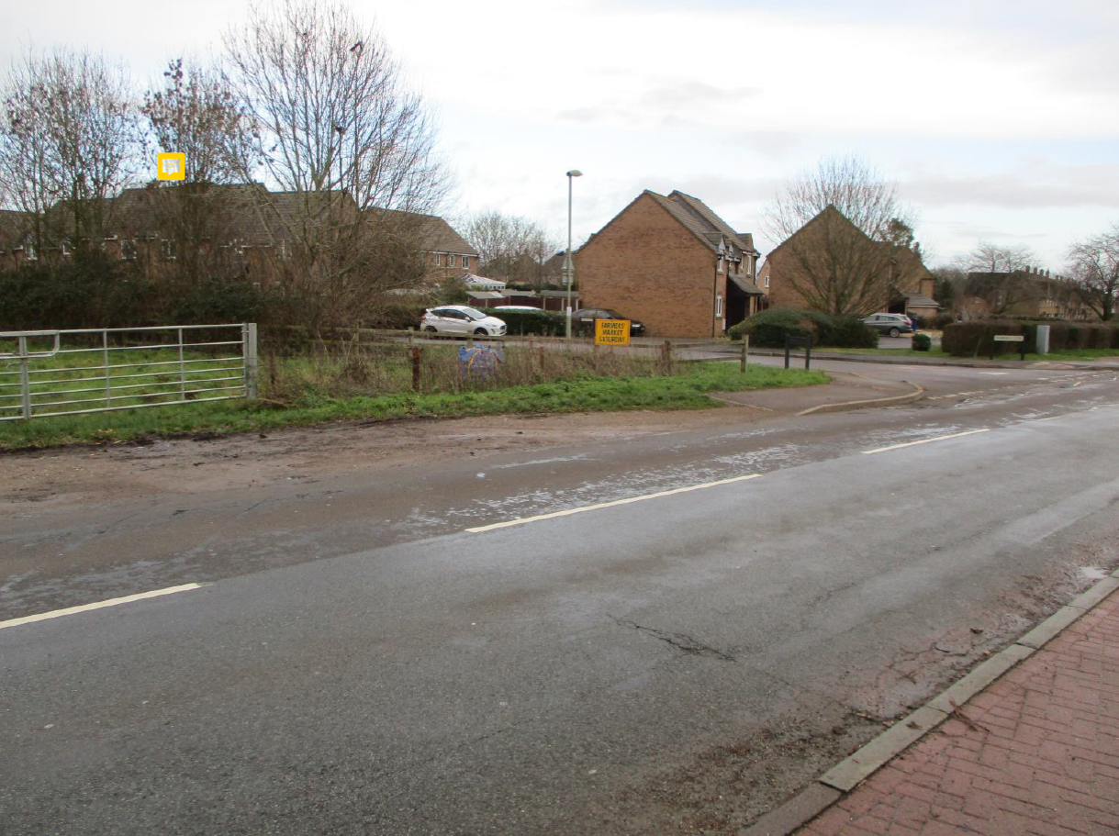

In relation to drainage the issue of contamination is raised – Is this something you require more details of at the outline stage or are you happy for it to be dealt with by the proposed condition?

Education

I note that a request has been made for a contribution towards the expansion of Christopher Rawlins CE Primary School.   Am I correct in understanding that this extension has already happened and is operation?  Do you have examples where you have sought and secured contributions retrospectively?   I also assume no secondary contributions are being sought?

Thanks

Kind regards

**James Kirkham BA (Hons) MSc MRTPI**

**Principal Planning Officer – General Developments Planning Team**

Development Management

Place and Growth Directorate

Cherwell District Council and South Northants District Council

Direct Line: 01295 221896

[**www.cherwell.gov.uk**](http://www.cherwell.gov.uk/) or [**www.southnorthants.gov.uk**](http://www.southnorthants.gov.uk/)

**Follow Us:**

Facebook [www.facebook.com/cherwelldistrictcouncil](http://www.facebook.com/cherwelldistrictcouncil)

or [www.facebook.com/southnorthantscouncil](http://www.facebook.com/southnorthantscouncil)

Twitter @cherwellcouncil or @southnorthantscouncil

**From:** Planning Consultations - E&E [<mailto:PlanningConsultations@Oxfordshire.gov.uk>]   
**Sent:** 21 January 2019 09:44  
**To:** Planning; James Kirkham; Cllr Arash Ali Fatemian  
**Cc:** Planning Consultations - E&E; DavidFlavin  
**Subject:** Oxfordshire County Council’s response to 18/02147/OUT Stone Pits Hempton Road Deddington   
**Importance:** High

Dear James

Please find attached Oxfordshire County Council’s response to 18/02147/OUT Stone Pits Hempton Road Deddington

If you have any further queries please send an email to [planningconsultations@oxfordshire.gov.uk](planningconsultations@oxfordshire.gov.uk%20)

and a member of Major Planning Applications Team will get back to you as soon as possible.

Thank you.

**Regards**

**Dan**

**Daniel Tritton** – Major Planning Applications Officer

**Oxfordshire County Council** – Environment & Economy

County Hall, New Road, Oxford, OX1 1ND



This email, including attachments, may contain confidential information. If you have received it in error, please notify the sender by reply and delete it immediately. Views expressed by the sender may not be those of Oxfordshire County Council. Council emails are subject to the Freedom of Information Act 2000. [email disclaimer](http://www.oxfordshire.gov.uk/emaildisclaimer). For information about how Oxfordshire County Council manages your personal information please see our [Privacy Notice.](https://www2.oxfordshire.gov.uk/cms/sites/default/files/folders/documents/aboutyourcouncil/corporateovernance/GenericPrivacyNotice.pdf)

This e-mail (including any attachments) may be confidential and may contain legally privileged information. You should not disclose its contents to any other person. If you are not the intended recipient, please notify the sender immediately.

Whilst the Council has taken every reasonable precaution to minimise the risk of computer software viruses, it cannot accept liability for any damage which you may sustain as a result of such viruses. You should carry out your own virus checks before opening the e-mail(and/or any attachments).

Unless expressly stated otherwise, the contents of this e-mail represent only the views of the sender and does not impose any legal obligation upon the Council or commit the Council to any course of action.

This email, including attachments, may contain confidential information. If you have received it in error, please notify the sender by reply and delete it immediately. Views expressed by the sender may not be those of Oxfordshire County Council. Council emails are subject to the Freedom of Information Act 2000. [email disclaimer](http://www.oxfordshire.gov.uk/emaildisclaimer). For information about how Oxfordshire County Council manages your personal information please see our [Privacy Notice.](https://www2.oxfordshire.gov.uk/cms/sites/default/files/folders/documents/aboutyourcouncil/corporateovernance/GenericPrivacyNotice.pdf)

This e-mail (including any attachments) may be confidential and may contain legally privileged information. You should not disclose its contents to any other person. If you are not the intended recipient, please notify the sender immediately.

Whilst the Council has taken every reasonable precaution to minimise the risk of computer software viruses, it cannot accept liability for any damage which you may sustain as a result of such viruses. You should carry out your own virus checks before opening the e-mail(and/or any attachments).

Unless expressly stated otherwise, the contents of this e-mail represent only the views of the sender and does not impose any legal obligation upon the Council or commit the Council to any course of acti