Policy ESD 3: Sustainable Construction
B.189 Policy ESD 3 sets out the Council’s approach to implementing the first step of the energy hierarchy in Policy ESD 2 specifically, its encouragement for the use of sustainable design and construction measures.
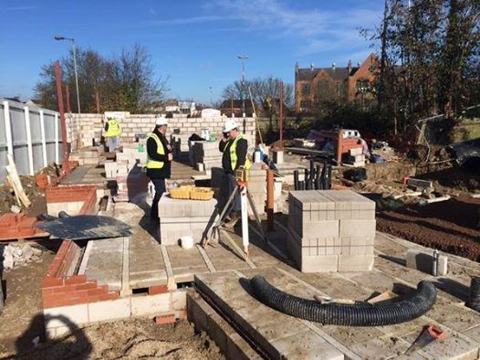
B.190 The delivery of sustainable development is a fundamental theme of the Local Plan and the Council places a high priority on the achievement of sustainable construction.
B.191 The expectations in Policy ESD 3 will be applied flexibly. The onus will be on the developer to demonstrate (with robust evidence) why the requirements cannot be met, for example where the application of the policy would conflict with other policy objectives, or where it can be satisfactorily shown that implementing the standards would not be feasible or financially viable, undermining delivery of the development. Negotiations will take place to ensure that sustainable construction is achieved as far as possible and we encourage discussion with the Council in the early stages of any development proposal. This policy will be subject to monitoring and review to ensure the standards and guidance remain appropriate and relevant. Any new national standards will need to be reflected in revisions to the local policy.
B.192 Sustainable design and construction issues will be considered and illustrated in more local detail in the Sustainable Buildings in Cherwell SPD.
Policy ESD 3: Sustainable Construction
All new residential development will be expected to incorporate sustainable design and construction technology to achieve zero carbon development through a combination of fabric energy efficiency, carbon compliance and allowable solutions in line with Government policy.
Cherwell District is in an area of water stress and as such the Council will seek a higher level of water efficiency than required in the Building Regulations, with developments achieving a limit of 110 litres/person/day.
All new non-residential development will be expected to meet at least BREEAM ‘Very Good’ with immediate effect, subject to review over the plan period to ensure the target remains relevant. The demonstration of the achievement of this standard should be set out in the Energy Statement.
The strategic site allocations identified in this Local Plan are expected to provide contributions to carbon emissions reductions and to wider sustainability.
All development proposals will be encouraged to reflect high quality design and high environmental standards, demonstrating sustainable construction methods including but not limited to:
- Minimising both energy demands and energy loss
- Maximising passive solar lighting and natural ventilation
- Maximising resource efficiency
- Incorporating the use of recycled and energy efficient materials
- Incorporating the use of locally sourced building materials
- Reducing waste and pollution and making adequate provision for the recycling of waste
- Making use of sustainable drainage methods
- Reducing the impact on the external environment and maximising opportunities for cooling and shading (by the provision of open space and water, planting, and green roofs, for example); and
- Making use of the embodied energy within buildings wherever possible and re-using materials where proposals involve demolition or redevelopment.
Should the promoters of development consider that individual proposals would be unviable with the above requirements, ‘open-book’ financial analysis of proposed developments will be expected so that an independent economic viability assessment can be undertaken. Where it is agreed that an economic viability assessment is required, the cost shall be met by the promoter.

