**NW Bicester Local Lettings Plan**

Introduction to NW Bicester

North West Bicester is the UK’s first eco-town. It is a Masterplan to bring more homes and jobs to Bicester. The first phase is known as the Exemplar. The NW Bicester exemplar scheme is located on the outskirts of Bicester (see Figure 1: Site Plan).

At North West Bicester, we’re creating a new kind of development, one that’s designed to be good for the environment, the economy, and most important of all – is a great place to live.

We’re doing that by creating vibrant and sustainable neighbourhoods where:

* Families can afford to live
* Jobs are created for local people
* Children can play outdoors safely
* Wildlife can thrive
* There is a strong community spirit

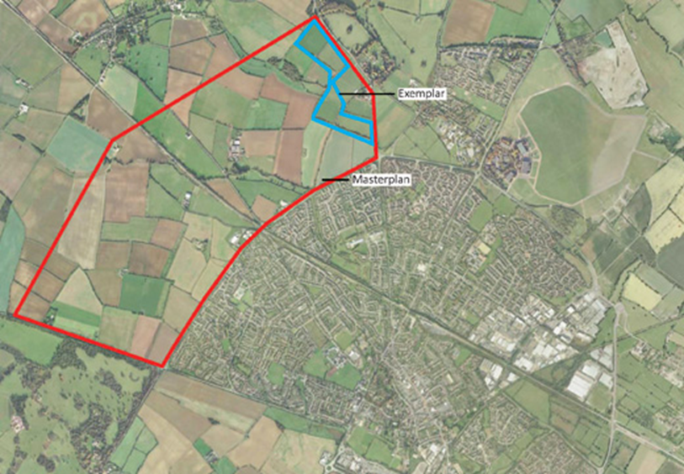

**Figure 1: NW Bicester Site Plan**

Purpose of the Local Lettings Plan

The purpose of the Local Lettings Plan is to outline the expectations of A2Dominon and Cherwell District Council in determining the suitability of applicants for the North West Bicester exemplar to ensure the creation of a sustainable community.

This Local Lettings Plan applies to any Affordable Rent, General Needs and Shared-Ownership properties.[1]

This Local Lettings Plan is not intended to replace any part of Cherwell District Councils Allocation Policy (www.cherwell.gov.uk ) or the nomination agreement.

Scheme Mix

We want to create a vibrant, mixed community in the Exemplar that reflects Bicester as a whole. That’s why 30 per cent of the Exemplar homes will be affordable housing; with 96 homes for affordable rent and 23 for shared ownership.



Nomination Criteria

Following the bidding process on a rented property through Choice Based Lettings, applicants on the housing register who have a local connection with Bicester or with the wards of Caversfield, Bucknell, Chesterton, Ambrosden and Launton will be prioritised for a nomination. The Nomination will be made within 10 workings days of the CBL cycle ending to A2 Dominion, which will provide sufficient time for the local connection to be verified by the Council.

The nomination process has been mapped out in Appendix A

Local connection is defined within Cherwell’s District Council Allocations Policy as meeting one of the following criteria:

* Have lived in Bicester, Caversfield, Bucknell, Chesterton, Ambrosden or Launton for a period of at least 6 out of the last 12 months continuously prior to acceptance onto the Housing Register
* Previously lived in Bicester, Caversfield, Bucknell, Chesterton, Ambrosden or Launton for 3 out of the past 5 years
* Be employed in Bicester, Caversfield, Bucknell, Chesterton, Ambrosden or Launton
* Have close relatives who have lived in Bicester, Caversfield, Bucknell, Chesterton, Ambrosden or Launton for at least the last 5 years. [2]
* Have a special reason for needing to live in Bicester, Caversfield, Bucknell, Chesterton, Ambrosden or Launton

.

If there is no one who bids for a property with the above local connection, the property will be allocated to anyone who qualifies to be on the Housing Register, who is eligible for the property and who has bid on the property subject to the criteria below.

In addition to the local connection priority the following criteria will be applied to all allocations:

* **70%** of all nominees will be employed, in training or education, or carrying out voluntary work (see definition in Appendix B)
* To take full advantage of the lifetime homes standards, priority for single level ground floor accommodation will be to those with a mobility need
* Those moving into affordable rented units will be offered a tenancy in line with A2Dominion’s tenure policy and Cherwell District Council's tenancy strategy.
* Nominees with an identified history of drug and/or alcohol dependency will only be considered if they are able to sustain a tenancy and the accommodation is considered suitable for their housing needs. A2 Dominion will work positively with any applicant that may be identified as requiring a support package.
* Nominees with an identified support need will only be considered if they have an ongoing support package in place and the accommodation is suitable for their housing needs. However A2 Dominion and the Council will work positively with any nominated applicant that does not currently have a support package in place but may be deemed to require one.
* All nominees not moving from existing social housing accommodation will be offered a 12 month starter tenancy
* Nominees who have previously been evicted by A2Dominion Group for anti-social behaviour or rent arrears will generally not be offered a property on the NW Bicester Exemplar Scheme. However, all cases will be carefully investigated and considered based on their past and current circumstances
* Should none of the applicants meet the above criteria then any applicant who is eligible and has bid will be considered for nomination to a property according to their housing need.
* All nominees will participate in pre-tenancy checks, this will include assessing their financial circumstances to ensure that they are able to afford the accommodation being offered

Plots 124 -134 are a group of ten houses to be built as a courtyard arrangement around a communal garden. Because of the communal aspect of this development we may want to identify residents who will most benefit from an aspect of communal living. A separate lettings plan will therefore be developed for these units 18 months prior to the first unit being handed over.

Residents Green Charter

In addition to the above Nomination Criteria applicants will need to sign up to the NW Bicester Residents Green Charter. This will cover:

* Getting to know your neighbours
* Getting the best out of the technologies in your home
* Engaging with your Community Management Company
* Helping us to monitor and capture success of the NW Bicester project
* Using water and energy responsibly
* Recycle, re-use and reduce waste
* Consider alternative ways to travel
* Protect and enhance your environment
* Participation in community activities
* Thinking about your food miles
* Learning how to grow your own food
* Use of your Shimmy
* Being part of Bicester
* Embracing the diversity of your community

Monitoring and Review of the Local Lettings Plan

It is recognised that the Local Lettings Plan is a working document and is subject to a review process.

The Lettings plan will be reviewed and finalised prior to the first letting so that all parties are satisfied that the services and facilities provided from the start are suitable and can support residents’ obligations under the pre-tenancy obligation.

The Lettings Plan will be monitored throughout the allocation process to check that the above criteria are being met, and that the document remains relevant and appropriate throughout the allocation of properties and will be reviewed on a minimum annual basis.

**Appendix A**

**Allocation Process of Properties**

The Property is advertised as awarding priority to those applicants who have a local connection to: Bicester, Caversfield, Bucknell, Chesterton, Ambrosden and Launton followed by those who are employed, in Education or training or doing voluntary work

The Property is advertised through the Council’s Choice Based Lettings system

An Affordable Rented property becomes available to let at NW Bicester

Each short list applicant is assessed in accordance with the priority criteria described

Following close of the CBL cycle a short list of eligible bidding applicants results

Property Let

Eligible applicants bid for the property

A2D offer the nominee a starter/assured tenancy

Following a maximum of 10 working days a nomination using the priority criteria* against the shortlist is made to A2D from CDC

A2D carry out a pre-tenancy questionnaire

Following a maximum of 10 working days a nomination from the short list is made to A2D

None of the bidding applicants meet the priority criteria

*There will be exceptional cases which will be considered outside this process based on housing needs or other reason as agreed between A2 Dominion and Cherwell District Council

Appendix B

For additional priority applicants will need to be in one of the following groups:

Applicant working household

You are a ‘working household’ if:

* You or a joint tenant living with you has a job – it can be permanent, temporary or self-employed
* The working person is 18 years or over
* They work for at least 16 hours a week and
* They have worked for at least nine out of the last 12 months

Applicants will be expected to provide the employees name and address and provide contact details for a person who can verify the employment.

Education or Training

You or a joint tenant living with you is undertaking a college course that lasts for more than 10 weeks

Applicants will be expected to provider the name of the college, the course they are undertaking and provide contact details for a person who can verify their attendance on the course

Making a positive contribution to the community

You or a joint tenant have been doing voluntary work for at least 10 hours per month within the local area, and has done so for at least 3 months within the last 12 months

1.
2. Close relatives are defined as parents, children, siblings, grandparents or grandchildren including step relatives and where there is evidence of frequent contact, commitment or dependency.