**From:** Joyce Christie   
**Sent:** 05 October 2018 12:18  
**To:** Bernadette Owens  
**Subject:** 18/00341/DISC and 18/00342/DISC

Hi Bernadette

I went to temple Mill on Tuesday morning and discussed the points I raised in my email of 1 October.  We will need some revised details and confirmation that my comments below are a fair representation of what was discussed on site:

**Condition no 3 Materials:**

**Slates and Blue Clay ridge tiles:**

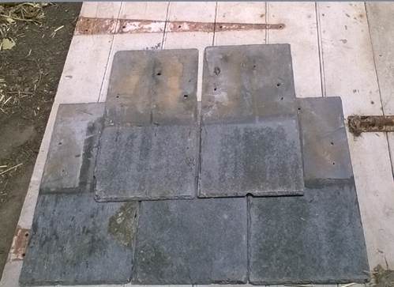

The samples are acceptable. No objections.

*Rainwater goods to be black metal.

**Timber Boarding:**

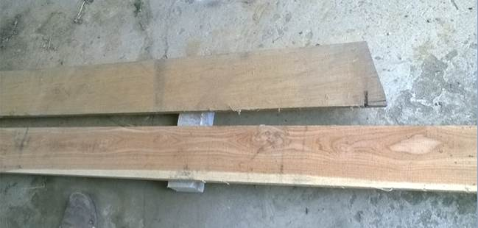

The top is oak the bottom is softwood. Either board would be acceptable but the oak is likely to last longer. The historic photo below shows lapped feather edged boarding. The other image shows Green oak feather-edged boarding. No objections.

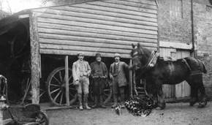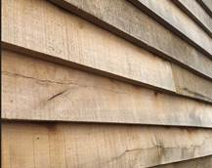

**Stone sample:**

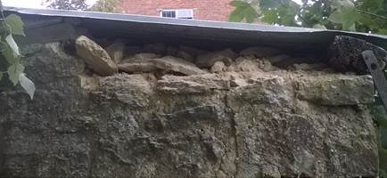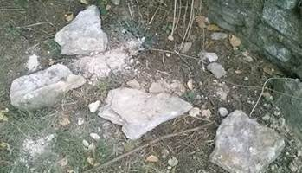

The existing stone will be reused, keeping the weathered face to the outside and this is acceptable.

It is not envisaged that any additional stone will be needed.

The lime mortar does not have a lot of grit in it, I would recommend a small mortar disc is produced with a lime: well- graded sharp sand (which could have some building sand added or Hornton Stone dust) in the first instance so that the colour of the mortar matches the existing.  For the 1sqm sample panel - the joints should be tight – say starting off with c5mm but will get bigger due to the nature of the stone not being squared.  The joint should be full and tamped back with a churn brush to expose the aggregate, so that the arris of the stone is just visible.

**I have now checked the decision notice and the 1sqm sample panel is a pre-commencement condition – can you confirm this to the Applicant please?**

**I can pop out at short notice to look at it.  If they need to dismantle some of the wall in order to reclaim stone for the sample panel, that would be acceptable.  I understand the tin roof is to be taken off for safety reasons so propping may not be required.**

**Condition no 4 joinery:**

**Timber doors to garage/stair door/workshop door:**

We discussed the door details not being traditional as drawn as they are framed ledged and braced.

**The Applicant confirmed the doors would be traditional ledged and braced timber doors. The Applicant could base his revised door details on the Mckay details below.**

A cover strip could be attached to the inside of the meeting stile on one of the door leaves to cut down on drafts.

The boards look to be a decent width and they should be of a good thickness.

The personnel door to the workshop would have a traditional thumb latch – see photo of existing handle below, there would be an additional rim lock as is found at the property. The Garage doors will have internal bolts/bars with no external handles.

I was shown some strap hinges on site which would be acceptable, painted black but the Applicant needs to size them to suit the door width.

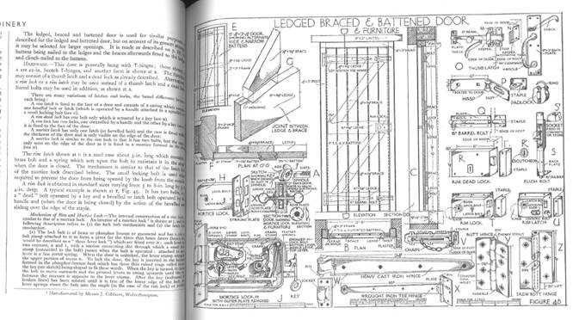

Mckay’s Building Construction shows the type of door discussed.

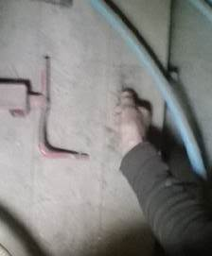

 Thumb latch handle for the workshop door.

**Window to Garage Gable:**

The detail shows an external and internal cover strip which is not traditional, neither is the planted on glazing bar which can drop off/be knocked off during cleaning leaving the spacer bar visible sandwiched between the two panes of glass.

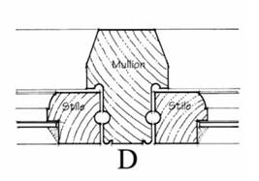or 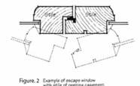

The windows needs to be a traditional flush timber casement, the images above are taken from Cotswold District Council’s guide and the right hand detail shows a ‘flying mullion’ which would allow both casements to be opened for escape: <https://www.cotswold.gov.uk/media/241376/traditional-casement-windows.pdf>

The window should have a true glazing bar, not planted/glued on to glass.

Edge spacers should be non-metallic finish – matt black works better if the window is to be painted a non-white.

Slimline double glazing (between 10-16mm thick) would look better than standard double glazing.

**We will need revised details or a photo of the recycled window.** *The Applicant stated he may have a flush timber casement that he could recycle and will forward photos/offer the window for inspection on site. Otherwise he will submit details for a new flush casement.

I mentioned that some off the shelf windows have a very wider gap than is traditional between the opening casement and the window frame – see image below.

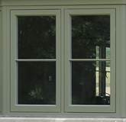

**We ALSO need confirmation of the colour/finish of the joinery – IF IT WILL BE LEFT TO SILVER NATURALLY/WILL IT BE OILED OR PAINTED ETC.**

**Condition no 5 rooflights:**

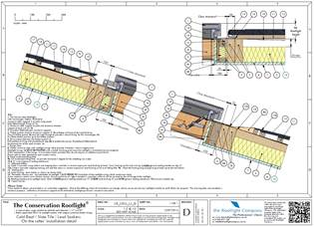

**The detail provided  is ‘on the rafter’**

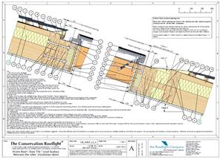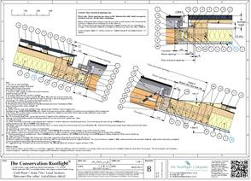

The images above from <https://www.therooflightcompany.co.uk/resources/drawings-downloads/installation-drawings/> show options for flush between the rafter rooflights.

However I would accept the detail as submitted as both are almost flush.

**Condition no 6 - Staddle Stone:**

The staddle stone is to be omitted, the historic photo show the posts going straight to ground, this is preferable to a reconstituted stone but will they need to apply to omit condition no 6?

If they decide to proceed with the staddle stone, the detail is acceptable subject to it being made from stone to match the walling.

No objections to either option.

**CONDITION NO 7 – RIDGE/EAVES/VERGE:**

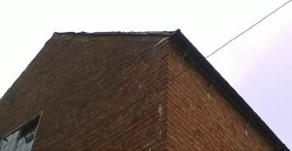

The Applicant confirmed the verge would match the existing gable detail in terms of undercloak and slate with mortar infill, and the eaves would be similar to the mill without the projecting rafter feet which we would support.

Can the Applicant confirm and ask the agent to revise his detail?

**Roof Insulation:**

The Applicant should confirm the internal finish to the roof which is to be insulated.

**Condition No 8 – Recording:**

Further recording during the dismantling of the forge and steps will be needed to inform the rebuilding, including measurements.

**\*NB. Slab and Footings relative to the existing listed mill was not conditioned:**

Trial Holes will inform the detail of the new slab/footing relative to the mill at the top and bottom of the steps which are proposed to be retained , a structural engineer should advise on the detail to ensure the mill is not destabilised by the new work.

Best wishes

Joyce Christie

Conservation Officer  
Design and Conservation Team

Cherwell District Council & South Northamptonshire Council  
Direct Dial 01295 221608  
[**joyce.christie@cherwellandsouthnorthants.gov.uk**](mailto:joyce.christie@cherwellandsouthnorthants.gov.uk)[**www.cherwell.gov.uk**](http://www.cherwell.gov.uk/)

[**www.southnorthants.gov.uk**](http://www.southnorthants.gov.uk/)

Find us on Facebook [www.facebook.com/cherwelldistrictcouncil](http://www.facebook.com/cherwelldistrictcouncil) or [www.facebook.com/southnorthantscouncil](http://www.facebook.com/southnorthantscouncil)

Follow us on Twitter @Cherwellcouncil or @SNorthantsCouncil