**From:** William Anstey   
**Sent:** 26 April 2019 16:35  
**To:** Clare O'Hanlon  
**Subject:** RE: Proposed Marina at Claydon 18/00904/F

Thanks Clare,

Given the contents of the map below it appears the red line does not encroach into South Northants so I don’t think you need to add a note onto any decision. I consider the issue resolved. Have a good weekend.

Kind regards,

**Will Anstey BSc (Hons) MSc**

Principal Planning Officer

General Developments Planning Team - Development Management

Place and Growth Directorate - Cherwell and South Northants Councils

**Direct Line:** 01327 322169

**Email:** [william.anstey@cherwellandsouthnorthants.gov.uk](mailto:william.anstey@cherwellandsouthnorthants.gov.uk)

**Website:** [www.southnorthants.gov.uk](http://www.southnorthants.gov.uk/) and [www.cherwell.gov.uk](http://www.cherwell.gov.uk/)

**Address**: South Northamptonshire Council, The Forum, Moat Lane, Towcester, Northamptonshire, NN12 6AD

**Follow Us:**

Facebook [www.facebook.com/southnorthantscouncil](http://www.facebook.com/southnorthantscouncil)  or [www.facebook.com/cherwelldistrictcouncil](http://www.facebook.com/cherwelldistrictcouncil)

Twitter @cherwellcouncil or @southnorthantscouncil

**You will appreciate that the above information, although believed to be correct, is given on the understanding that the information provided is not binding upon the Council or any Officer.**

**Note:** Fees for Planning Applications are set to rise in the region of 20% on 17th January 2018: <https://www.southnorthants.gov.uk/info/173/planning/248/making-a-planning-application>

Please note that South Northamptonshire Council adopted the Community Infrastructure Levy (CIL) on 21 October 2015.  This means that all liable developments granted planning permission**,** including those allowed by an appeal decision, on or after **1st April 2016** will need to pay the levy.  The CIL will not apply to liable developments that receive permission before this date.  **The CIL will also apply to some developments that do not need planning permission if they are commenced on or after 1st April 2016.**  Charges will apply to developments of new houses AND to new residential and retail developments of over 100sqm.  More information about the CIL (including the Charging Schedule, definitions of what developments are liable and what developments are exempt) can be viewed by clicking here: <http://www.southnorthants.gov.uk/7143.htm>

**From:** Clare O'Hanlon   
**Sent:** 26 April 2019 15:45  
**To:** William Anstey <[William.Anstey@cherwellandsouthnorthants.gov.uk](mailto:William.Anstey@cherwellandsouthnorthants.gov.uk)>  
**Subject:** FW: Proposed Marina at Claydon 18/00904/F

Hi Will, please see below. As discussed, given that there is no ‘development’ per se on the land immediately abutting SNC’s boundary and as the district boundary is not readily apparent on site and it’s not really clear as to whether there is any technical encroachment of the red line, would SNC be content if I were simply to draw attention to this matter as a note on any planning permission?

Many thanks

Clare

**Clare O’Hanlon** BA (Hons) BTP MSc MRTPI   
**Principal Planning Officer – Major Projects Planning Team**

**Place and Growth Directorate**  
Cherwell District Council & South Northamptonshire District Council

Direct Dial 01295 221900

[**clare.o’hanlon@cherwellandsouthnorthants.gov.uk**](mailto:jim.newton@cherwellandsouthnorthants.gov.uk)

[**www.cherwell.gov.uk**](http://www.cherwell.gov.uk/)

[**www.southnorthants.gov.uk**](http://www.southnorthants.gov.uk/)

Find us on Facebook [www.facebook.com/cherwelldistrictcouncil](http://www.facebook.com/cherwelldistrictcouncil) or [www.facebook.com/southnorthantscouncil](http://www.facebook.com/southnorthantscouncil)

Follow us on Twitter @Cherwellcouncil or @SNorthantsCouncil

**From:** Stephen Rice   
**Sent:** 26 April 2019 12:48  
**To:** Clare O'Hanlon  
**Cc:** David Jackson  
**Subject:** Re: Proposed Marina at Claydon 18/00904/F

Hi Clare

We had already imported the SNC boundary onto a CAD version of our site plan to check whether any of the site within the red line encroached into SNC territory.

More by luck than judgement, as we didn’t know about the SNC boundary, the red line avoids it. See the attached.

I would hope that Will would agree that this plan confirms none of the application site is within SNC.

Regards

Stephen

**Stephen Rice MRICS**  
**Director**

cid:image002.png@01D4FC4D.F22920D0  
**07557 880112**  
[**www.sbrice.co.uk**](http://www.sbrice.co.uk)  
**We operate a paperless office, so please email wherever possible.**Correspondence Address: SBRice Ltd, Abbey House, 1650 Arlington Business Park, Theale, Reading, RG7 4SA  
Information contained in this email and any attachments must be considered confidential and must not be distributed to anybody outside of the intended recipients without written permission.  Although we’ve taken precautions to minimise the risk of passing on computer viruses, we advise you to carry out your own checks on any attachments. We cannot accept liability for any loss or damage caused by software viruses. S B Rice Ltd  Registered office:  Abbey House, 1650 Arlington Business Park, Theale, Reading, RG7 4SA | Registered in England & Wales No. 08018937   |  VAT Reg. No. 127683689.   
  
 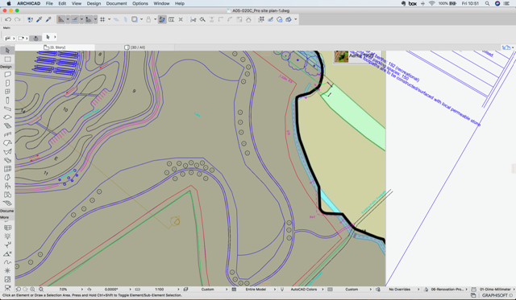

This e-mail (including any attachments) may be confidential and may contain legally privileged information. You should not disclose its contents to any other person. If you are not the intended recipient, please notify the sender immediately.

Whilst the Council has taken every reasonable precaution to minimise the risk of computer software viruses, it cannot accept liability for any damage which you may sustain as a result of such viruses. You should carry out your own virus checks before opening the e-mail(and/or any attachments).

Unless expressly stated otherwise, the contents of this e-mail represent only the views of the sender and does not impose any legal obligation upon the Council or commit the Council to any course of action.

This e-mail (including any attachments) may be confidential and may contain legally privileged information. You should not disclose its contents to any other person. If you are not the intended recipient, please notify the sender immediately.

Whilst the Council has taken every reasonable precaution to minimise the risk of computer software viruses, it cannot accept liability for any damage which you may sustain as a result of such viruses. You should carry out your own virus checks before opening the e-mail(and/or any attachments).

Unless expressly stated otherwise, the contents of this e-mail represent only the views of the sender and does not impose any legal obligation upon the Council or commit the Council to any course of action.

This e-mail (including any attachments) may be confidential and may contain legally privileged information. You should not disclose its contents to any other person. If you are not the intended recipient, please notify the sender immediately.

Whilst the Council has taken every reasonable precaution to minimise the risk of computer software viruses, it cannot accept liability for any damage which you may sustain as a result of such viruses. You should carry out your own virus checks before opening the e-mail(and/or any attachments).

Unless expressly stated otherwise, the contents of this e-mail represent only the views of the sender and does not impose any legal obligation upon the Council or commit the Council to any course of action.