**From:** Plater, Roger - E&E   
**Sent:** 11 June 2018 14:10  
**To:** Bob Neville  
**Cc:** Cllr George Reynolds  
**Subject:** RE: 18-00640-F Tyne Hill Barn Sibford Ferris

Hi Bob,

Following the receipt of further information and updated drawings, I am able to change my recommendation to **no objection** to the granting of planning permission. The applicant has now demonstrated that the required vision splay of 2.4m x 90m can be achieved. This involves building up the access road so that it is level with the carriageway at the junction.

A S184 agreement will be required for the verge crossover. Please see  <https://www2.oxfordshire.gov.uk/cms/content/dropped-kerbs>  for further details.

I continue to request the two conditions as listed below, to approve the access details and to maintain the vision splay.

Kind regards

***Roger***

Roger Plater

Transport Planner, Transport Development Control

(Cherwell and West Oxfordshire)

Oxfordshire County Council

Mobile 07789 653049

**From:** Plater, Roger - E&E   
**Sent:** 04 June 2018 14:02  
**To:** 'Bob Neville' <[Bob.Neville@cherwellandsouthnorthants.gov.uk](mailto:Bob.Neville@cherwellandsouthnorthants.gov.uk)>  
**Cc:** Cllr George Reynolds <   
**Subject:** 18-00640-F Tyne Hill Barn Sibford Ferris

Hi Bob,

I have looked over the above planning application and have the following comments to make.

  _____

**Planning application:**  18/00640/F

**Location:** Land At Tyne Hill Barn Tyne Hill Sibford Ferris Banbury OX15 5AD

**Description:** The formation of a new private driveway from Sibford Road using an existing access to serve a residential property

**Type:**                                     Full Development

**Case officer**:                         Bob Neville

  _____  

**Recommendation:**

Oxfordshire County Council, as the Local Highways Authority, hereby notify the District Planning Authority that they ***object*** to the granting of planning permission. Should permission be granted, we request the following conditions:

**Conditions:**

**Access: Full Details**

Prior to the commencement of the development hereby approved, full details of the means of access between the land and the highway, including, position, layout, construction, drainage and vision splays shall be submitted to and approved in writing by the Local Planning Authority. Thereafter, the means of access shall be constructed and retained in accordance with the approved details.

Reason - In the interests of highway safety and to comply with Government guidance contained within the National Planning Policy Framework

**Vision Splay Protection**

The vision splays shall not be obstructed by any object, structure, planting or other material of a height exceeding 0.6m measured from the carriageway level.

Reason - In the interests of highway safety and to comply with Government guidance contained within the National Planning Policy Framework

**Comments:**

A speed survey was carried out and included with the application documents. It was concluded that a 90m x 2.4m visibility splay is required for northbound traffic, and this has been superimposed on the topographical survey drawing. However, this does not give a true picture of the limitations caused by the curvature of the road. At the pre-application stage I advised that I had measured the actual visibility at less than 70m towards the south-west (for northbound vehicles). Using the elevation data provided by the topographical survey I have plotted the elevation of the nearside kerb (shown in blue in the diagram below), and superimposed the sightline (in red) from a point 1.05m above the road surface, and it confirms that the visibility is 70m at best.

From Table 3 of the design Manual for Roads and Bridges, Volume 6 Section 1, TD 9/93, a 70m visibility is appropriate for a speed of 50 kph (= 31.1 mph), which is significantly lower than the measured northbound 85%ile wet weather speed of 37.5mph. Therefore, I do not consider that this is a safe and suitable access, as required by the NPPF (paragraph 32).

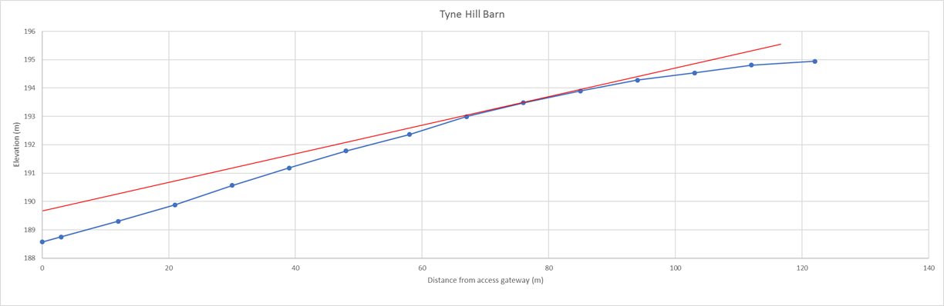

If you would like to discuss any of the above in more detail, then please do not hesitate to contact me.

Kind regards

***Roger***

Roger Plater

Transport Planner, Transport Development Control

(Cherwell and West Oxfordshire)

Oxfordshire County Council