**From:** Joyce Christie   
**Sent:** 10 February 2016 12:26  
**To:** Nathanael Stock  
**Cc:** Clare Mitchell  
**Subject:** Muddle Barn Farm consult revised scheme Feb 2016

HI Nat

I have added some comments and photos to the original consult.  I am happy to go through this with you.

Sketches below:

a) shows a pavilion with flanking wing and separating wall/loggia – this works better without the double pitched hipped roof (in some large piled houses there are inner roof pitches with internal box gutters running through the attics to the external box gutters)

b) shows a pavilion with side extension – this works better without the double pitched hipped roof

c) A double piled gable with chimneys, the orangery form is quite grand for this form but the typical lower side extension with pitched roof would be awkward with the double gable

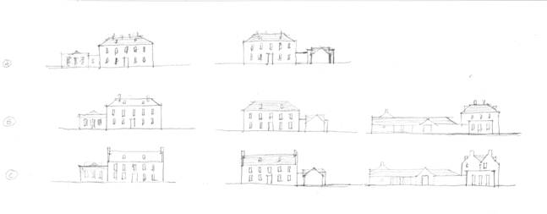

Best wishes

Joyce