Contents

1 introduction 2

1.1 Background 2

1.2 Source of Flooding 2

2 Area of Islip considered under this FMEP 4

2.1 Layout 4

3 Flood Planning 5

3.1 Identification of Responsible People 5

3.2 Flood Warnings 5

3.3 Registering for the Flood Warning Service 7

3.4 Preparation for a Flood Event 7

3.5 Identification of Flood Muster Points 8

3.6 Identification of Safe Exit Routes for Evacuation 9

3.7 Considerations / Identification of Other Hazards 9

4 Response to Flood Warnings 10

4.1 Personal Safety in a Flood Event 10

4.2 Flood Warning and Evacuation Procedures 10

4.3 Flood Monitoring and Re-occupation of Area 11

5 Briefing / Training Exercises 13

6 Flood Management Plan Details 14

6.1 Key Contacts 14

***ANNEX A SITE LAYOUT***

***ANNEX B CONTENT OF DETAILED FLOOD PLAN***

***ANNEX C ENVIRONMENT AGENCY’S COMMUNITY FLOOD PLAN TEMPLATE***

# introduction

## Background

Chiltern Railways is proposing to construct a new railway (including the reconstruction of an existing railway) between Bicester and Oxford, together with the construction or reconstruction of stations including Islip. As part of the new railway scheme, removal of all level crossings along the route was proposed based on health and safety grounds for rail passengers, drivers and pedestrians alike. This proposal included the closure of the Mill Lane crossing located in Islip.

The Secretary of State for Transport made the TWA Order and granted the planning direction subject to a number of conditions. One such condition, ***Condition 14 - ‘Safe Access and Egress under Flood Conditions’*** was applied in recognition of public concern regarding safe egress from parts of Islip in times of flood. This is due in part to the historical use of the Mill Lane level crossing by residents to achieve egress under such circumstances.

This document outlines the *Flood Management and Evacuation Plan* (FMEP) for the residents of Islip, Oxfordshire; in particular, those residents based within the area of Mill Street and Mill Lane. This FMEP has been prepared following detailed discussion and consideration of responses from local residents, the Parish Council, Thames Valley Local Resilience Forum, Environment Agency and local Emergency Services.

The Flood Warden (as identified by the Parish Council) will ensure that all requirements of the Flood Management and Evacuation Plan are implemented, including the completion of the *Detailed Flood Plan* (see *Annex B*).

The FMEP and *Detailed Flood Plan* are live documents and should be reviewed quarterly, and immediately following a flood event, and updated as appropriate.

## Source of Flooding

The primary risk of flooding to the Islip area is from the fluvial flood waters related to the River Ray and it’s confluence with the River Cherwell. According to the Environment Agency, eastern, southern and western areas of Islip are located within Flood Zone 2 and Flood Zone 3 with a medium (between 1 in 100 (1%) and 1 in 30 (3.3%) annual probability flood risk) to high (greater than 1 in 30 (3.3%) annual probability flood risk) chance of flooding. The Environment Agency indicate that there are no flood defences currently serving the Islip area.

Flood risk models have shown that during a large flood event, caused by either intense rainfall within the catchment or a prolonged period of less intense rainfall within the catchment; the River Ray will bust it banks.

Figure 1: Extract from WHS report illustrating the extent of flood water during 1 in 1000 year flood event

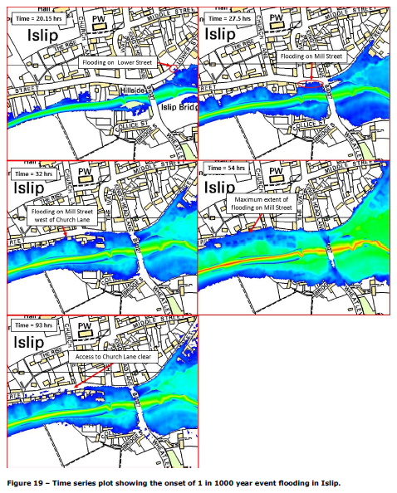

The hazard associated with the 1 in 1000 flood event extents shown in *Figure 1* is illustrated in *Figure 2* below. There is a moderate to high flood hazard rating associated with the 1 in 1000 flood event.

Figure 2: Extract from WHS report showing flood hazard ratings associated with a 1 in 1000 year flood event

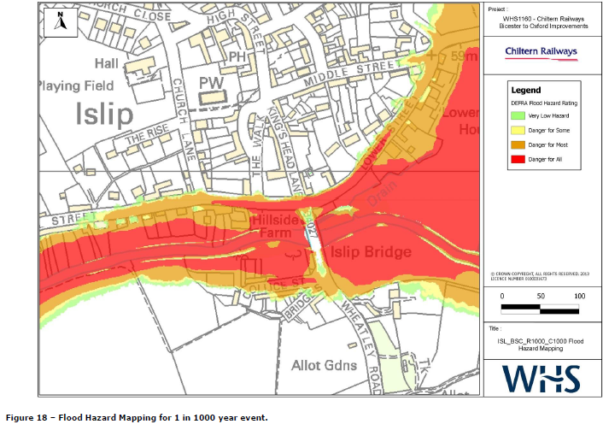

The initial flooding will occur on Lower Street in areas to the west of the car park area at the junction with Mill Street.

Prior to flooding from Lower Street overtopping Mill Street at the junction with the Kings Head Lane, waters from the River Ray will rise through gardens behind properties fronting onto Mill Street, and start to flood the road directly at the section between Church Lane and Kings Head Lane.

As waters continue to rise, there will be flooding along Mill Street towards the junction with Church Lane, followed by flooding of Mill Street to the west of Church Lane via the residential gardens of properties adjoining the road.

During extreme events the multiple flows paths will combine to result in the inundation of the junction of Church Lane and Mill Street.

# Area of Islip considered under this FMEP

## Layout

The area of consideration covered under this FMEP is shown in *Annex A*, and relates to those residents situated in the area of Lower Street, Mill Street and Mill Lane and at the junction with Church Lane.

# Flood Planning

## Identification of Responsible People

A Flood Warden/s for the area have been identified by the Parish Council as the person(s) responsible for aiding in the Flood Evacuation Plan. Details of the appointed flood warden(s) are available in the Detailed Flood Plan contacts section, See Section 6. If other roles within the local community deal with Health and Safety issues; close consultation between all persons with these health and safety responsibilities will be required. There should always be a minimum of one Flood Warden in the Mill Street / Mill Lane area.

The duties to be carried out by the Flood Warden/s are as follows:

• Be aware of the flood warning system for the area (see *Section 3.2*) and how to enrol to the Environment Agency Flood Warning and Flood Alert systems (see *Section 3.3*);

• Be aware of, and be able to effectively disseminate, a Flood Muster Point for assembly of residents in the event that the local housing needs to be evacuated due to flooding (see *Section 3.5*);

• Be aware of, and be able to effectively disseminate, safe routes to reach the Flood Muster Point in the event that the area needs to be evacuated due to flooding (see *Section 3.5 and Section 3.6)*;

• Identify critical equipment or services to be moved or turned off in the event of receiving a Flood Warning (see *Section 3.7)*;

• Activate procedures in the event that a flood warning is received (see *Section 4*); and

• Co-ordinate safe evacuation of the area with Police and Fire Service in the event of a flood (see *Section 4*).

Further information can be found in CCS emergency plan toolkit - <https://www.gov.uk/government/uploads/system/uploads/attachment_data/file/60925/Community-Emergency-Plan-Toolkit.pdf>

## Flood Warnings

The Environment Agency provides a flood warning service throughout England and Wales in areas at risk of flooding from rivers or the sea. These can be viewed online at <http://apps.environment-agency.gov.uk/wiyby/> and by selecting the “Flood Warning and Alert Areas” option.

Currently the area under consideration is located or close to flood warning areas and flood alert areas for the ‘*River Ray and its tributaries from Shipton Lee to and including Islip*’ - including Ludgershall, Blackthorn and Murcott and ‘*River Cherwell from Lower Heyford to and including Oxford*’ - including Rousham, Enslow, Thrupp and Hampton Poyle.

The Environment Agency flood warning system is structured as shown below:

* + 1. ***Flood Alert***

***Flooding is possible. Be Prepared***

Alerts are issued when water levels across the catchment have risen and flooding is possible but not imminent. This should usually provide between two hours and two days in advance of flooding and may not result in flooding. An alert is issued to provide time to prepare in case a flood warning is issued and are likely to be issued with more frequency than flood warnings.

* + 1. ***Flood Warning***

***Flooding is expected. Immediate action required.***

Expected to provide two hours warning of flood waters rising at the site.

* + 1. ***Severe Flood Warning***

***Severe flooding. Danger to life.***

Flood waters at or expected at the site soon and may pose risk to life.

* + 1. ***Warnings No Longer in Force***

Flood warnings and flood alerts that have been removed within the last 24 hours.

Further details of the Environment Agency Flood Warning system can be found on the Environment Agency website (www.environment-agency. gov.uk).

## Registering for the Flood Warning Service

To register for the Flood Warning Areas noted in *Section 3.2*, contact the local Environment Agency Flood Warning Team and ask to be added to the warning service.

• **National EA floodline number: 0345 988 1188**, select option 1 and enter Quickdial number 171449 to get more information

The Flood Warden/s in the area of Mill Street should request to be registered for the following Flood Alert and Flood Warning services:

• **Flood Alert:** ***River Ray and its tributaries from Shipton Lee to and including Islip and River Cherwell from Lower Heyford down to and including Oxford*** – this will provide a ‘Watching Brief’ alert, on average covering a time period of around two days, indicating that a Flood Warning may be issued within that period; and

• **Flood Warning:** ***River Ray and its tributaries from Shipton Lee to and including Islip and River Cherwell from Lower Heyford down to and including Oxford*** – this will provide at least a 2 hour advanced warning that a flood event could potentially affect the local area.

In order to set up the service, the following details will need to be provided to the Environment Agency:

• Contact name of the Flood Warden/s;

• Address of the area;

• 24 hour contact numbers; and,

• Email address of the Flood Warden/s.

## Thames Valley Local Resilience Forum

[TVLRF - Are you ready for emergencies?](http://thamesvalleylrf.org.uk/useful-links/publications/are-you-ready.ashx)

See Chapter 10 for Flooding

## Preparation for a Flood Event

Residents of Mill Street / Mill Lane or adjacent areas should be identified to take charge during a flood event. They will take responsibility for ensuring safe evacuation to a muster points and aid the Flood Warden in coordinating tasks to ensure the area is made safe during a flood event.

The Flood Warden/s should be responsible for the contents and regular maintenance of a flood kit(s) for use during a flood event and evacuation from the area. The kit(s) should include:

• Key documents, including a copy of this FMEP and evacuation routes;

• Torch;

• Mobile phone (with fully charged batteries) programmed with key contacts (see *Section 6*);

• First aid kits;

• Blankets; and

• Rubber gloves/waterproof clothing.

The flood kit(s) should be located at one central location and taken to the flood muster points by the appointed flood wardens.

The flood kit(s) should be subject to a quarterly inspection with the flood plan.

## Identification of Flood Muster Points

A suitable muster point should be provided that is outside of the potential influence of an extreme flooding event, and away from the potential flow of flood waters.

The chosen Muster Point should therefore be:

• Located away from the potential overtopping points on Mill Street;

• Easily reachable by foot for ALL residents; and

• If possible, have access to food, water and comfort facilities.

A possible Muster Point for consideration is located at the local church which is elevated above the area and has sufficiently wide enough footpaths/vacant areas to accommodate residents in the area. Previous modelling has shown that the central areas of Islip are at the lowest risk of flooding. This area therefore represents the best muster point in the event of a flood warning being received. The location of the muster point should be disseminated to all local residents.

An additional figure is appended in *Annex A* to show the potential locations of the Muster Point.

The muster location should be used as an information dissemination point for safe evacuation procedures. The Flood Warden should convey the precautionary approach being taken in order to promote a calm and measured response. Clear instruction should be given concerning the egress point, use of vehicles, likely period of evacuation and procedures for communicating the ‘all clear’ and re-entering the area.

**Given the potential for waters to restrict site egress, it is recommended that the area is fully evacuated within TWO HOURS of receiving a Flood Warning.**

**At the receipt of a Flood Alert, this should NOT trigger an evacuation. The alert is to provide additional advanced warning that a Flood Warning may be issued.**

## Identification of Safe Exit Routes for Evacuation

Details of exit routes and muster points will be displayed on the Parish Council notice boards located within Islip. Under no circumstances must escape routes be blocked or altered to differ from the routes displayed on the information boards.

It will be the responsibility of the Flood Warden/s to be fully aware of any access and egress restrictions at all times.

A map of the Islip area showing the critical flood outline and suggested pedestrian evacuation routes is included in Annex A.

## Considerations / Identification of Other Hazards

The Flood Warden/s in consultation with the Parish Council / local residents should identify any critical / vulnerable equipment or services that may be moved or turned off in the event of receiving a flood warning.

The Flood Warden/s should always be aware that the size of a potential flood event will not be supplied as part of the Flood Warning, and that an extreme event could, therefore, occur. A precautionary approach should be taken when a Flood Warning is received, and vulnerable equipment moved above ground level.

The movement of equipment must, however, only be considered after all necessary steps have been taken to safeguard local residents and the Flood Warden’s own safety.

# Response to Flood Warnings

## Personal Safety in a Flood Event

Personal safety during a flood event should be considered first and foremost. If any of the actions detailed below cannot be carried out without undue risk then they should be ignored in favour of protecting local residents. The Flood Warden/s should be aware of any personnel requiring additional support during a flood evacuation, and appropriate arrangements should be in place. It may be prudent to include specific details within the *Detailed Flood Plan*.

All local residents should be notified of the following:

• Avoid walking or driving through flood water: six inches of fast-flowing water can easily knock over an adult and two feet of water can move a car;

• Be aware that flooding can cause manhole covers to be lifted and/or removed;

• Never try to swim through fast flowing water; and

• Avoid contact with flood water in case of contamination.

## Flood Warning and Evacuation Procedures

The following procedures should be followed in order to protect local residents and minimise the damage flooding can cause.

### Flood Alert Procedures: Dissemination of Flood Warning Information to local residents

The Flood Warden/s should:

• Alert other members of the community, in particular those most vulnerable such as those with impaired hearing, sight or with restricted mobility;

• Monitor the weather forecast, Environment Agency website and river levels to enable a prompt response to flooding;

• Ensure that safe egress routes and Flood Muster Point are clearly known and are freely accessible;

• Prepare the flood kits, ensure mobile phone batteries and spares are fully charged and are programmed with all necessary emergency contact details;

• Identify all critical equipment and services and their isolation points; and

• Identify and inform local helpers to be ready to move critical equipment in event of Flood Warning being issued.

### Flood Warning Procedures

The Flood Warden/s should:

• Confirm the time the warning was issued. The Flood Warden/s should allow no more than two hours from the time the warning is issued to completion of the site evacuation;

• The Flood Warden/s is/are to ensure that flood kits are retrieved and that mobile phones are fully charged and spare battery packs are held;

•Inform residents to turn off gas, water and electricity services at their isolation points;

• Inform residents to congregate at the Flood Muster Point via designated safe routes;

• Flood Wardens to complete a roll call of all at Flood Muster Point and identify if there vulnerable residents who may still be in flood areas;

• Flood Warden assist Emergency Services to disseminate precautionary approach, evacuation procedures, Flood Muster Point, likely time away from area and ‘all clear’ procedures to local residents; and

• Help to get local residents to the Flood Muster Point via the designated safe routes.

### Severe Flood Warning: Immediate Evacuation

In the event that a Severe Flood Warning is issued:

• Go directly to the Flood Muster Point via the designated safe routes and liaise with Emergency Services.

## Flood Monitoring and Re-occupation of Area

• The Flood Warden/s should wait until the “‘all clear’ Warning No Longer in Force” has been issued by the Environment Agency’s Flood Warning Service;

• Once they have received the “Warning No Longer in Force” message they should undertake discussions with any relevant Emergency Service personnel, to assess if it is safe for residents to return. The area should not be entered if there are indications that flood waters continue to inundate safe access and egress areas;

• If any inundation has occurred, or there is a suspicion inundation may have occurred, contact the emergency services and follow their instructions;

• If no inundation has occurred the Flood Warden will help residents to return to their homes.

# Briefing / Training Exercises

Flood Wardens should be aware of:

• Their responsibilities;

• How to receive Flood Alert and Flood Warning;

• What each Flood Alert / Flood Warning means; and

• What to do in the event of receiving a flood warning.

• Register of local volunteers and resources;

• Register of people who may require assistance;

• No specific flood evacuation training needs to be implemented.

# Flood Management Plan Details

## Key Contacts

1. Parish Council and Councillors of Islip

Name:

E-mail address:

Telephone:

2. Cherwell District Council

Yan Southwell -

E-mail address:

Telephone:

Name:

E-mail address:

Telephone:

3. Oxfordshire County Council

Name:

E-mail address:

Telephone:

Paul Wilson – Highway Network Resilience Co-ordinator

E-mail address:

Telephone:

Thames Valley Local Resilience Forum will be co-ordinated through OCC.

5. Environment Agency West Thames region (Red Kite House office)

Name:

E-mail address:

Telephone:

6. Environment Agency Floodline Service:

• Local EA Flood Warning Team

Telephone:

• National EA Floodline

Telephone: 0345 988 1188

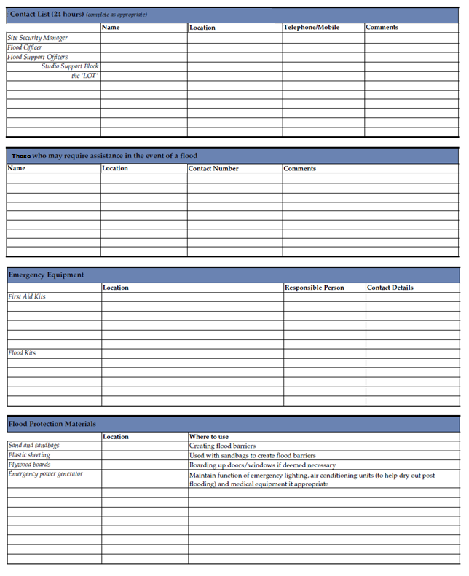

***See Annex C for Environment Agency Template, electronic version can be found:*** <https://www.gov.uk/government/publications/community-flood-plan-template>