**From:** Andrew Ferguson   
**Sent:** 01 May 2019 02:49  
**To:** DC Support; Clare O'Hanlon  
**Subject:** My objection to proposed new Marina at Claydon  
**Importance:** High

OBJECTION TO PLANNING APPLICATION FOR GLEBE FARM CLAYDON MARINA

I have lived in Claydon with my wife Angela for 28 years and our 3 children were brought up here. I worked for Oxfordshire County Council for 10 years and my wife taught at local schools through her career, we are both very committed to community life. As such we regard the consequences of the application as a threat to the quality of life for all who live or work in the area and those who visit. I set out our reasons below.

Andrew Ferguson

9 Bignolds Close

Claydon

BANBURY OX17 1ER

30 April 2019

1. Impact on Claydon village and its community.

* The village has about 100 dwellings, 300 residents. The marina has a proposed 192 boats, with multiple occupants, and takes up more land than the village.
* The village has seen some brown field building in recent years replacing disused homes. However an application for a new single dwelling was recently refused on the basis it would cause extra traffic in the playing field area (this application was for a patch of community land behind No 7 Bignolds Close on the corner of Appletree Road and Cropredy Road). If one property with maybe 2 cars will impact on that traffic, how can up to 200 extra cars in the area be a good idea?
* There is no information as to how leisure boats can be prevented from becoming residential boats. The house on Appletree Road half a mile outside the village began as a barn, was converted to a holiday home and then was given planning permission as a residence. The “Barn House” in Claydon was built inside a barn and then retrospective planning permission was applied for. It thus seems likely on available evidence that the arrival of 192 boats each up to 70 feet long and designed as living accommodation will result in a new, unapproved, housing estate.
* This ad hoc housing collective will require school places which have not been budgeted for.
* The nearest GP surgery to Claydon is at Cropredy. I understand that Dr Tucker there has pointed out that the marina at Cropredy has resulted in habitation (without planning consent) requiring GP services which are not available. Further unapproved habitation at the proposed marina will further impact.
* I was for some years Service Manager for Oxfordshire Social Services covering the Banbury area. The experience of social services was that people living on boats were more vulnerable than those in conventional housing. This was especially so for children. If this planning application is approved the possibility is created that families may live in a marina, where there are no primary services such as public transport or day care. The consequent pressure for support for children in need, vulnerable adults or elderly people will be thrown onto social services departments in Daventry or Banbury who do not have the resources for this. I suggest that those making the planning decision consult their colleagues on the county councils about the possible unintended impacts.

1. Impact on canal users.

* The proposed marina is located above the Claydon flight of 5 locks, which takes a single boat up to an hour to navigate. There are already often queues of boats waiting, with diesel engines running, to pass through. In recent years summer travel through locks has been subject to water conservation measures such as disallowing boat travel after 8pm. The impact of dozens of boats attempting to travel down to Oxford, or return to the marina, will be devastating to the canal. It is conceivable that at weekends boats may be unable to travel down the canal at all. It has also been established that there is no spare water to fill and maintain a marina.
* The canal water is already so filthy that canoeists at the nearby Cropredy Canoe Club are instructed to be cautious in using the canal, and vets advice is to not let dogs swim in the water. The addition of hundreds of diesel engines to this small length of water will be to worsen the water purity. This will be added to by the grey water produced, from kitchen sinks, pressure washers to clean boats and associated chandlery activity.
* The canal bridges between Cropredy and Fenny Compton are mostly in a state of poor repair. Bridge No 145 on the Appletree Road from Claydon to Lower Boddington will be used in the construction of the marina as it accesses Glebe Farm. Despite the 3 ton weight limit, heavier vehicles (sometimes driven by sat nav) already cross it. I have seen HGV vehicles cross the bridge and ground on it. The road surface on it is damaged by this (see attached photo).
* Further damage will be caused if this planning application is agreed, and other bridges are in a similar state. Any bridge collapse or repair will jeopardise travel on the canal.
* I have spoken two staff who work for the Canal and River Trust (a privatised body who took over from the British Waterways Authority who managed the canal for years)   who stated that resources for maintenance are very limited and work must be prioritised. This can be seen in the leaking lock gates and poor state of the tow path. Further boat traffic on the canal has not apparently been budgeted for.

1. Impact on traffic.

* I have lived in Claydon for 28 years and seen the volume and speed of traffic increase in this time. There is real danger of a serious accident due to the factors below which will be worsened by the increased traffic caused by 200 boat users and their vehicles , plus boat transporters and maintenance and support vehicles.
* Firstly there are 5 roads into Claydon and all are narrow and not suitable for large vehicles (two have as a consequence have weight limits and one a height limit). Vehicles leaving the M40 at Junction 11 and heading to the proposed marina are directed by Sat Nav along the Cropredy / Claydon Road. The attached photo shows where this enters Claydon, near Bignolds Close.
* 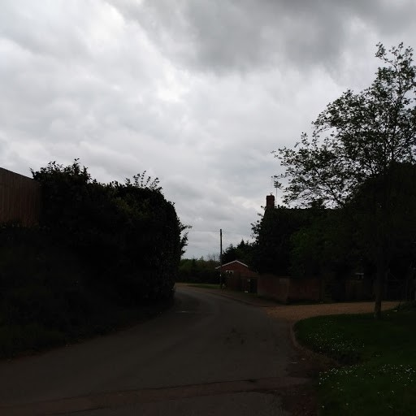
* It can be seen that this narrow road  ( not wide enough for two vans to pass) has a blind S bend and  has no pavement nor street lighting, like many of the roads in the village. The school bus to Cropredy hit a tree here on the bend and children were injured. Last winter a vehicle left the road and hit a tree, being written off. This road is used by the horses and riders from nearby Clattercote stables. This road is just one example of how more cars and the heavier vehicles associated with canal boats will be a threat to safety.
* Claydon roads are already less safe than those in neighbouring villages. For instance Fenny Compton (the nearest village which is in Warwickshire) has a 20 mph speed limit. In Claydon the limit is 30mph. In fact the Claydon children’s’ playing field is accessed by pedestrians and cars from the Appletree Road where the limit is 60mph. There are no traffic calming measures in place in Claydon, despite neighbouring villages such as Cropredy having chicanes on through roads, and the nearby Southam A423 having a 50mph limit. I walk my dog every day along these Claydon village roads and am very worried at the number of vehicles and the high speed they travel at.
* I regularly use the Boddington Road, where the access gate for the proposed development is, and heavy agricultural vehicles on the narrow lane are a real danger to all. Has any traffic survey been undertaken?

1. Impact on the environment

* Other respondents have pointed out the current situation where the village has minimal light and noise pollution. This situation is already threatened by the fortunately small number of canal boats which live along the nearby canal bank and when stationary run diesel motors to charge batteries, and show bright lights at night. The proposed marina will worsen this.
* In recent years the 250 boat marina at Cropredy has added to the Fenny Compton marina in polluting the canal with diesel and other effluent and the air with noise and light.  Both marinas currently have vacancies and there are further spaces in Banbury. It is hard to see how more boat spaces are needed. Even if the Glebe Farm marina is little used by boats due to the oversupply of moorings, there will be environmental impact from the building of the marina and passage of vehicles to maintain it while half empty.
* Both Northamptonshire and Oxfordshire have complex strategic plans for environmental protection, including reducing diesel usage; diesel usage is a large part of canal boat use. Many narrowboats for canal use were built more than 20 years ago and do not have modern emissions controls.
* There are also restrictions on building house on green belt land, yet the experience of the Cropredy marina is that boats will become homes for people who chose to do this in the absence of enforcement. As such this 192 boat marina represents a building of homes on green belt without roads, services or agreement of the local community, all of which is against good environmental practice.
* The applicant states that uncertainty over Brexit necessitates diversity. This has not been evidenced and is it not likely that if this application is allowed the applicant will then follow up with further requests to industrialise the countryside? “Planning creep” is a real danger when permission is given for large scale developments (this marina is bigger than the village it neighbours) which duplicate nearby provision. Experience of failed speculative business developments is that the owner will then apply to turn it, again speculatively, into something else. Will the Council sanction in the near future the underused marina being added to by a caravan park or warehousing? Surely not, so why allow this huge development at all?

--------------------------------------------------------------------------------------------------ENDS