**From:** Louise Sherwell [<mailto:louisesherwell@warwickshire.gov.uk>]   
**Sent:** 26 October 2017 11:07  
**To:** Arminder Uppal  
**Cc:** Linda Griffiths; David Laight  
**Subject:** Re: 17/00471/DISC - Discharge of condition 46 (bat and bird box details) of 13/00433/OUT Bicester phase KME

Hi Arminder,

Thank you, that is great.  Increasing the number of swift bricks and bird/bat boxes you have suggested would be a great enhancement within the development for these species.  Please do copy me in to the revised location plans when they're available.

Kind regards,

Louise

Louise Sherwell MSc ACIEEM

Assistant Ecologist

Ecological Services

Community Services

PO Box 43, Shire Hall

Warwick

CV34 4SX

Tel: 01926 418028

email: [louisesherwell@warwickshire.gov.uk](mailto:louisesherwell@warwickshire.gov.uk)

On 26 October 2017 at 09:24, Arminder Uppal <[Arminder.Uppal@bovishomes.co.uk](mailto:Arminder.Uppal@bovishomes.co.uk)> wrote:

Good morning Linda/Louise,

I have received your comments with regards to the number of swift boxes on the development and have reviewed this. On the original proposal I had calculated, based on the guidance set out below, that we would need 10no crevice units for bats and swifts, 5 bricks for house sparrows and 4 bricks for house martins and swallows. This was on the basis that we have 207 dwellings, therefore we deemed it sufficient number of brick proposed. That being said I have taken on board your comments about swifts being a notable/protected species within the vicinity and increased the number of swift bricks from 10 to 21 and in addition to that I have added 3 additional ibstock bat bricks. I will be changing the specification to a cheaper alternative such as the Cambridge swift brick, on the amended drawings.

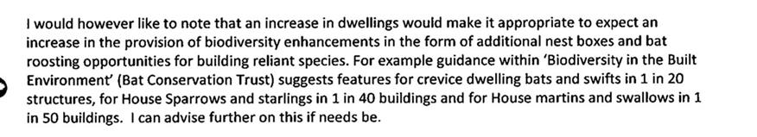

Please can you confirm that this is sufficient so I can get the plans updated and sent back in for approval. I think we have gone above and beyond what is required and recommended, so I think this will suffice but let me have your thoughts before I proceed please. I look forward to hearing from you in due course.

Kind regards

**Arminder Uppal**

Landscape Architect- West Midlands Region

Direct: 01675 437 174

Mobile: 07827 843 486

1 Bromwich Court | Gorsey Lane | Coleshill

Birmingham | B46 1JU | 01675437000



[www.bovishomes.co.uk](http://www.bovishomes.co.uk/)

This email is confidential and may be legally privileged. If you are not the intended recipient of this email and its attachments you must not copy, distribute, disclose or use them for any purpose. If you have received this email in error, please notify [postmaster@bovishomes.co.uk](mailto:postmaster@bovishomes.co.uk) and delete all copies from your system. Email communications cannot be guaranteed to be secure or free from error or viruses. Bovis Homes accepts no liability for any loss or damage which may be caused by viruses. Opinions, conclusions and other information within this email unrelated to the business of Bovis Homes are the responsibility of the individual sender. Bovis Homes Group PLC is registered in England and Wales with registered number 306718. Bovis Homes Limited is registered in England and Wales with registered number 397634. The registered office of both companies is The Manor House, North Ash Road, New Ash Green, Longfield, Kent DA3 8HQ.

This transmission is intended for the named addressee(s) only and may contain confidential, sensitive or personal information and should be handled accordingly. Unless you are the named addressee (or authorised to receive it for the addressee) you may not copy or use it, or disclose it to anyone else. If you have received this transmission in error please notify the sender immediately. All email traffic sent to or from us, including without limitation all GCSX traffic, may be subject to recording and/or monitoring in accordance with relevant legislation.