**From:** Hamer, Katherine - E&E [<mailto:Katherine.Hamer@Oxfordshire.gov.uk>]   
**Sent:** 23 February 2016 16:28  
**To:** Caroline Ford  
**Cc:** White, Joy - E&E  
**Subject:** RE: Exemplar Local Centre Planning Application (reference 15/00760/F)

Hi Caroline,

I appreciate that you will be well tied up with the NW Bicester applications.  I have noted your comments and have outlined my response back to you in green below.

If there is anything further that you would like to discuss, then please do not hesitate to contact me.

Kind regards,

*Kt Hamer*

*Asst. Transport Planner*

*Transport Development Control*

*Cherwell and West Localities Team*

*Oxfordshire County Council*

*Speedwell House*

*Oxford OX1 1NE*

*Mob: 07775 025229*

*Tel: 01865 815700*

**From:** Caroline Ford [<mailto:Caroline.Ford@Cherwell-DC.gov.uk>]   
**Sent:** 22 February 2016 11:39  
**To:** Hamer, Katherine - E&E  
**Cc:** White, Joy - E&E  
**Subject:** RE: Exemplar Local Centre Planning Application (reference 15/00760/F)

Hi KT,

Thank you for your comments below. I have been working on the NW Bicester applications for the wider site and only just got to reviewing these so apologies for only just coming back to you now. I have a couple of queries with your comments and have added these in red beside yours. If you have anything further, would you be able to let me know?

Many thanks,

Caroline

**Caroline Ford** BA. (Hons) MA MRTPI   
Principal Planning Officer   
Development Management   
Cherwell District Council   
Ext. 1823

Direct Dial: 01295 221823   
<mailto:caroline.ford@cherwell-dc.gov.uk>   
[www.cherwell.gov.uk](http://www.cherwell.gov.uk/)

**From:** Hamer, Katherine - E&E [<mailto:Katherine.Hamer@Oxfordshire.gov.uk>]   
**Sent:** 18 January 2016 17:10  
**To:** Caroline Ford  
**Subject:** FW: Exemplar Local Centre Planning Application (reference 15/00760/F)

Hi Caroline

***Cycle parking***

I have looked at the revised plans and it seems that across the whole site, the total number of public cycle spaces has gone up from 72 to 108.  This addition comes from the uncovered on street parking, which now totals 70 rather than 34.  This is an increase that will benefit this central location in the exemplar development and encourage more people to cycle, due to their prominent on street location.

With regards to the two tiered covered cycle parking behind the community centre, these have been shunted to the east slightly to make room for the access into the waste storage area.  Whilst they do still total 24 cycle spaces, the design, however, is unacceptable.  The distance between stands is 400mm, which falls at the lower end of the normal 400 – 500mm acceptable space between racks for this type of stand.

For a two-tiered bike stand, a minimum aisle width of 2500mm beyond the lowered frame is required, to enable the cycle to be turned and loaded in comfort.  From the revised plans, the aisle width behind the stand when the top tier is up is only 2200mm, so when it is lowered, there would be barely any manoeuvring space at all.  This dimension of 2200mm for the aisle width, is the same across all the tiered stands for the site, with some being as low as 2000mm.

Also, the width between the end cycle rack and the adjacent wall should be 300mm to allow for the handle bars, however, this is not quite the case on the western side of the community hall cycle parking, where it does not quite meet this distance.

The headroom required for such two-tiered systems is also specified at between generally 2800mm and 3000mm, however, the plans do not specify what heights are available to accommodate these two-tiered stands and their users.

If these two tiered stands were approved, I feel that these stands would be under used because of the difficulties they would pose to users, especially those with children or several bags.

As the Local Highways Authority, we want to subject the cycle parking to the following condition:

*Prior to the first use or occupation of the development hereby permitted, full details of the two tiered, covered cycle parking (to include construction, layout and dimensions) shall be submitted and approved in writing to the Local Planning Authority for approval.  Thereafter, the covered cycle parking facilities shall be permanently retained and maintained for the parking of cycles in connection with the development.*

*Reason:   In the interests of sustainability and to ensure a satisfactory form of development, in accordance with Government guidance contained within the National Planning Policy Framework.*

The last response from Jeff Hernandez did not query the cycle parking and recommended the following condition, which was included on the report which went to committee. This required the provision to be provided in accordance with the submitted details rather than requiring anything further. I note the concerns raised and I think Joy did raise these but I thought that the issue had been overcome in accordance with Jeff’s advice. I will have to go back to the applicant and see if they are willing to accept such a condition.

*Prior to the first use or occupation of the development hereby permitted, covered cycle parking and Sheffield stands shall be provided within the application site in accordance with the details submitted. The covered and uncovered cycle parking facilities shall be permanently retained and maintained for the parking of cycles in connection with the development.*

Unfortunately Jeff has left OCC, so I am unable to consult with him on this issue, but I am aware of Jeff’s comments.  The main issue is not with the amount of cycle parking that is being provided, as the total number of cycle parking spaces has actually increased on the amended plans from 72 to 108, so this is an improvement on the provision in the original plan.

I would not recommend a tiered storage facility in a development of this nature as they can be notoriously difficult to use.  The location proposed for the two tiered stand in question that was moved in the amended plans, would appear to save space, however, this could prove to be a poor decision, if it turns out to be under used. I appreciate that the 3 remaining tiered storage facilities on site are dedicated to staff, who would be leaving their cycles there for a longer period of time and may not be so overly concerned with the level of convenience such a facility offers them, however. Given the inadequate dimensions that they are proposing, they are not suitable.

I propose that the developer use Sheffield stands across the entirety of the site, which are much easier to use.  I would be willing to allow for a minimal spacing of 900mm between stands, which would mean that where existing Sheffield stands are proposed, you would be able to fit in more stands.  I have totalled up how many stands you could fit in at the various locations around the site, as outlined below and I suggest a condition that is linked to the amount of cycle stands provided in the form of Sheffield stands, rather than the original one in Jeff’s response.  Some areas are ok as they are, as we need to leave access for pedestrians crossing the road.

9 stands/18 spaces

6 stands/12 spaces6 stands/12 spaces15 stands/30 spaces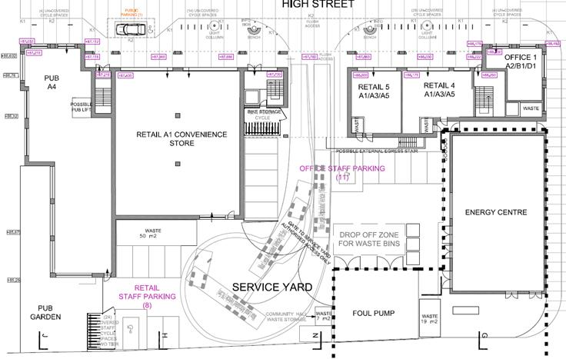



7 stands/14 spaces3 stands/6 spaces2 stands/4 spaces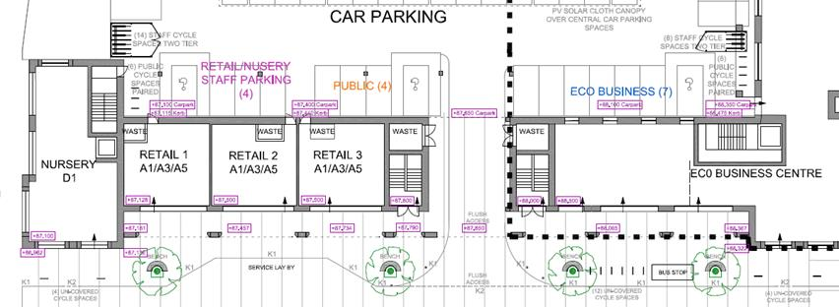

By my calculations, this would give you a new total (I have also counted those on the amended plan that I have not changed above) of 104 spaces for the public and 22 spaces for staff.  This is not far off what was proposed in the amended plan and I would much rather approve this than two tiered.  The developer may wish to continue with a two tier facility, however they would have to justify that they have suitable dimensions to fit such a facility in and this would mean implications on the car parking and tracking etc.

The condition would read as follows:

*Prior to the first use or occupation of the development hereby permitted, 15 covered Sheffield stands and 48 uncovered Sheffield stands shall be provided within the application site in accordance with the details submitted. The covered and uncovered cycle parking facilities shall be permanently retained and maintained for the parking of cycles in connection with the development.*

*Reason:   In the interests of sustainability and to ensure a satisfactory form of development, in accordance with Government guidance contained within the National Planning Policy Framework.*

***Pedestrian Crossings***

Due to the new cycle parking on the street, the pedestrian crossings have been removed from the High Street.  Given the fact that the whole street is a flushed surface, this should ensure that vehicles are moving at slower speeds through the area.  There is still opportunity to cross the road between the two sets of 4 cycle spaces at each end of the local centre.  This has the effect of moving people away from crossing in the central part of the High Street, where the entrances to the car parks are. Noted

***Car parking***

Public and staff car parking spaces remain the same as the original plan, totalling 80 spaces ( 34 public, 23 staff and 23 Eco Centre).  As stated in our previous comments in our original response, this is well below the maximum parking standards used by CDC.  The max parking standard for the Eco Business Centre and Nursery (intended predominantly for staff) alone, would total 84, so there is a significant risk that staff all-day parking will overspill onto the already very limited public parking and residential areas.  I cannot find any evidence that a parking management plan has been submitted for approval as of yet, which was something that was conditioned in our previous comments.  Has any such thing been received? No, but a planning condition has been recommended and will be included on the permission once issued and so we would deal with this via a DISC application in the future. Noted.

***Vehicle tracking***

The vehicle tracking for the service yard to the rear of the southern arcade, has been tracked for a refuse vehicle of 7.9m in length.  I wanted to raise this point, as this length is much shorter than the usual 10.5m vehicle tracking that we would normally ask for, for a development.  I am aware however, that this is for a commercial site, but it is still good to raise this issue at this stage, to ensure successful manoeuvring of any such vehicle.

The height of the archway into the service yard is on a gradient and ranges in height from 5.2m at the western end, to 5m at the eastern end.  I have noticed that no tracking (not that I can see) has been provided for a typical goods delivery vehicle delivering under this arch.  It would be extremely unacceptable for any such vehicle to pull up on the main High Street and more difficult now, that more cycle parking is present on the street.

Noted, but this was not raised by Jeff – the plan is annotated as ‘max legal articulated vehicle 16.5m’ – do you know what this refers to? In respect of the height, what is the average height of a HGV and does the height proposed raise concern?

Sorry, Caroline, I think I must have been looking at another earlier plan, so not sure where the 7.9m came from.  The tracking for the 16.5m is fine.  This just means that the maximum legal length for an articulated lorry is 16.5m in length and this is what they have tracked as a longest length scenario.  I believe that typical heights for articulated lorries are about 4.3 m, however, I would advise you to find out from the proposed retail store what height their lorries are, to ensure they can be accommodated.  On the whole this shouldn’t be an issue, but with the slight gradient laterally across the access, it would be safer to check.

***Waste storage behind the community centre***

By re-positioning the waste storage for the community centre adjacent to the cycle parking, it has only allowed for a 1100mm access passage to and from it.  It is likely that users that are dropping off waste will come from the building to the north and therefore, they might have difficulty carrying waste through this width to the drop off point. Noted

I have spoken to Joy about the details contained within my comments above and she agrees with me.

If you would like to discuss anything further, then please do not hesitate to contact me.

Kind regards,

*Kt Hamer*

*Asst. Transport Planner*

*Transport Development Control*

*Cherwell and West Localities Team*

*Oxfordshire County Council*

*Speedwell House*

*Oxford OX1 1NE*

*Mob: 07775 025229*

*Tel: 01865 815700*

**From:** White, Joy - E&E   
**Sent:** 15 January 2016 09:37  
**To:** Hamer, Katherine - E&E  
**Subject:** FW: Exemplar Local Centre Planning Application (reference 15/00760/F)

Hi Kt

Please see attached.

I think this is one that Jeff last dealt with – but it could have been me.  Anyway, could you have a look at this please and comment on whether parking and cycle parking are now acceptable (you should be able to find previous comments in the single response folder).  If it seems they have reduced the number of parking spaces this is not acceptable as there are barely enough anyway.

Let me know if you are swamped and can’t deal with this.  Monday/Tuesday would be fine.

Thanks,

Joy

**From:** Caroline Ford [<mailto:Caroline.Ford@Cherwell-DC.gov.uk>]   
**Sent:** 13 January 2016 10:40  
**To:** Kevin Larner; Vickie Zielinski; White, Joy - E&E  
**Subject:** FW: Exemplar Local Centre Planning Application (reference 15/00760/F)

Hi Kevin, Vickie, Joy,

In relation to the above application, you may recall this from late last year. One of the outstanding issues was that of the refuse storage for the community centre. This has now been moved to sit directly behind the cycle parking for this community centre, however, the implication of this is that the parking arrangement has slightly changed to the rear of the southern building. Can I have your comments on whether the refuse bin location is now acceptable (Kevin/ Vickie) and whether the resulting parking arrangements are acceptable (Joy)?

Kevin, Vickie, the internal layout of the community hall has also been reviewed and the internal store has been re-located. Can I have your thoughts on the amended internal layout for the community hall please?

If you need me to forward across the previous revision of these plans for comparison, please let me know - they are all scanned and available via public access however.

I am thinking about how to deal with this but thought it best to seek your comments initially.

Many thanks,

Caroline

**From:** Alex Wilson [<mailto:Alex.Wilson@bartonwillmore.co.uk>]   
**Sent:** 06 January 2016 14:01  
**To:** Caroline Ford  
**Cc:** [gyoung@higgsyoung.com](mailto:gyoung@higgsyoung.com); [steve.hornblow@a2dominion.co.uk](mailto:steve.hornblow@a2dominion.co.uk)  
**Subject:** Exemplar Local Centre Planning Application (reference 15/00760/F)

Afternoon Caroline

I hope you are well.

When we met on 23rd December, Gary presented to you a proposed waste storage strategy for the Exemplar local centre community hall and a revised community hall layout (storage room now within main room).

I have attached the plans which Gary presented. Could you please advise whether the waste storage strategy is acceptable?

Are you also able to advise whether the community hall layout can be addressed under delegated powers, or would we need to deal with this amendment separately, post issue of the local centre decision notice?

Many thanks

Alex  
  
***Alex Wilson***  
Associate  
  
Planning . Design . Delivery  
**bartonwillmore.co.uk**  
7 Soho Square  
London  
W1D 3QB  
  
t : 0207 446 6888  
f : 0207 4466 889  
[www.bartonwillmore.co.uk](http://www.bartonwillmore.co.uk)  
Please consider the environment before printing this email