**18/00836/LB**

**Goodmayes, Burdrop, Banbury**

**Alterations to the configuration of internal ground floor spaces, alterations to the main bedroom, raising of chimneys, partial re-design and replacement of ground floor fireplaces, re-painting of iternal beams, replacement of timber doors and the electrical rewiring of the property (retrospective)**

**Understanding the heritage assets affected**

Goodmays is an early 18th century building (with a date stone of 1724) and is grade II listed. The building was listed in September 1988 and the list description states that the interior was not inspected at the date of listing.

Goodmays lies within the Sibford Gower, Sibford Ferris and Burdrop Conservation Area.

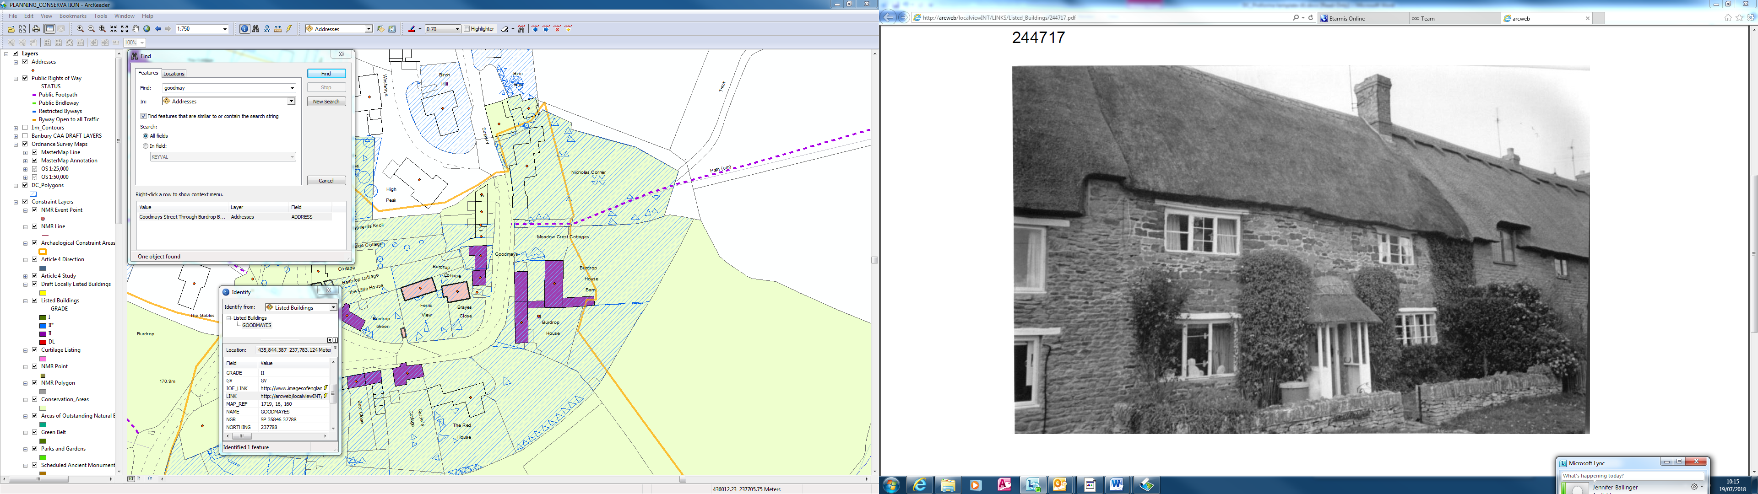

The photograph above was taken around the date of listing.

**Significance**

The list description is for identification purposes only and does not identify the significance of the building.

The significance lies in its vernacular character and survival of its historic form and fabric.

The building is listed in its entireity (inside and out) and the interior is of significance despite the fact that it was not viewed at the date of listing. This was usual for the area based surveys undertaken at the time of listing.

The building appears to have had a through passage plan form, which is a particular characteristic of the Banbury region.

**Proposals**

The work has already been carried out and the application is retrospective to regularise the work undertaken.

A Design, Access and Heritage Statement accompanies the application, but this appears to be very generic. The historic information within the document relates to the settlement as a whole and is heavily based on readily available sources of information (conservation area appraisal, historic maps). There is no indication that any detailed historic research has been done at the Local History Centre to ascertain whether there is any archive material relating to the property. Nor is there any reference to the planning history of the site (although there does not appear to be any).

The works listed in the application description are

* Alterations to the configuration of internal ground floor spaces
* Alterations to the main bedroom
* Raising of the chimneys
* Partial re-design and replacement of ground floor fireplaces
* Re-painting of internal beams
* Replacment of timber doors
* Re-wiring of the property

In addition the following works have been identified from a comparision of the photograph taken at the date of listing and the current building and rapid analysis of the building fabric

* Removal and replacement of 20th century porch
* Replacement of one of the ground floor windows
* Re-thatching of the building with a decorative rather than traditional flush ridge
* Conversion of door at rear of central passageway to window (this may have been prior to the date of listing)

**Appraisal of issues**

The issues will be considered individually

**Alterations to the configuration of internal ground floor spaces**

The main alteration has been to the central passageway which is shown on the ‘existing’ drawing as a cupboard. Analysis of the fabric at the rear of the building shows that the current window was originally a door (it is unclear whether this alteration took place before or after the date of listing) and therefore this was originally a passageway leading all the way through the property. The alignment of the central passage is therefore of significance to an understanding of the property.

* Given that there is no information to determine at what date the rear door to the passage was converted to a window it is not considered expedient to refuse this element.
* There are no objections to the utilisation of the space for a ground floor toilet and basin.
* The alignment of the passageway is however of significance and a partition and door should be reinserted to the dining room to the north of the cottage to retain this alignment.
* **Listed building consent to be given for conversion of cupboard to downstairs WC, partition and door to be reinstated to dining room**

**Alterations to the main bedroom**

The works have involved the removal of an internal partition (the current owner suggests 20th century hardboard) and the ceiling of the room. The construction of a mezzanine floor. It is unclear whether there have been any alterations to the timber roof structure.

The alterations to the main bedroom are significant and have involved the loss of a substantial amount of historic fabric as well as the traditional proportions of the room. There is also the possibility that there have been works to the roof which have undermined the structural properties of the building. The removal of ceiling joists is likely to have weakened the structure as these would have provided a triangular tie for the roof construction.

* It is possible that the partition between the two rooms was 20th century and there is no need to reinstate this.
* The works to remove the ceiling have had a significant detrimental impact. Remaining historic fabric in the mezzanine area shows historic wide timber boards which are likely to have continued across the length of the room. The owner suggests that the ceiling was sagging and fell down as a result of the works to remove the partition. This suggests that there was a lath and plaster ceiling in this area.

**Listed building consent should not be retrospectively granted for this area. The ceiling should be reinstated including the use of floor joists, wide timber boards and a lath and plaster ceiling. Full details will need to be submitted for listed building consent.**

**Raising of the chimneys**

The photograph taken at the date of listing shows a chimney of a similar height as the existing, but constructed of historic brick and with greater detailing. It is possible that the chimneys had previously been lowered and were then heightened again. The existing chimneys are constructed of a standard modern brick which is not traditional to the area. There are has been a loss of significance to both the listed building itself and the character and appearance of the conservation area with the loss of material and detailing to the chimneys.

The chimneys were put in as part of works to insert wood burning stoves to the property. There are usually significant concerns with installing stoves to thatched properties due to the increased risk of fire. It needs to be demonstrated that the stoves comply with up to date fire regulations.

* If the stoves do not comply with up to date fire regulations they should be removed or a separate application submitted to indicate the required works to ensure they do comply. The impact on the significance to the property can then be assessed.
* If the stoves do comply with up to date fire regulations the height of the chimney will need to remain, but the correct material and detailing need to be reinstated.
* **Further information required before a decision can be taken on the way forward. The chimneys will need to be rebuilt in any case, but the key issue will be to what height.**

**Partial re-design and replacement of ground floor fireplaces**

The current owner has provided photographs of the fireplaces as they were at the time of his purchase of the building

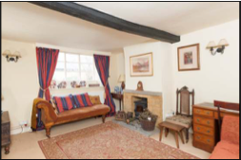 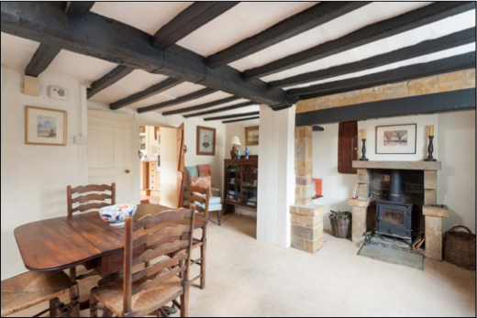

The fireplace to sitting room was clearly a modern insert and there are no objections to its alteration.

The fireplace to the dining room was originally an inglenook which has been substantially re-modelled with the insertion of a modern brick chimney (possibly prior to the date of listing). There are no objections to the removal of the 20th century surround shown on the photpgraph above.

**Listed building consent to be granted for alterations to 20th century fireplaces in sitting room. No objection to removal of 20th century surround. The owners should be encouraged to submit a new application for the reconstruction fo the inglenook fireplace.**

**Re-painting of internal beams**

The photographs above show the internal beams painted black at the time of the purchase of the building by the current owner. This appears to be a 20th century addition and the beams have now been painted white. It is unclear what method was used for cleaning of the beams or what type of paint has been used and whether this was breathable. The timber beams would have originally been exposed wood.

* There would be no benefit to returning the beams to be painted black.
* Depending on the paint used there could potentially be a detrimental impact on the historic fabric of the beams through the use of paint.
* It may be beneficial to remove the paint and re-expose the timber beams, but advice from a specialist company would be required.A sample area of cleaning should be required to ensure the cleaning does not damage the suface of the beam / tool marks / carpentry marks etc.

**Listed building consent to be issued, but consideration should be given to re-exposing beams subject to specialist advice (listed building consent would be required for this).**

**Replacment of timber doors**

The Heritage Statement indicates that the doors that were removed were ‘outdated’ and ‘incongrous’, but there is no mention of their design or date. The current doors simple plank doors of an appropriate design and material. There are no objections to the current doors.

**Listed building consent to be granted for this matter.**

**Re-wiring of the property**

The property would have required listed building consent for rewiring and care should be have been taken to avoid disruption of historic fabric. The work has now been done and greater harm would be caused by undoing the work.

**Listed building consent to be granted.**

**Removal and replacement of 20th century porch**

The porch has been changed since the date of listing. The listing description acknowledges that the porch is of 20th century date therefore there is no loss of historic fabric, but the pitch of the canopy at the date of listing is more appropriate than the current canopy.

**Porch canopy to be replaced with one similar to that at date of listing when porch needs rethatching**

**Replacement of one of the ground floor windows**

The window to the southern side of the building at the ground floor has changed since the date of listing. This was not assessed on site, but a photograph of the building indicates that the style of the window is largely appropriate. This will need to be confirmed with a drawn record of the replacement window to be regularised.

**Listed building consent likely to be forthcoming.**

**Re-thatching of the building with a decorative rather than flush ridge**

The building has been rethatched since the date of listing with a decorative ridge rather than a flush ridge. A flush ridge would have been the traditional and historic treatment and should be re-instated, but this can wait until the thatch needs to be re-done. A planning note should be made to this effect.

**Conversion of door at rear of central passageway to window**

This has been discussed above. The view is taken that this is likely to have taken place prior to the date of listing and therefor listed building consent is not required.

**Level of harm**

Less than substantial, but significant.

**Recommendation**

Split decision. Some elements acceptable, others require additional information, others should be refused and work reinstated.

**Jenny Ballinger, 19th July 2018**