**From:** Joyce Christie   
**Sent:** 03 July 2018 14:05  
**To:** Bob Neville  
**Cc:** Nathanael Stock  
**Subject:** 18/00616/F Initial comments

Hi Bob

I have the following comments on the changes.

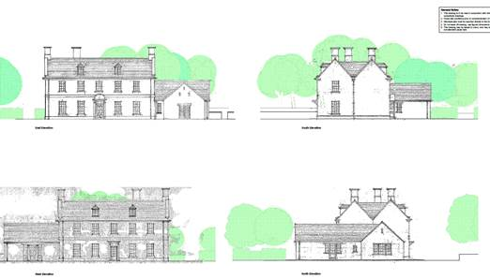 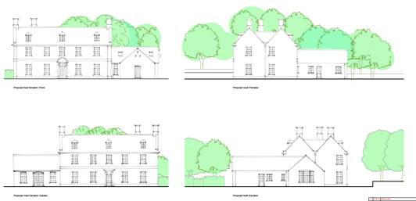

No objections to the dormer positions it looks better balanced than the previous scheme.

I am still concerned about the depth of the plan and pitch looking like a bungalow attached to the side of the main house.

The arched heads on the single storey element looks forced.  I would keep the trabeated head on the gable and west elevations and the south ground floor window – the single storey wing that runs off the kitchen could have arched heads.

I have no objections to the single storey element moving back from the front elevation.

Rooflight positions on east elevation the left hand one looks to straddle where you would expect a common rafter to come down relative to the ‘lay board’/’valley rafter’ for the roof that adjoins it.

We have 2 additional windows on the south elevation – their position on the gable avoids the chimney which is more authentic – perhaps the same could be done for the windows in the front pile?

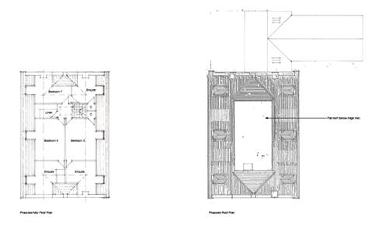

We need to see how rainwater discharges of the flat roof and the detail with the ridge to the pirched roofs.

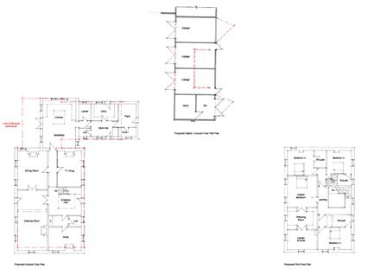

**Best wishes**

**Joyce Christie**

**Conservation Officer**  
**Design and Conservation Team**

**Place and Growth Directorate**

Cherwell and South Northamptonshire District Councils  
Direct Dial Number: 01295 221608

Extension Number: 1608  
Email Address: [joyce.christie@cherwellandsouthnorthants.gov.uk](mailto:joyce.christie@cherwellandsouthnorthants.gov.uk)

[www.cherwell.gov.uk](http://www.cherwell.gov.uk/)

[www.southnorthants.gov.uk](http://www.southnorthants.gov.uk/)

Please be advised that this email contains informal Officer advice only that cannot prejudice any decision of the Local Planning Authority.

This e-mail (including any attachments) may be confidential and may contain legally privileged information. You should not disclose its contents to any other person. If you are not the intended recipient, please notify the sender immediately.

Whilst the Council has taken every reasonable precaution to minimise the risk of computer software viruses, it cannot accept liability for any damage which you may sustain as a result of such viruses. You should carry out your own virus checks before opening the e-mail(and/or any attachments).

Unless expressly stated otherwise, the contents of this e-mail represent only the views of the sender and does not impose any legal obligation upon the Council or commit the Council to any course of action.

This e-mail (including any attachments) may be confidential and may contain legally privileged information. You should not disclose its contents to any other person. If you are not the intended recipient, please notify the sender immediately.

Whilst the Council has taken every reasonable precaution to minimise the risk of computer software viruses, it cannot accept liability for any damage which you may sustain as a result of such viruses. You should carry out your own virus checks before opening the e-mail(and/or any attachments).

Unless expressly stated otherwise, the contents of this e-mail represent only the views of the sender and does not impose any legal obligation upon the Council or commit the Council to any course of action.