Our ref: | Q210286
Your ref: | 21/03177/F
Email: | johnathan.welton@quod.com
Date: | 17 January 2022
Caroline Ford
Cherwell District Council
Development Management
Bodicote House
Bodicote
Banbury
OX15 4AA
By Email
Dear Caroline
Axis J9, Bicester
Applicant Response to LLFA objection
I write on behalf of the applicant in connection with the above planning application for employment development at Axis J9.
Please find enclosed a Site-Specific Flood Risk and Drainage Strategy which has been issued on behalf of the applicant in response to the comments made by the Lead Local Flood Authority, dated 23 November 2021. This assessment provides further details relevant to the application and addresses concerns raised by the consultee.
We look forward to hearing feedback on this additional information. Should you require any further queries please do not hesitate to contact me or my colleague, Emma Lancaster.
Yours sincerely

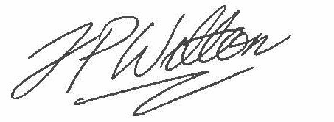

Johnathan Welton
Assistant Planner

enc. As noted
cc. Kelvin Pearce, Albion Land

