Caroline Ford

Principal Planning Officer

Development Management

Cherwell District Council

Bodicote House

White Post Road

Bodicote

Banbury

OX15 4AA

22nd May 2018

Dear Caroline,

**FURTHER INFORMATION TO DISCHARGE CONDITION 19 ‘MATERIALS AND FINISHES’ OF PLANNING PERMISSION ‘10/01780/HYBRID’ and ‘17/00116/NMA’ RELATING TO PHASES 3 AND 4, ELMSBROOK, BICESTER**

Following recent correspondence, you highlighted a potential concern in relation to the elevational treatment to the enriched brick units. You highlighted a concern that because the unit has a particularly tall brick flank wall, the protruding brick detail proposed on the lower third of the wall needed greater distinctiveness by either mixing the colour of texture of the bricks. By using the same brick for the entire detailing could lead to blandness and monotony.

As such, we wish to propose mixing a light and dark brick to highlight this particular architectural detail. The majority of the house is proposed as ‘Rural Multi’ brick by Freshfield Lane– a sample of which you have already received. We propose that the producing brick as part of the architectural detail to be a darker coloured brick, constrating against the Rural Multi.

We propose the darker protruding brick to be ‘Selected Dark’ by Freshfield Lane.

The below technical drawing shows the proposed mixture of the two bricks.



Upper Façade – Rural Multi Brick

Protruding Brick – Selected Dark Brick

Flush Brick – Rural Multi Brick

Accompanying this letter is a sample panel of the ‘Selected Dark’ brick by Freshfield Lane . I hope you will be able to compare the brick against the previous sample panel of ‘Rural Multi’ that was sent through a couple of weeks ago. A visual mock-up of the façade detail is as below.

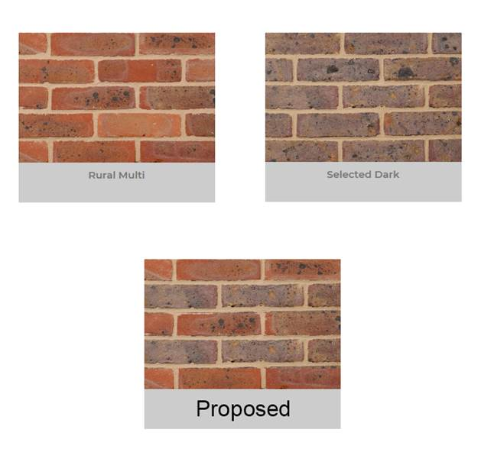We believe that because the proposed brick is produced by the same manufacture as the acceptable ‘Rural Multi’, the texture and finish would complement as opposed to clash with the rest of the façade. In addition, the colour tone provides enough of a contrast to highlight the architectural detail avoiding a monotonous and dull façade.

If acceptable, we would seek to place the brick order as soon as possible in order not to delay the procurement programme. I look forward to your response.

Yours Sincerely,

Andrew North

Development Manager

cc- Estelle Hutchinson, Strutt and Parker