**From:** Richard Ponsford   
**Sent:** 04 May 2017 21:37  
**To:** Planning  
**Subject:** Planning application 15/00837/OUT

Dear Sir/Madam,

In October 2014, I wrote to CDC to express my concerns about the modifications to the local plan with specific regard to the Gavray Meadows (otherwise known as Bicester 13). I attach that letter for reference; the concerns it raises still hold true nearly 3 years on.

It is with both great sadness and considerable frustration that I find myself writing again to voice my strong objection to the application for 300 houses to be built on Gavray Wildlife Meadows. I was utterly shocked that the developer had the sheer affront (and indeed the power) to take CDC to the High Court and have the Council’s initial decision to decline their original application successfully overturned. I am also flabbergasted by their insistence that building these 300 homes on this historic haven for rare wildlife will actually increase biodiversity! An audacious and highly dubious claim, to say the least.

As a designated Conservation Target Area, and one of such historical and natural significance, Gavray Meadows should be rigorously protected and preserved for future generations, especially so if any of the Healthy/Garden/Eco Town tags are to mean anything at all for Bicester.

I find it very hard to believe that given the scale of development that is already underway in Bicester, this relatively small piece land – beloved of the local people, home to some astounding species, and a great asset to the town – cannot be spared.

Furthermore, given the developer’s vehement determination to build on Gavray Wildlife Meadows (for, in construction terms, relatively small financial gains), it is rather distasteful to find the marketing team at south-west Bicester’s brand new Kingsmere estate openly boasting about their newly-planted ‘enhanced’ wildlife habitats as an asset to attract potential buyers, while residents of Langford Village are being made to fight for the protection of one that is centuries old.

Yours faithfully,

Mr Richard Ponsford

(Langford Village Community Association committee member)

30 Ravencroft

Bicester

OX26 6YQ

01869 321661

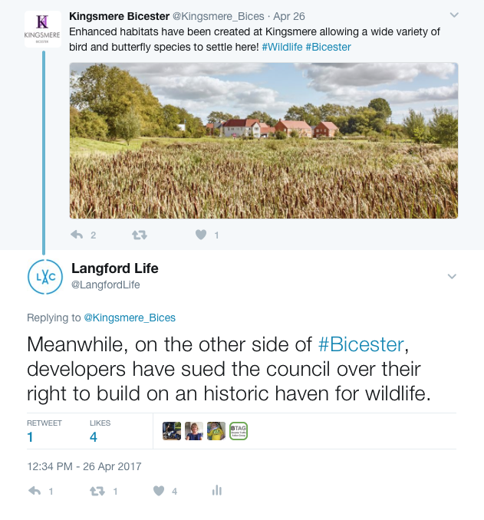

Dear Sir/Madam,

Reference: Schedule of Proposed Main Modifications to the (Submission) Local Plan (August 2014)

Proposed housing developments at the South East Bicester (Bicester 12) and Gavray Drive (Bicester 13) sites

I write in connection with the above proposal. I live in close proximity to both sites and know them well. I wish to object strongly to the proposed developments as well as some of the modifications to the Local Plan.

Firstly, the Gavray Drive site (Bicester 13) is home to a wide variety wildlife species, including several that are of protected status. The meadows there are much cherished by the existing community. Not only is the area enjoyed regularly by residents, naturalists and dog walkers, but it is not without considerable historical significance. It is my belief that Gavray wildlife meadows should be granted a new designation as a Local Green Space, and hereby request that Cherwell District Council consider the site for such status, given that it fulfils all the criteria for LGS’s set out in para 77 of the National Planning Policy Framework. Building on this space can only lead to demise of wildlife and the diminishing of much valued local countryside.

My other overriding concern regarding the development of this site, is that of flooding. I would like to bring to your attention the fact that Gavray Meadows becomes marshland during the winter months, and development of the site could force floodwater to instead travel downstream, putting the existing housing that backs onto the Langford Park area under threat of flooding from Langford Brook. Langford Brook already floods with alarming frequency, and I believe that building on the Gavray Meadows marshland would exacerbate an already worrying, all-too-frequent problem.

I would also like to strongly object to the proposed development of the Bicester 12 site. Currently Wretchwick Farm, and a so-called Conservation Target Area, I think it is quite out-of-step to earmark this site as a potential joint residential and industrial area. The proposal states:

• Development proposals should seek to protect cultural heritage and archaeology. A scheme which respects the setting of Wretchwick Deserted Medieval Settlement with an appropriate landscape buffer to maintain the open setting of the scheduled monument. An indicative Safeguarding Area is shown on Map Bicester 12 (Appendix 5). Development proposals should seek to protect cultural heritage and archaeology, in particular Wretchwick Deserted Medieval Settlement, a Scheduled Ancient Monument, and incorporate an appropriate landscape buffer in consultation with English Heritage, to maintain the SAM’s open setting. In consultation with English Heritage, appropriate public access and interpretation facilities should be provided.

I would strongly argue that the current proposal does NOT attempt to preserve the areas of historical interest that that can be found at Bicester 12 . Building a huge housing estate and an industrial area with employment for 3,000 people on this site – with all the traffic and pollution that would bring - is hardly safeguarding these ancient and important historical sites.

Furthermore, the road that is intended to feed this new industrial site (running from the A41, behind Graven Hill, finishing up at the Gavray Drive roundabout) is not identified anywhere on the local Plan! I would suggest this is a major oversight, and the plan is therefore unsound.

Finally, I would also like to remind Cherwell Dictrict Council of the original plan to build just 400 homes on Bicester 12 - significantly fewer than the newly proposed 1,500 and increasing the area from 40 to 155 hectares! The impact of an additional 1,500 homes on South East Bicester (as opposed to 400), plus an industrial park, would be colossal, and this ‘modification’ to the Local Plan should not go unnoticed.

Please also remember Bicester’s ill-fated Kingsmere estate which, despite the fanfare, hasn’t exactly gone according to plan, and required the levelling of vast areas of once dense flora which has still yet to be built on. Can you be certain that demand for housing on Bicester sites 12 & 13 will be great enough to warrant similar sacrifice?

I have lived on Langford Village estate for a decade, and have come to know many of the people who also live there, as well as a good number of people who reside elsewhere in Bicester. It is a great surprise to me that when asked, they know very little, if nothing at all about the Local Plan and the proposals for Bicester 12 & 13 (let alone the modifications). Cherwell District Council are obliged to seek the views of local people when considering sites for development, but in this case, public information regarding the modifications has been esoteric at best, and the readiness to consult with Bicester residents unforthcoming. I would therefore suggest that the Local Plan is unsound given that public consultation in the lead-up to submission has been inadequate.

I understand that the associates of the Langford Village Community Association share these concerns as well as having objections relating to other aspects of the Local Plan. I urge the councillors to give serious consideration to all points raised by concerned members of the public before deciding the shape of Bicester’s future later this month. I look forward very much to hearing the outcome.

Yours faithfully

Mr Richard Ponsford

30 Ravencroft  
Bicester  
OX26 6YQ

Tel: 01869 321661