**From:** Iain Osenton   
**Sent:** 01 August 2018 13:58  
**To:** Clare O'Hanlon  
**Cc:** Caroline Morrey  
**Subject:** RE: Application No: 18/00792/OUT, land at Tappers Farm, Oxford Road, Bodicote

Hi Clare,

I have had a look at the trees proposed to be removed and offer the following comments, for clarity I have attached a screenshot of the trees, T8 on the right with purple flowers, and T6 to the left, the smaller tree in the centre of the field.

T6 – Overall I agree with the report, and categorisation of the tree however do have some concerns. The tree has grown much larger than is expected of a hawthorn, and such in my opinion has gained far greater amenity value than it would have had when the TPO was placed upon it in 1993. Equally the report inherently doesn’t detail the ecological value presented by a tree that could arguably be classed as a tree of notable ecological value. The defects mentioned in the reports comments are correct in that there is an area of decay at the base, however on inspection I felt the tree is showing signs of reaction wood that do not compromise its structure in its current location. Whilst it may not be suitable for retention within close proximity to development I do not believe the defects present in its current location would justify its removal as a protected tree.

T8 – Again I agree with the categorisation and report against this tree however do not feel the defects mentioned give sufficient evidence to remove the tree. The tree offers considerable amenity not only to the site, but passers-by (see snip from oxford road). the seasonal pink flowers offer great visual diversity to the location. There are no defects present on the tree that with correct management, would prevent the tree from standing for another 10 - 20 years. I object to the removal of this tree to facilitate development due to its protection status, and visual amenity.

T7 – I'm not sure if this has been mentioned prior, or if it was requested of me however I share concerns that T7 is plotted extremely close to proposed plot 07/06 that will most certainly call for pruning works, or even removal once the properties are occupied. I do not believe the proposed layout accommodates the tree in the long term.

Also, the TPO document from 1993 states in its statement of reasons for the TPO as *“several proposals for new development and road connections have been put forward within the vicinity of the site. It is the opinion of the local planning authority that the trees specified in the order should be afforded the protection of a tree preservation order and should be preserved under a direction of section 198 and 201 of the town and country planning act 1990 - taking effect immediately”* – the trees were originally protected due to development pressures, as their amenity and condition was assessed as able to *“offer considerable amenity for many years to come*”. I believe this statement is still valid and thus object to removal of the TPO trees to facilitate development.

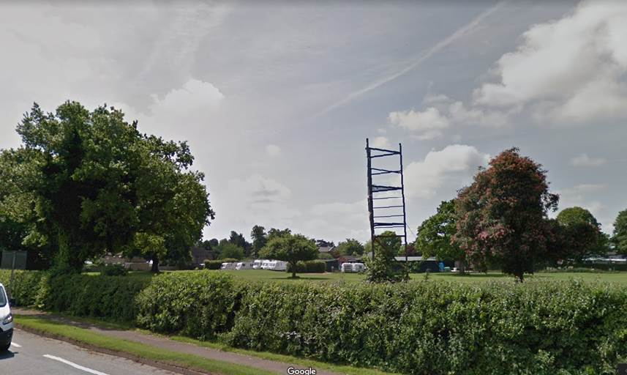

I hope that helps, please let me know if you need anything further.

Kind regards,

**Iain Osenton**

Arboricultural Officer (South)

Environmental Services

Cherwell District & South Northants Councils

**Phone**01295 221708

<mailto:iain.osenton@cherwellandsouthnorthants.gov.uk>

[www.cherwell-dc.gov.uk](http://www.cherwell-dc.gov.uk/)

<www.southnorthants.gov.uk>

[www.facebook.com/cherwelldistrictcouncil](http://www.facebook.com/cherwelldistrictcouncil)

[www.facebook.com/southnorthantscouncil](http://www.facebook.com/southnorthantscouncil)

Follow us on Twitter: @Cherwellcouncil

Follow us on Twitter : @SNorthantsC

This e-mail (including any attachments) may be confidential and may contain legally privileged information. You should not disclose its contents to any other person. If you are not the intended recipient, please notify the sender immediately.

Whilst the Council has taken every reasonable precaution to minimise the risk of computer software viruses, it cannot accept liability for any damage which you may sustain as a result of such viruses. You should carry out your own virus checks before opening the e-mail(and/or any attachments).

Unless expressly stated otherwise, the contents of this e-mail represent only the views of the sender and does not impose any legal obligation upon the Council or commit the Council to any course of action.