**Sent:** 02 November 2017 18:56  
**To:** Planning  
**Subject:** FW: 17/01981/F  Change of use from A4 to C3 (ACV Listed) | The Pheasant Pluckers Inn Street Through Burdrop Burdrop Banbury OX15 5RQ

**FAO  
Bob Neville MSc**  
Senior Planning Officer  
Development Management  
Cherwell District Council  
   
I wish to object to this application 17/01981/F | Change of use from A4 to C3 (ACV Listed)  
for the following reasons:  
   
1.The viability of the Bishop Blaize/Bishops End/Pheasant Plucker has been commented on by a planning inspector (**From Sara Morgan’s report**  
Section 25) “*There was little evidence from the appellant to suggest that at the time of this marketing exercise the Bishop Blaize could not be a viable public house in the long term. It had clearly been viable under the previous owners not so very long before. Mr and Mrs Noquet were making losses while the public house was still open but that appears to have been specifically due to a dispute between Mr and Mrs Noquet and the village. That does not mean to say that the Bishop Blaize could not be viable under another operator”*  
  
Nothing has changed apart from The Noquets are only opening the Bishop Blaize/Bishops End/Pheasant Plucker 4 hours in some weeks and not open at all in other weeks purely as an attempt to not get prosecuted for living in the accommodation that has the planning condition that it be only occupied as an ancillary to the running of the Public House. A PUBLIC HOUSE CANNOT BE VIABLE IF IT IS NOT OPEN!!  
   
2.The attempted sale of The Bishop Blaize/Bishops End/Pheasant Plucker  
  
  
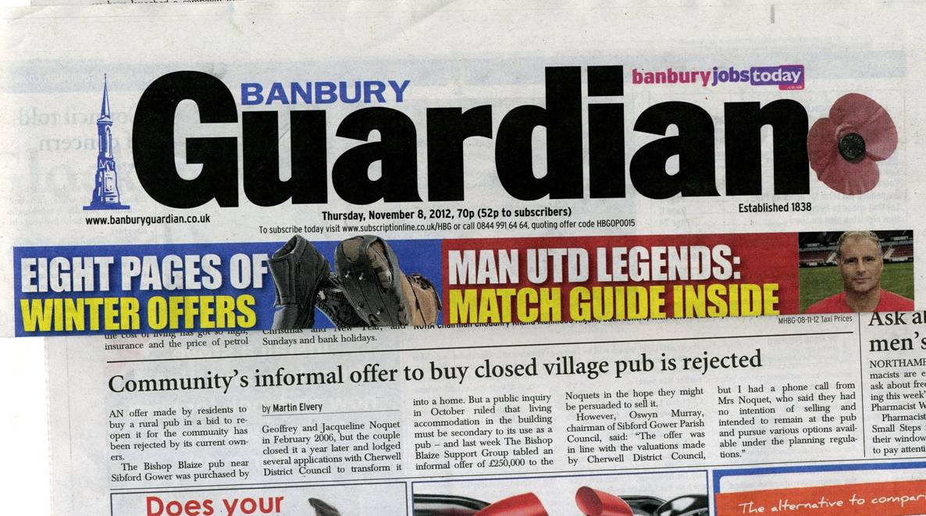  
Over the past 10 years the Noquets have had at least three different agents market the Pub it was sold by Fleurets but Mr Noquet insisted on putting a development clause in the contract which scuppered the sale because the Lender would not lend with that clause on the title. The Pub was also marketed by Mark David estate agents and they described it as a house and trading standards stopped the sale as it was being miss described. Then Sydney Philips marketed the Pub and after a short while only Cash buyers were allowed to be shown around.  
In other words the Pub was on the market but not for sale.  
   
3. If it was marketed at a sensible price it would sell easily, bear in mind that the Pub needs a lot of money spending on it to return it back to its former glory.  
   
4. With the right Landlords the  Bishop Blaize/Bishops End/Pheasant Plucker could easily be the best public house around here however it is overpriced for its current state and closed for most of the time.  
   
**Please Refuse the application**  
   
Tony Haynes  
Cubbs Cottage,  
Hawkes Lane  
Burdrop.  OX15 5RL