**From:** Chillman, Barbara - CEF [<mailto:Barbara.Chillman@Oxfordshire.gov.uk>]   
**Sent:** 03 June 2019 14:39  
**To:** James Kirkham  
**Subject:** RE: Oxfordshire County Council’s response to 18/02147/OUT Stone Pits Hempton Road Deddington

Hi James – we have checked, and can confirm that the contribution would comply with pooling regulations.

Barbara

**From:** James Kirkham <[James.Kirkham@cherwellandsouthnorthants.gov.uk](mailto:James.Kirkham@cherwellandsouthnorthants.gov.uk)>   
**Sent:** 08 May 2019 16:59  
**To:** Chillman, Barbara - CEF <[Barbara.Chillman@Oxfordshire.gov.uk](mailto:Barbara.Chillman@Oxfordshire.gov.uk)>  
**Subject:** RE: Oxfordshire County Council’s response to 18/02147/OUT Stone Pits Hempton Road Deddington

Hi Barbara

Thanks for your information on this.  The applicants now appear to be agreeing to pay the contribution.  Could you please confirm that the contributions would comply with the CIL regulations in relation to pooling restrictions?   The applicant has stated that they have seen a report which indicate that the 4 contributions had already been secured nearly 4 years ago.

Thanks

Kind regards

**James Kirkham BA (Hons) MSc MRTPI**

**Principal Planning Officer – General Developments Planning Team**

Development Management

Place and Growth Directorate

Cherwell District Council and South Northants District Council

Direct Line: 01295 221896

[**www.cherwell.gov.uk**](http://www.cherwell.gov.uk/) or [**www.southnorthants.gov.uk**](http://www.southnorthants.gov.uk/)

**Follow Us:**

Facebook [www.facebook.com/cherwelldistrictcouncil](http://www.facebook.com/cherwelldistrictcouncil)

or [www.facebook.com/southnorthantscouncil](http://www.facebook.com/southnorthantscouncil)

Twitter @cherwellcouncil or @southnorthantscouncil

**From:** Chillman, Barbara - CEF [<mailto:Barbara.Chillman@Oxfordshire.gov.uk>]   
**Sent:** 02 April 2019 16:27  
**To:** James Kirkham  
**Cc:** Chillman, Barbara - CEF  
**Subject:** FW: Oxfordshire County Council’s response to 18/02147/OUT Stone Pits Hempton Road Deddington

Hi James – sorry for the delay.

For ease, this email includes information previously provided, so that you can use it as a complete response.

The decision to expand Christopher Rawlins School was taken in the explicit context of the (then draft) Cherwell District Council Local Plan, which set an expectation of housing growth in Adderbury and Deddington. In addition, at the time we committed to the expansion,  Cherwell had not adopted their Local Plan and did not have a 5 year land supply in place, and were experiencing pre-emptive applications from landowners and/or developers. Planning appeal decisions at that time made it clear that there would be housing growth in this area.

There was insufficient primary school capacity in the Adderbury/Deddington area for housing growth, and therefore expansion of a school was required. Following extensive feasibility assessment, it was identified that the most viable solution would be to expand Christopher Rawlins School to create the necessary capacity to serve housing development across both villages. The expansion is therefore directly related to this development.

As Christopher Rawlins (and also Deddington Primary School) was already a 1 form entry school, the smallest feasible expansion was to increase it to 1.5 form entry. This was more than would be required by the housing permitted at that time, but created capacity to allow for future housing developments, such as this site. The expansion was therefore necessary to make this development acceptable in planning terms, as without it, there would not have been sufficient school places.

The county council has a statutory duty to ensure sufficient school places. We cannot wait until there is a shortage before we take action – we have to ensure that shortage does not arise. It is not possible to wait for all housing development to be completed, or even permitted, before expanding school capacity. Children at the earliest housing occupations need to have a school to go to, they can’t wait  a few years until the rest of the houses are completed/permitted. We therefore need to commence the expansion in good time to ensure the school places are available when needed, forward funding the cost from council resources ahead of s106 funding being available. It was on this basis that the capital project to expand Christopher Rawlins was approved – the OCC governance approval document (attached, see section 3) makes clear that further s106 contributions will be sought. We now seek from this development a contribution towards the cost of this project based on the expected pupil generation and the per pupil cost of the expanding the school. The contribution is therefore fairly and reasonably related in scale and kind to the development.

The CIL tests are, in our opinion, met in this case:

* The expansion was necessary for us to be able to accept this housing growth
* The expansion creates sufficient capacity for this housing growth and therefore is directly related.
* The contribution is proportionate in scale and kind.

The NPPG on Use of *planning obligations and process for changing obligations* was updated on 15 March, and helpfully clarifies (but doesn’t fundamentally change) education contributions: <https://www.gov.uk/guidance/planning-obligations>. Of relevance here are:

*Paragraph: 007 Reference ID: 23b-007-20190315: “Government provides funding to local authorities for the provision of new school places, based on forecast shortfalls in school capacity. There is also a central programme for the delivery of new free schools. Funding is reduced however to take account of developer contributions, to avoid double funding of new school places. Government funding and delivery programmes do not replace the requirement for developer contributions in principle.”*

*Paragraph: 008 Reference ID: 23b-008-20190315: “When local authorities forward-fund school places in advance of developer contributions being received, those contributions remain necessary as mitigation for the development.”*

The information attached details three appeals in West Oxfordshire where we were successful in securing retrospective funding. Should this site end up at a planning appeal, and the retrospective contributions be raised as an issue, we would expect to defend our case again.

With reference to Mr Dobson’s specific questions:

1.

The question raised of “how far back” retrospective funding can be sought can be answered with reference to the CIL tests: did the expansion in question provide the necessary capacity for the proposed development? If the expansion has already been filled by other developments/population growth, then it would not be compliant to seek funding, but that is not the case here.

The key issue is that schools cannot be expanded in small increments related to each individual development – realistically, a primary school has to go up in increments of half a form of entry, which may (as here) provide sufficient capacity for a number of developments, not all of which may have been permitted at that time.

Putting aside education operational requirements, hypothetically we could have expanded the school by one room at a time, in which case the final room would not yet have been built, and the development in question would have been required to pay towards the not-yet-built classroom. However, this would be hugely disruptive for the school, damaging to the education of pupils (including those who will live at the proposed development) and increase total building costs – requiring a higher level of contribution from each development. Why should the development escape payment, and why should developers have to pay higher contributions overall,  because we have instead completed all of the expansion in one project?

2.

The contribution can and will be spent – it will be spent on repaying the forward funding provided by the council.

3.

When Mr Dobson says that central government provides 90% of the funding for school places at VA schools, he is referring to the “Basic Need” funding referred to in Paragraph 007 of the new NPPG. Basic Need funding is intended to fund school expansion which cannot be funded from developer contributions – e.g. they are due to general population growth and not housing. Where expansion is required for housing growth, the government is clear this should be funded by developers. If Basic Need funding has to be used to support housing-related expansions, it is then not available to fund other expansion. The payment of the S106 sought in this case would free up Basic Need funding for the use to which it should be put – i.e. expanding schools which cannot be funded from s106. (To be clear, OCC has received no funding from government specifically for Christopher Rawlins School, as Basic Need is provided based on area-wide forecasts of need, and not for specific schools.)

It is therefore not the case that the county council needs to repay the government, rather that future Basic Need allocations will be reduced to reflect the s106 contribution. In effect, central government forward funds the county council via Basic Need so that the council can forward fund against future s106.

Mr Dobson’s reference to the Diocese funding 10% of capital projects only relates to the use of Local Authority Co-ordinated Voluntary Aided Programme (LCVAP) funding. LCVAP is principally to enable schools to fund capital maintenance projects which are beyond the scope of the Devolved Formula Capital Grant. It is primarily used for essential R&M works. As with Basic Need it is not a substitute for developers funding to mitigate the impact of their development.

Best wishes

Barbara Chillman   
Pupil Place Planning Manager  
Access to Learning

Oxfordshire County Council

County Hall  **|** New Road **|** Oxford **|** OX1 1ND   
 07554 103418   
    
[The Oxfordshire Pupil Place Plan is available on the county council's website.](https://www.oxfordshire.gov.uk/cms/content/pupil-place-plan) *.*

**From:** James Kirkham <[James.Kirkham@cherwellandsouthnorthants.gov.uk](mailto:James.Kirkham@cherwellandsouthnorthants.gov.uk)>  
**Sent:** Monday, March 18, 2019 3:34:36 PM  
**To:** Chillman, Barbara - CEF  
**Cc:** Planning Consultations - E&E  
**Subject:** RE: Oxfordshire County Council’s response to 18/02147/OUT Stone Pits Hempton Road Deddington

Hi Barbara

Thanks for your email below.  The applicant has come back to me with the attached response outlining why he does not consider we can pursue the education contribution.  Could I please have your thoughts?

I will need to discuss with my senior managers  and it would be extremely helpful if you could point me in the direction of any committee paper or any other evidence which clearly outlines that the extension to Adderbury school was forward funded on the basis that the funding would be collected from developers of sites in Adderbury and Deddington (given this is not a site allocated in the Local Plan) in the future?

Kind regards

**James Kirkham BA (Hons) MSc MRTPI**

**Principal Planning Officer – General Developments Planning Team**

Development Management

Place and Growth Directorate

Cherwell District Council and South Northants District Council

Direct Line: 01295 221896

[**www.cherwell.gov.uk**](http://www.cherwell.gov.uk/) or [**www.southnorthants.gov.uk**](http://www.southnorthants.gov.uk/)

**Follow Us:**

Facebook [www.facebook.com/cherwelldistrictcouncil](http://www.facebook.com/cherwelldistrictcouncil)

or [www.facebook.com/southnorthantscouncil](http://www.facebook.com/southnorthantscouncil)

Twitter @cherwellcouncil or @southnorthantscouncil

**From:** Chillman, Barbara - CEF [<mailto:Barbara.Chillman@Oxfordshire.gov.uk>]   
**Sent:** 06 February 2019 08:09  
**To:** James Kirkham  
**Cc:** Planning Consultations - E&E  
**Subject:** RE: Oxfordshire County Council’s response to 18/02147/OUT Stone Pits Hempton Road Deddington

Hi James

I can respond on the Education issue. It is very common for us to secure s106 towards building projects which we have completed, where those building projects have created the necessary capacity to serve the development, and without which we would have had to object due to lack of school capacity.

Finding a named example is tricky, as we don’t store our data in a way that makes it easy to search in that particular way, but so far I have identified Land at Land At Lince Lane (15/00822/F) signed 17/11/16 with a contribution towards the rebuilding & expansion of Bletchingdon Primary School, which was completed 2015. There will be others as well, but perhaps not in Cherwell.

In the hopes of not having to plod through dozens more folders, I can give you a fuller explanation of why we think this type of contribution is CIL compliant.

The decision to expand Christopher Rawlins School was taken in the explicit context of the (then draft) Cherwell District Council Local Plan, which set an expectation of housing growth in Adderbury and Deddington. In addition, at the time we committed to the expansion,  Cherwell had not adopted their Local Plan and did not have a 5 year land supply in place, and were experiencing pre-emptive applications from landowners and/or developers. Planning appeal decisions at that time made it clear that there would be housing growth in this area.

There was insufficient primary school capacity in the Adderbury/Deddington area for housing growth, and therefore expansion of a school was required. Following extensive feasibility assessment, it was identified that the most viable solution would be to expand Christopher Rawlins School to create the necessary capacity to serve housing development across both villages. The expansion is therefore directly related to this development.

As Christopher Rawlins (and also Deddington Primary School) was already a 1 form entry school, the smallest feasible expansion was to increase it to 1.5 form entry. This was more than would be required by the housing permitted at that time, but created capacity to allow for future housing developments, such as yours. The expansion was therefore necessary to make this development acceptable in planning terms.

It is not possible to wait for all housing development to be completed, or even permitted, before expanding school capacity. Children at the earliest housing occupations need to have a school to go to, they can’t wait  a few years until the rest of the houses are completed/permitted. We therefore need to commence the expansion in good time to ensure the school places are available when needed, forward funding the cost from council resources ahead of s106 funding being available. It was on this basis that the capital project to expand Christopher Rawlins was approved. We now seek from this development a contribution towards the cost of this project based on the expected pupil generation and the per pupil cost of the expanding the school. The contribution is therefore fairly and reasonably related in scale and kind to the development.

I would suggest that the developer in this case benefits from us having taken early action, as prospective buyers will have confidence that school places will be available. For clarity, the building work has been completed, but the increase in pupil numbers will take several more years to complete, as the new housing occupies and matures.

You are correct that no secondary contributions are being sought. Although the catchment secondary school is being expanded, due to the current pooling restrictions, we are not seeking secondary contributions from smaller development, such as this.

Hope that helps.

Barbara Chillman   
Pupil Place Planning Manager  
Access to Learning

Oxfordshire County Council

County Hall  **|** New Road **|** Oxford **|** OX1 1ND   
 07554 103418   
    
[The Oxfordshire Pupil Place Plan is available on the county council's website.](https://www.oxfordshire.gov.uk/cms/content/pupil-place-plan) *.*

**From:** James Kirkham [<mailto:James.Kirkham@cherwellandsouthnorthants.gov.uk>]   
**Sent:** 04 February 2019 12:36  
**To:** Planning Consultations - E&E <[PlanningConsultations@Oxfordshire.gov.uk](mailto:PlanningConsultations@Oxfordshire.gov.uk)>  
**Subject:** RE: Oxfordshire County Council’s response to 18/02147/OUT Stone Pits Hempton Road Deddington

HI

Thank you for your comments on this application.   Please see my queries below:

Did the County Archaeologist have any comments on the application?

Also the parish council had requested contribution towards local libraries but I note not comments in this respect are provided by the County?

I also have queries for the highway engineer and education officer.

Highways

I have been on site and the proposed footpath connection (shown on drawing number 20172-01 Rev B) does not appear to extend as far as the existing footpath.  I assume that you would want it to connect up to this?  Furthermore the redline does not include the area of the proposed footpath.   Are you satisfied that the footpath can be accommodated on land in the redline and the highway limits?

Do you also require the requested traffic calming measures to be shown on the plans as ‘access’ is not a reserved matter?

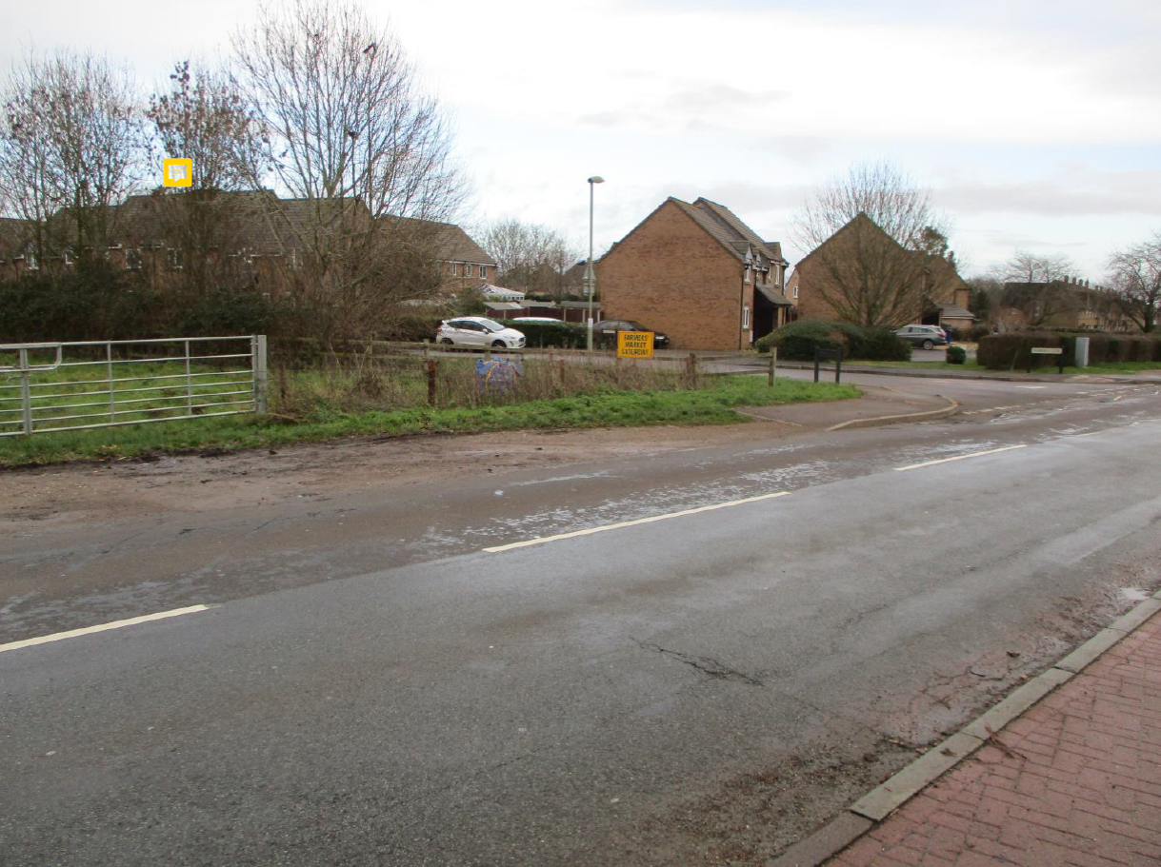

In relation to drainage the issue of contamination is raised – Is this something you require more details of at the outline stage or are you happy for it to be dealt with by the proposed condition?

Education

I note that a request has been made for a contribution towards the expansion of Christopher Rawlins CE Primary School.   Am I correct in understanding that this extension has already happened and is operation?  Do you have examples where you have sought and secured contributions retrospectively?   I also assume no secondary contributions are being sought?

Thanks

Kind regards

**James Kirkham BA (Hons) MSc MRTPI**

**Principal Planning Officer – General Developments Planning Team**

Development Management

Place and Growth Directorate

Cherwell District Council and South Northants District Council

Direct Line: 01295 221896

[**www.cherwell.gov.uk**](http://www.cherwell.gov.uk/) or [**www.southnorthants.gov.uk**](http://www.southnorthants.gov.uk/)

**Follow Us:**

Facebook [www.facebook.com/cherwelldistrictcouncil](http://www.facebook.com/cherwelldistrictcouncil)

or [www.facebook.com/southnorthantscouncil](http://www.facebook.com/southnorthantscouncil)

Twitter @cherwellcouncil or @southnorthantscouncil

**From:** Planning Consultations - E&E [<mailto:PlanningConsultations@Oxfordshire.gov.uk>]   
**Sent:** 21 January 2019 09:44  
**To:** Planning; James Kirkham; Cllr Arash Ali Fatemian  
**Cc:** Planning Consultations - E&E; DavidFlavin  
**Subject:** Oxfordshire County Council’s response to 18/02147/OUT Stone Pits Hempton Road Deddington   
**Importance:** High

Dear James

Please find attached Oxfordshire County Council’s response to 18/02147/OUT Stone Pits Hempton Road Deddington

If you have any further queries please send an email to [planningconsultations@oxfordshire.gov.uk](planningconsultations@oxfordshire.gov.uk%20)

and a member of Major Planning Applications Team will get back to you as soon as possible.

Thank you.

**Regards**

**Dan**

**Daniel Tritton** – Major Planning Applications Officer

**Oxfordshire County Council** – Environment & Economy

County Hall, New Road, Oxford, OX1 1ND