**From:** Joyce Christie   
**Sent:** 20 September 2016 15:17  
**To:** Nathanael Stock  
**Subject:** for discussion quick notes

Hi Nat

North elevation: It is a pity that all the accommodation cannot be contained within the main house.  The addition of the kitchen extension, with its own extension for the utility/plant room do not enhance the design of the main house and are not yet fully resolved.  The Architect was going to look at this following our meeting.  Externally it would look better if the kitchen extension moved forward, this would avoid the awkward rainwater arrangement but would mean the kitchen would be entered on the corner. As proposed we have the awkward rainwater hopper arrangement to the valley and the door opens just off centre which would always look odd. By moving the kitchen forward to the west you would lose the thin window to the dining room but it would help the rainwater disposal and avoid the offset door under the ridge of the kitchen ceiling when looking towards the main house internally.

The detail of the rainwater goods/sump from valley gutter needs to be neatly handled and should be conditioned to arrive at a more elegant arrangement (see comment above).

Query how the rainwater disposal of flat roof below the ridge will be handled?

The presumed en-suite on gable wall at first floor won’t have a window.

Position of door to master bedroom will no doubt change when the interior furniture is laid out, I wouldn’t object if this altered later on.

Dormers look too tall, and corresponding proportion of glass – recommend these are reduced in height so the rdige of the dormer does not project above the ridge of the linking roof between the two main roofs and a the proportion of the glass is also shorter than currently shown in the dormer casements.

Glazed screen to kitchen to the west elevation the top of the screen alighns with top of winodws to the main house but on east elevation top of window is lower. Consider it would look more subserviant if the screen was also lower than the top of the windows.

The ridge of the utility/plant room wingneeds to come in below the ridge of the kitchen extension, it looks a bit tight as drawn.

Query the treatment of the double doors on the utility/plant room wing are these louvred? If so the traditional game hanging larder structures might provide inspiration for ventilation.  Details to be conditioned.

Outbuildings:

During earlier discussions these were proposed to be removed as they were of low quality. Drg 1759.127 – is this being retained and converted to the stable?

Garage:Are they introducing 2No rooflights as the arrows only point to 2No as being existing?

Landscaping:

The proposed landscaping needs to be carefully handled to blend with the existing landscape. It would be helpful to see updated visuals based on the current scheme.

**Conditions**

Masonry:

* Sample panel of masonry, lime mortar no cement gauging
* chimney details.
* kneeler and coping detail.
* Eaves detail
* String and plinth detail, including how the string returns.
* Detail of the corner stones to ensure the return of the stone is not thin – may need to have alternating L-shaped stones in plan to avoid this.
* Ventilation slots/in gable of utility/plant room wing.
* Doorcase details.
* Louvred window details
* Cill and lintol details
* Steps

Condition lead or Cast iron or rainwater goods and colour; as well as details in particular the north valley gutter above the kitchen and the flat roof of the main house.

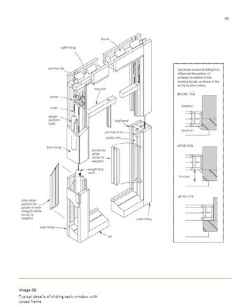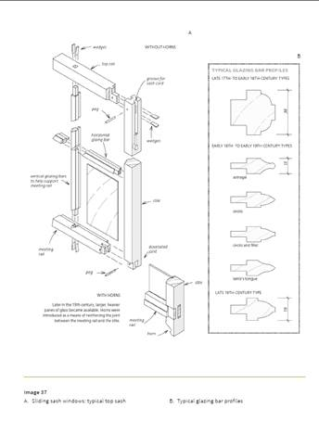 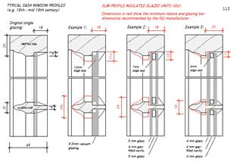

Condition Joinery

* Timber sliding sash and case windows and colour:

Detail submitted shows sash box hidden in stone reveal (typical detail after 1774 in London by law, later copied in other parts of the country) with glazing bars at 35mm wide (typical 38mm in late 17thC/ early 18thC but by late 18thC the glazing bars had slimmed down), Historic England ‘https://content.historicengland.org.uk/images-books/publications/traditional-windows-care-repair-upgrading/heag039-traditional-windows.pdf/’ + need to think about avoiding cold bridging and draftstripping in due course. Historic England illustrate slimline double glazing with an 18mm glazing bar.  The colour of the spacer bar/edge between the two sheets of glass needs to have a non-metallic finish – matt black might work better with certain colours, especially if an off white or colour is proposed suggest trialing which colour looks best with chosen window colour.

* Doors, including fanlight
* Dormers – casmeent should be flush
* Rooflights.

Condition roofing sample of the proposed stone tiles, including details of ridge.  Code of lead – Code 3 may be quite thin for an exposed position?

Best wishes

Joyce Christie

Design and Conservation Officer

Design & Conservation Team   
Development Management  
Cherwell District Council  
Direct Dial Number: 01295 221608

Extension Number: 1608  
Email Address: [joyce.christie@cherwell-dc.gov.uk](mailto:joyce.christie@cherwell-dc.gov.uk)  
[www.cherwell.gov.uk](http://www.cherwell.gov.uk/)