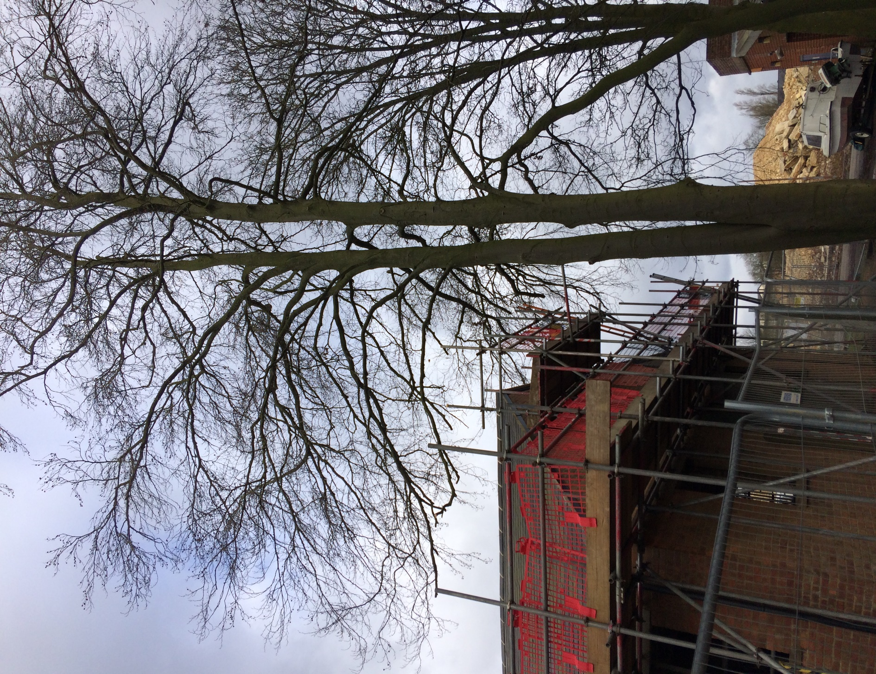
View looking from the south towards T641.
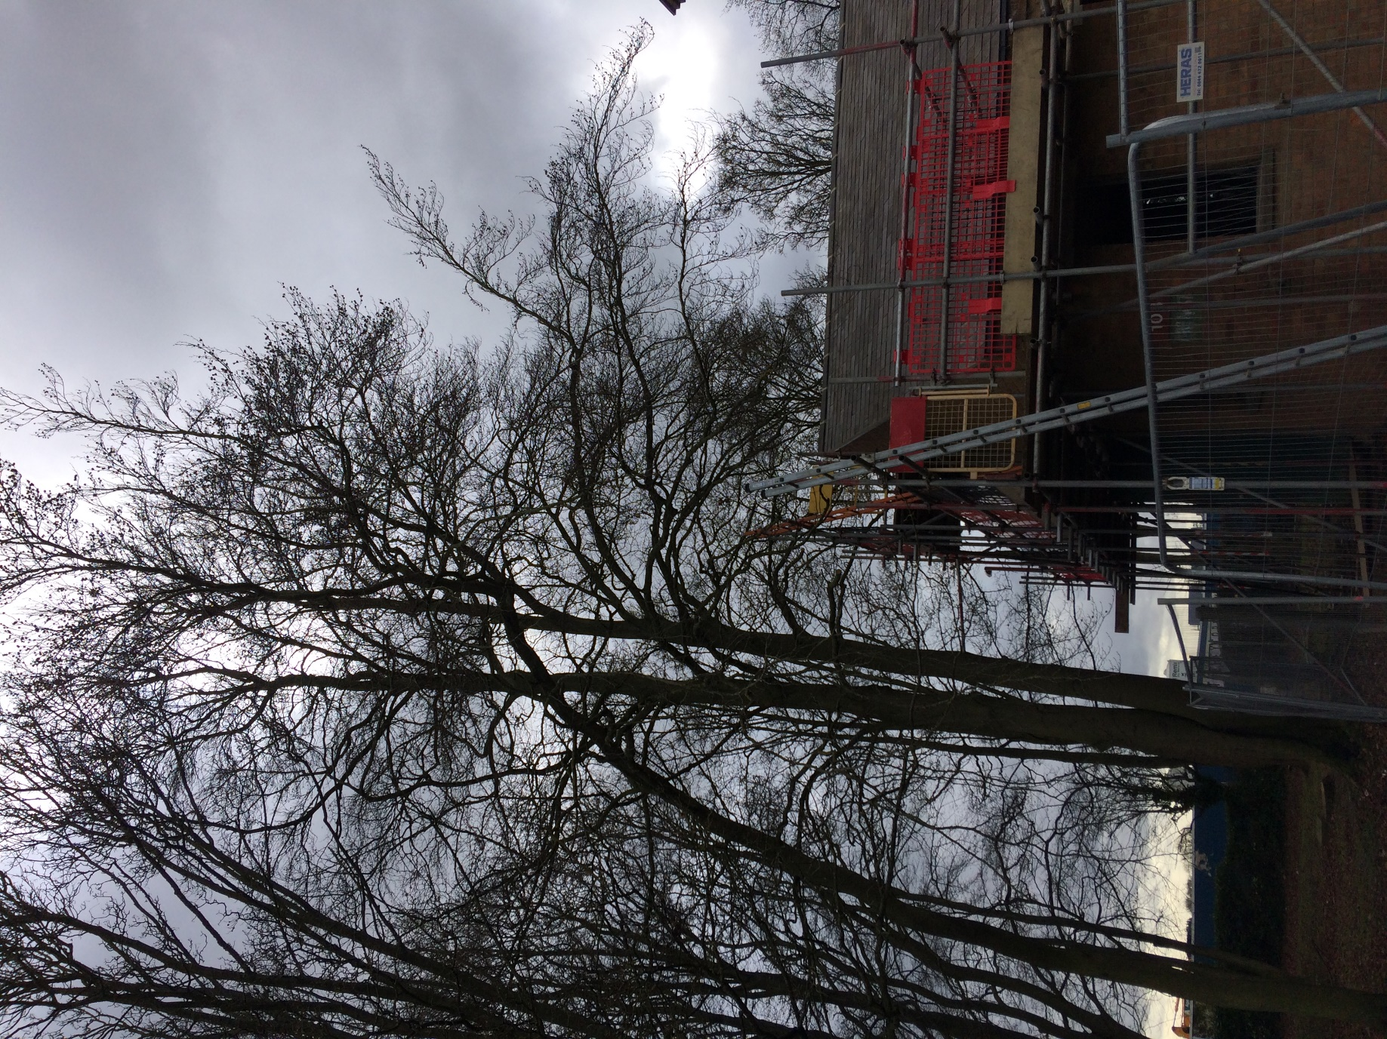
View from north looking south towards T164. Branches proposed to be pruned highlighted in yellow

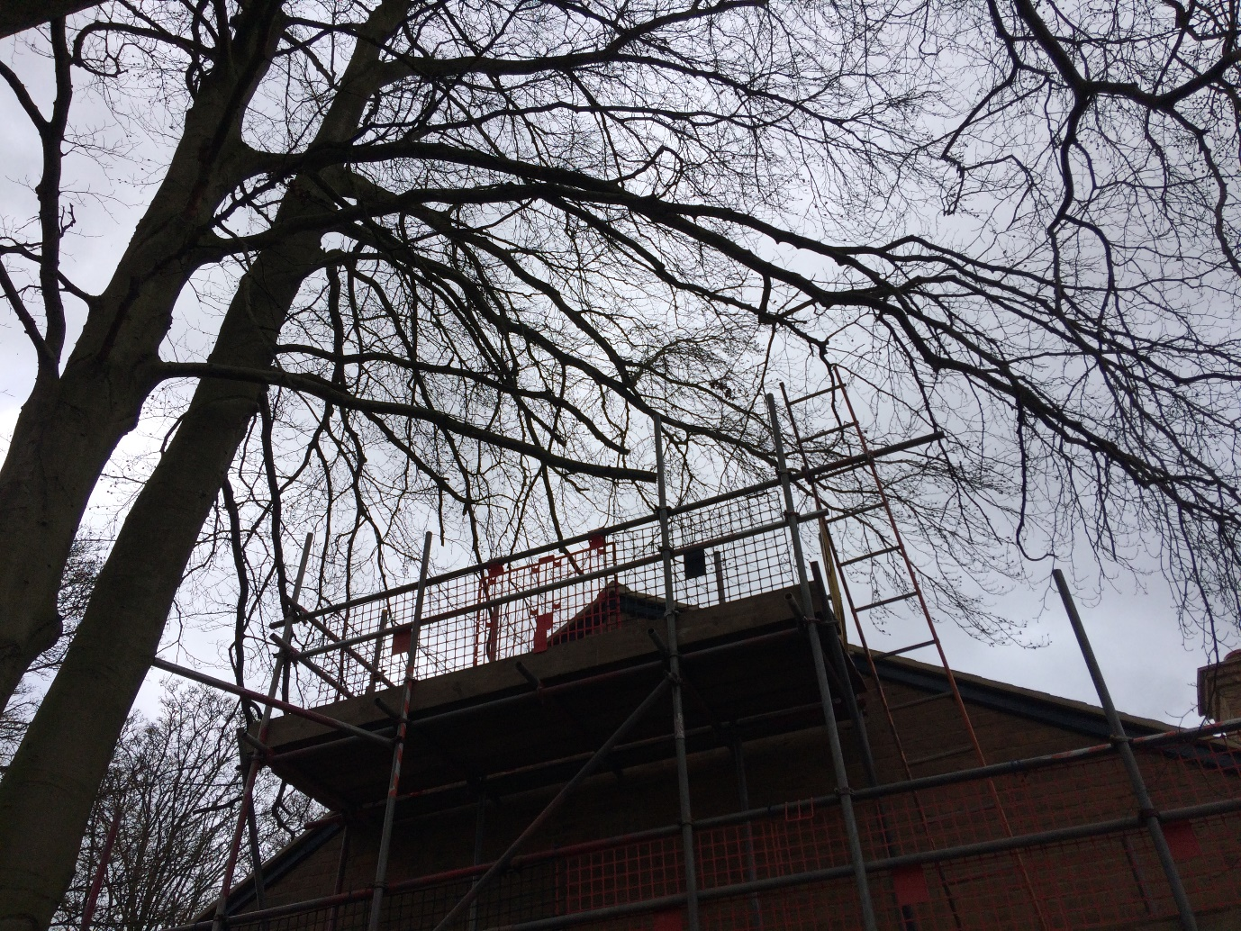
View looking up towards the western canopy of T164 with proposed branches to be pruned highlighted in yellow.

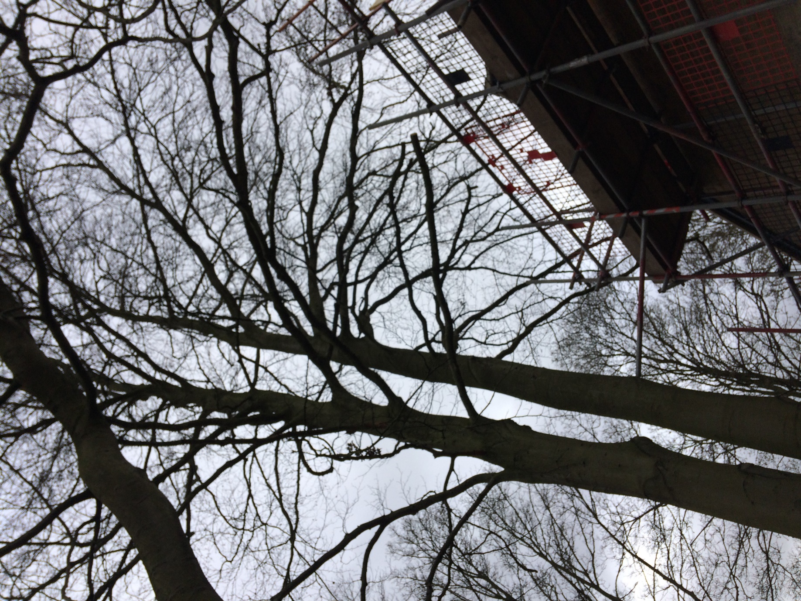
View looking up towards the western canopy of T164 with proposed branches to be pruned highlighted in yellow.

