**From:** Judith Ward   
**Sent:** 16 June 2016 13:50  
**To:** 'Andrew Finding'  
**Cc:** Paul Watson  
**Subject:** RE: Haynes Barn - discharge of conditions (15/02280/F)

Dear Josephine

Thank you for sending in the attached plan.

I am in agreement with your proposed hedge positions B-Y and Y-Z.  It would be good to have a few hedgerow trees in the hedges as they are very much a feature of the surrounding landscape.

I also agree with the small copses at B, Y and the midpoint between them.

A line of trees to the track/public right of way side of the Agricultural barn would help screen it from the public viewpoint. I don’t think that you need trees along the west side.

In addition I would like to see the boundary hedge which runs alongside the track gapped up to make a complete line.

For all these proposals you need to submit details of the planting as in condition 11a which asks for species, numbers, sizes and positions on a plan. For hedges you need the space between plants and space between rows.

I hope this helps

Judith

**Judith Ward**

**Landscape Planning Officer**

Cherwell District & South Northants Councils

**Phone**01295 221711   
Fax 01295 221878

<mailto:Judith.ward@cherwellandsouthnorthants.gov.uk>

<www.cherwell-dc.gov.uk>

<www.southnorthants.gov.uk>

[www.facebook.com/cherwelldistrictcouncil](http://www.facebook.com/cherwelldistrictcouncil)

[www.facebook.com/southnorthantscouncil](http://www.facebook.com/southnorthantscouncil)

Follow us on Twitter: @Cherwellcouncil

Follow us on Twitter : @SNorthantsC

**From:** Andrew Finding   
**Sent:** 07 June 2016 09:37  
**To:** Judith Ward; Judith Ward  
**Cc:** Andrew Finding  
**Subject:** Haynes Barn - discharge of conditions (15/02280/F)

Dear Judith

Last week I delivered to Paul Watson, the planning officer who issued the planning approval for Haynes Barn, a document in which we set out the discharge of conditions.  You suggested in an earlier ‘phone call that I should send to you that element of our submission which deals with landscaping associated conditions.  Thus, I am setting out below the covering letter and pages 7 and 8 of the document plus a A4 size scanned drawing of the proposed planting at Haynes Barn (it expands on larger drawings already in the possession of the council; they travelled with the original planning application).

Thank you very much again for your helpful and pragmatic advice.

Best wishes

Josephine

Andrew and Josephine Finding

****************************************************************************

From: Mr and Mrs A R Finding

Paul Watson BSc (Hons) MSc

Planning Officer

Development Management

Cherwell District Council

Bodicote House

Bodicote

BANBURY

Oxon

OX15 4AA                                                                                                                            May 2016

Dear Sir

**DISCHARGE OF CONDITIONS ASSOCIATED WITH PLANNING PERMISSION GRANTED FOR APPLICATION NUMBER 15/02280/F ON 11 MARCH 2016**

We were delighted to receive the notification of permission granted for the above application on 11 March 2016.  This letter sets out the discharge of the conditions associated with the permission and we enclose the payment of £97.

For ease, the discharge of conditions is addressed numerically and copies of  supporting documents are attached and labelled appropriately.

Please contact us if you require further information.

Yours faithfully

A R and J Finding

Encs

**LANDSCAPING ASSOCIATED CONDITIONS**

11  Prior to the commencement of the development hereby approved, a landscaping scheme shall be submitted to and approved in writing by the Local Planning Authority. The scheme for landscaping the site shall include:-

(a)  details of the proposed tree and shrub planting including their species, number, sizes and positions, together with grass seeded/turfed areas,

(b)  details of the existing trees and hedgerows to be retained as well as those to be felled, including existing and proposed soil levels at the base of each tree/hedgerow and the minimum distance between the base of the tree and the nearest edge of any excavation,

(c) details of the hard surface areas, including pavements, pedestrian areas, reduced- dig areas, crossing points and steps.

Thereafter the development shall be carried out in accordance with the approved landscaping scheme.

Reason - In the interests of the visual amenities of the area, to ensure the creation of a pleasant environment for the development, and in the interests of biodiversity, to comply with Policies ESD10 and ESD13 of the adopted Cherwell Local Plan 2011-2031 and Government guidance contained within the National Planning Policy Framework.

***Please see the attached plan on drawing number 5569-05b dated 14 Nov 15 with the proposed landscaping scheme and the smaller attached sheet which outlines the position of our plans for native hedging to enhance the position of stock proof fencing and the siting of copses of native trees. We have no intention of felling existing trees nor removing existing hedges.  It has always been our intention that our home, Haynes Barn should continue to sit comfortably in its environment, as it has done for in excess of 200 years and thus all planting will be simple, naturalistic and comprise native species, as well as attracting and providing habitat for wildlife.  NB sub para (c) asks for details of hard surface areas, including pavements, pedestrian areas, reduced dig areas, crossing points and steps.  Due to the isolated rural location of Haynes Barn, rest assured there will be no pavements, pedestrian areas nor crossing points.  The only spot which might be categorized as a reduced dig area would be the area around a crab apple tree on the southern boundary of Haynes Barn.  We will ensure that the tree’s roots are not disturbed in any way.  All other details are provided for your approval.***

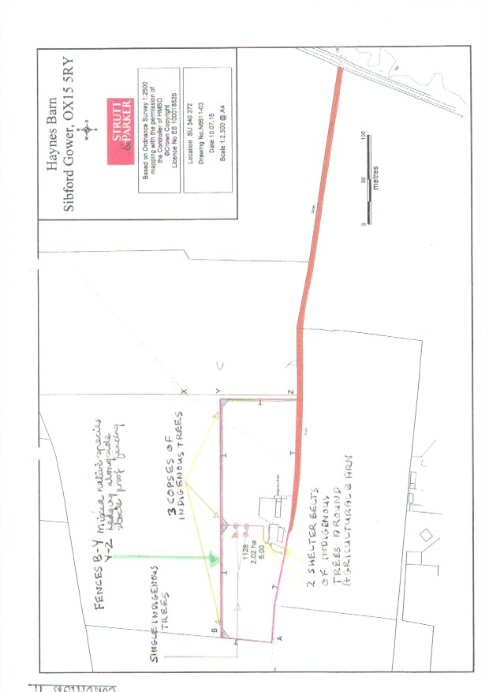

12  All planting, seeding or turfing comprised in the approved details of landscaping shall be carried out in accordance with BS 4428:1989 Code of Practice for general landscape operations (excluding hard surfaces), or the most up to date and current British Standard, in the first planting and seeding seasons following the occupation of the building(s) or on the completion of the development, whichever is the sooner. Any trees, herbaceous planting and shrubs which, within a period of five years from the completion of the development die, are removed or become seriously damaged or diseased shall be replaced in the current/next planting season with others of similar size and species.

Reason - In the interests of the visual amenities of the area, to ensure the creation of a pleasant environment for the development, and in the interests of biodiversity, to comply with Policies ESD10 and ESD13 of the adopted Cherwell Local Plan 2011-2031 and Government guidance contained within the National Planning Policy Framework.

***We will ensure that we abide by the conditions as detailed.***

***\*\*\*\*\*\*\*\*\*\*\*\*\*\*\*\*\*\*\*\*\*\*\*\*\*\*\*\*\*\*\*\*\*\*\*\*\*\*\*\*\*\*\*\*\*\*\*\*\*\*\*\*\*\*\*\*\*\*\*\*\*\*\*\*\*\*\*\*\*\*\*\*\*\*\*\*\*\*\*\*\*\*\*\*\*\*\*\*\*\*\*\*\*\*\*\*\*\*\*\*\*\*\*\*\****