**From:** Rose Todd   
**Sent:** 24 November 2016 17:18  
**To:** Bob Neville  
**Subject:** RE: THE PHEASANT PLUCKERS INN : 16/02030/F

The design of the proposed building is both unacceptable and uninspiring. There is nothing that reflects the local built heritage in respect to inns or their ancillary buildings. May I suggest the applicant takes the following buildings as potential inspiration:

18th century stable building at College Farm in Wendlebury

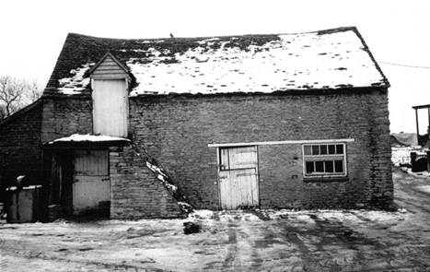

18th century stable building North Arms Wroxton

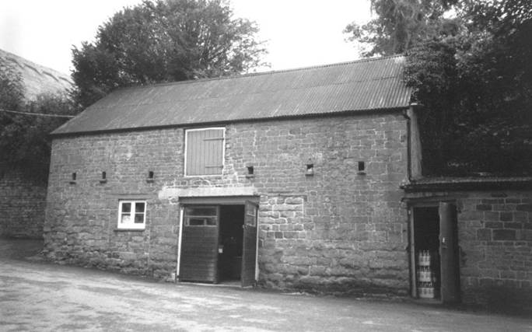

In the case of the Wroxton building the idea would be to have a single external door to a lobby with rooms off.

I recommend that the current application is withdrawn or refused as contra to policies ESD15 and NPPF 131 – fails to make a positive contribution to local character and distinctiveness. It is also recommended that the applicant engage in pre-app discussions.

Dr Rose Todd

Senior Conservation Officer  
Design & Conservation Team   
Development Management  
Cherwell District Council  
Extension: 1846  
Direct Telephone: 01295 221846

Mobile: +44 7968 115605  
mailto: [rose.todd@cherwell-dc.gov.uk](mailto:rose.todd@cherwell-dc.gov.uk)  
[www.cherwell.gov.uk](http://www.cherwell.gov.uk)