- APPLICATION SITE AND LOCALITY

  - The Lion is a Grade II listed building situated on the south east side of Main Street, Wendlebury. The detached property is situated within the centre of the village and dates back to the 18th Century. The building is situated across the road from two other listed buildings (Elm Tree House and Willow Cottage).

  - The building is constructed from coursed limestone rubble under a tile and slate roof. Two extensions protrude from the rear of the main body of the building, one of which is single storey, flat roofed and accommodates the kitchen and the other of which is 1 ½ storey and accommodates a store.

  - The site is used as a public house and restaurant. The building has been refurbished and extended to now include a formal dining area, outside seating area and most recently has received permission for the removal of a building and proposed replacement with a detached accommodation block (ref 15/00185/F & 15/00186/LB refers). A large tarmac car park is situated to the west of the pub (to which this application relates) with a small beer garden beyond the tiled dining area.

- DESCRIPTION OF PROPOSED DEVELOPMENT
2.1 Full consent is now being sought for the retention of the existing tarmac car park. The original planning permission (14/01026/F as amended by 15/00172/F) for the extension of the car park proposed a permeable car park covering which did not include a tarmac finish as is currently visible on site.

2.2 As part of the enforcement investigation, pre-application advice has been given to the applicants both in writing and at a meeting. This application is one of a series of applications to be submitted following this investigation.

- RELEVANT PLANNING HISTORY

APP NUMBER | DESCRIPTION | DECISION
14/01026/F & 14/01027/LB | Single storey rear extensions, internal alterations and extension to parking area | APPROVED
15/00172/F & 15/0007/LB | Amendments to application 14/01026/F | APPROVED
15/00185/F | Detached accommodation block | APPROVED
15/00186/LB | Removal of curtilage listed building | APPROVED
16/01430/F | Proposed accommodation block - Alteration to approval 15/00185/F | APPROVED
16/01876/F & 16/01877/LB | Retrospective amendments to previous consent | APPROVED
16/02581/F & 16/02582/LB | Erection of external stone hearth with chimney | REFUSED

- PRE-APPLICATION DISCUSSIONS

4.1 Given that this application has come about through an enforcement generated investigation, some informal pre-app has already been given. The culmination of this advice was in the form of a detailed letter to the owners dated 22 July 2016 and this advice was further emphasised at a meeting at these offices on 09 August 2016.

4.2 This advice clearly outlined that the retention of the tarmac finishing on the car park would not be something which the Council would consider as appropriate development due to the potential for an increase in surface water flooding as the surfacing was not permeable and also visually, is considered to have a significant visual impact on the area and the setting of the listed building.

- RESPONSE TO PUBLICITY

  - This application has been publicised by way of a site notice displayed near the site, by advertisement in the local newspaper, and by letters sent to all properties immediately adjoining the application site that the Council has been able to identify from its records.
The comments raised by third parties are summarised as follows
- Flooding resulting from the use of tarmac as opposed to permeable surfacing
  - The comments received can be viewed in full on the Council’s website, via the online Planning Register.
- RESPONSE TO CONSULTATION

  - Below is a summary of the consultation responses received at the time of writing this report. Responses are available to view in full on the Council’s website, via the online Planning Register.
PARISH/TOWN COUNCIL
6.2 Wendlebury Parish Council: object;
The Parish Council has considered the application and has commissioned a report from a civil and structural engineering company – Hamill Davies Limited – to review the applicant’s Flood Risk Assessment and Drainage Statement.
Having received this independent report, the Parish Council strongly objects to the tarmac surface and does not believe that the solutions suggested in the applicant’s report will mitigate the visual appearance or the practical flooding issues.
When the initial application for the car park was received (14/01026/F and 14/01027/LB), the Parish Council welcomed the proposal for the car park which was specified in the Design and Access Statement as ‘porous paving’ and was very surprised when tarmac was installed. It had been assumed that it would be more like the recently installed Bicester Park and Ride car park (photographs attached).
The Parish Council has always supported the development of the business but a balance needs to be kept between the impact of the development and the impact on the community. The non-compliance of these planning issues is raising significant concern.

STATUTORY CONSULTEES
6.3 Cherwell District Council Environmental Protection Manager: No objection
6.4 Cherwell District Council Conservation Officer: The differences in the car park design and details are not great and it cannot be said that as built the car park causes excessive harm to the setting of the listed building. However, that said it would have been less grievous if the car park had actually been constructed to the scheme originally agreed
6.5 Oxfordshire County Council Senior Drainage Officer: object:
Oxfordshire County Council Drainage Team wish to object to the application 16/02584/F due to the drainage scheme not being sufficiently designed to cater for all surface water within the developed site. The current designed scheme will allow surface water to run off of the lower section of the carpark straight out onto the highway.

The proposed piped outfall from the site is still subject to agreement from Thames Water. Without this agreement in principal from Thames Water, there is no guarantee that an outfall from the site is possible.

The Flood Risk Assessment mentions that soakaway drainage could be utilised, however no infiltration rate test seem to be have been carried out. The indicative drainage scheme does show a tank attenuation chamber with a flow control chamber outlet, however infiltration methods should be looked at first where possible.

The drainage scheme will need to be re-designed to allow for all of the surface water within the site to be taken into the onsite system.

6.6 Oxfordshire County Council Highway Authority: do not object to the granting of planning permission.

NON-STATUTORY CONSULTEES
6.7 Environment Agency: Initial comments: I have briefly reviewed the details submitted for application reference: 16/02584/F. We have no flood risk concerns with the proposed extension of the tarmac car park in Flood Zone 2/3. There are no other constraints within our remit.
NB: The Case Officer went back to EA with copies of the report that the Parish Council had submitted and these were the comments in relation to this additional information:
I have briefly reviewed the report that you attached. The two principal issues appear to be related to the surface water drainage scheme and the safe access & egress arrangements. As neither of these matters are within our remit, we have no further flood risk comments to make on the proposed development.
- RELEVANT PLANNING POLICY AND GUIDANCE

- Planning law requires that applications for planning permission must be determined in accordance with the development plan unless material considerations indicate otherwise.

- The Cherwell Local Plan 2011-2031 - Part 1 was formally adopted by Cherwell District Council on 20th July 2015 and provides the strategic planning policy framework for the District to 2031. The Local Plan 2011-2031 – Part 1 replaced a number of the ‘saved’ policies of the adopted Cherwell Local Plan 1996 though many of its policies are retained and remain part of the development plan. The relevant planning policies of Cherwell District’s statutory Development Plan are set out below:

CHERWELL LOCAL PLAN 2011 - 2031 PART 1 (CLP 2031 Part 1)

- BSC 12: Indoor sport, Recreation and Community Facilities
- ESD 6: Sustainable Flood Risk Management
- ESD7: Sustainable Drainage Systems (SuDS)
- ESD 15: The Character of the Built Environment

CHERWELL LOCAL PLAN 1996 SAVED POLICIES (CLP 1996)

- C28: Development Control Design
- ENV1: Development likely to cause detrimental levels of pollution

- Other Material Planning Considerations

- National Planning Policy Framework (NPPF)
- Planning Practice Guidance (PPG)

- APPRAISAL

- The key issues for consideration in this case are:

- Visual amenity and Heritage Impact
- Flooding
- Impact on neighbours
- Highway safety

Visual amenity and Heritage Impact

8.2 Government guidance contained within the NPPF attaches great importance to the design of the built environment and states that good design is a key aspect of sustainable development, is indivisible from good planning, and should contribute positively to making places better for people.

8.3 Saved Policy C28 of the adopted Cherwell Local Plan seeks to control new development to ensure that it is sympathetic to the character of its context.

8.4 Section 66 of the Planning (Listed Buildings and Conservation Areas) Act 1990 (as amended) states that: In considering whether to grant planning permission for development which affects a listed building or its setting, the local planning authority…shall have special regard to the desirability of preserving the building or its setting or any features of special architectural or historic interest which it possesses.

8.5 Listed Buildings are designated heritage assets, and Paragraph 132 of the NPPF states that: when considering the impact of a proposed development on the significance of a designated heritage asset, great weight should be given to the asset’s conservation. The more important the asset, the greater the weight should be. Significance can be harmed or lost through alteration or destruction of the heritage asset or development within its setting. As heritage assets are irreplaceable, any harm loss should require clear and convincing justification. Policy ESD15 of the CLP 2031 Part 1 echoes this guidance.

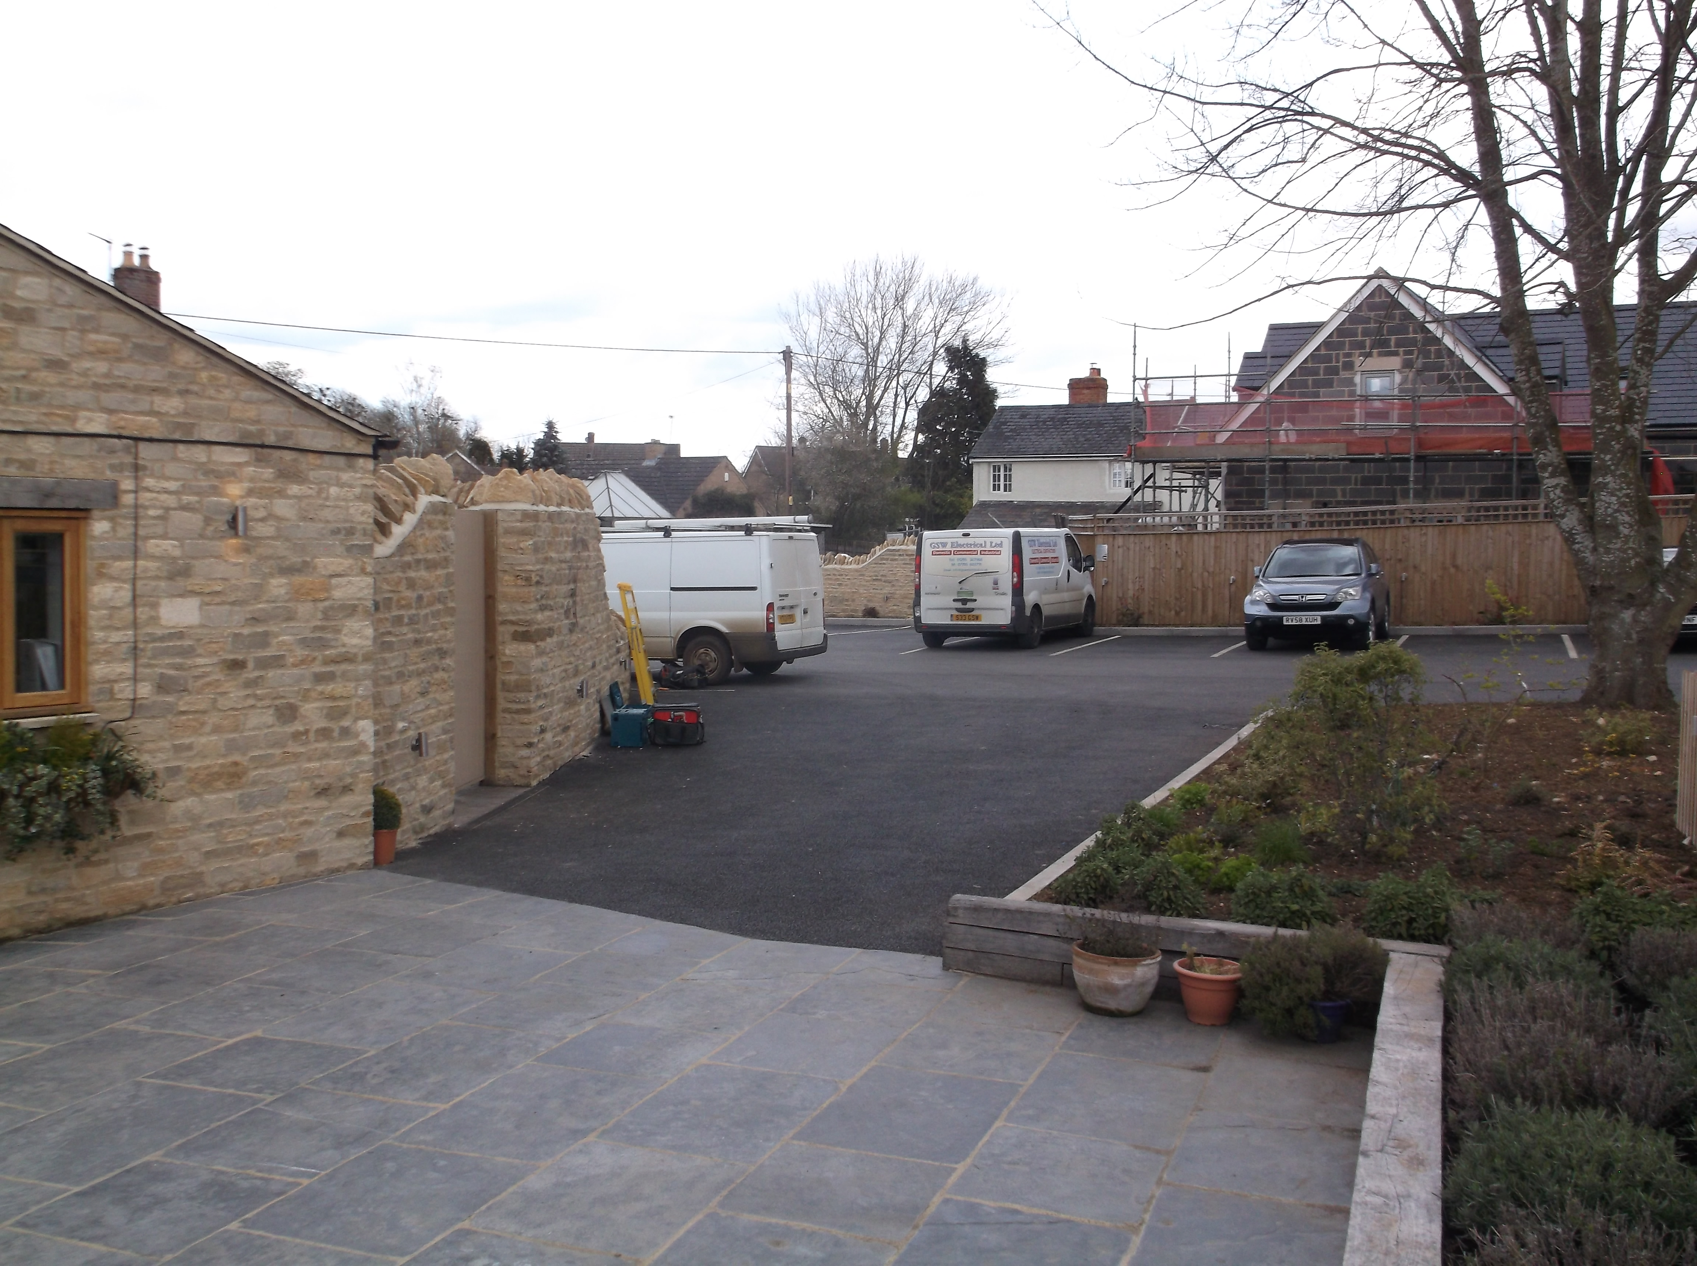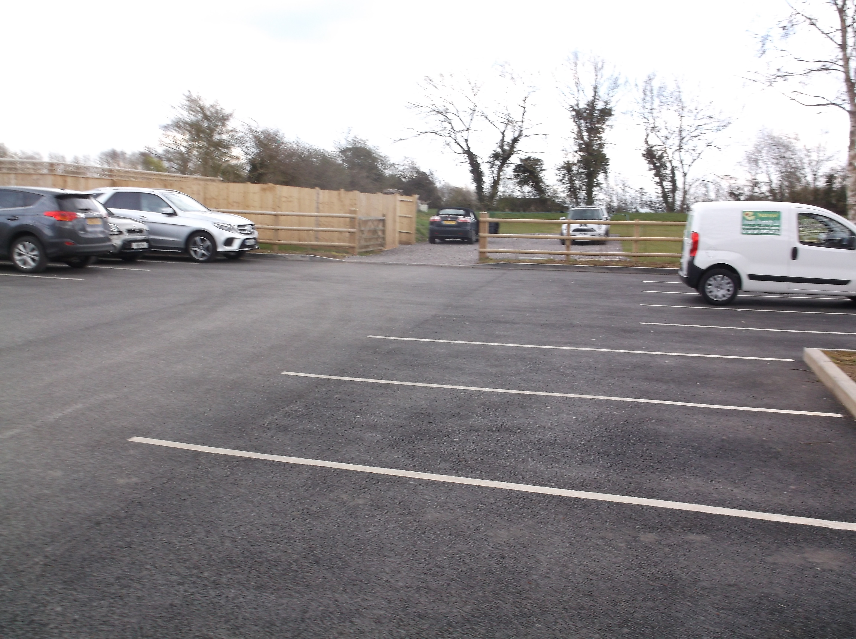

View of the car park from the seating area View of the car park from the pub entrance

8.6 The car park extends from the entrance to the pub and along the boundary with the neighbouring property. There is also an area beyond the public car park which is separated by fencing but is an area that is used periodically for the parking of vehicles. The area of formal car park is marked out and there are a total of 32 spaces available for vehicular parking.

8.7 In addition to the formal parking, the whole rear area of the pub is laid to hard standing (paving tile which are illustrated in the photo above). There is very little landscaping provided on the site. The car park and the remaining hard standing do have a significant visual impact when viewed in the context of the building.

8.8 The Council’s Conservation Officer whilst not objecting to the application does state “it would have been less grievous if the car park had actually been constructed to the scheme originally agreed”.

8.9 It has already been outlined that the pub is a Grade II Listed Building and by definition therefore a Designated Heritage Asset. Paragraph 134 advises that where a development proposal will lead to less than substantial harm to the significance of a designated heritage asset, this harm should be weighed against the public benefits of the proposal.

8.10 Policy ESD 15 of the CLP is consistent with the advice and guidance within the NPPF with regard to the conservation of the historic environment and looks for development to:

• Contribute positively to an area’s character and identity by creating or reinforcing local distinctiveness;
• Conserve, sustain and enhance designated and non-designated Heritage Assets, including their settings, ensuring that new development is sensitively sited and integrated;
• Respect the traditional pattern of routes, spaces, blocks, plots, enclosures and the form, scale and massing of buildings.

8.11 Whilst the proposal does provide an area for patrons of the pub to park in safely, the large swathe of tarmac does have an impact on the character and appearance of the area and whilst the Conservation Officer does not object to the proposal, I remain concerned that when this is viewed in context with the listed building, there is an unacceptable impact on its setting.

8.12 The tarmac is very dark and has a significant urbanising impact on the area. Whilst it is not an uncommon material to be used in village locations, it tends to be used on roads and minor driveways and does not usually cover large expanses. Many of the properties immediately located on the entry into the village and towards the pub have used a softer, bound gravel hard standing to create their driveways and parking areas. This gravel also acts as a more permeable surface and can regulate surface water run off more effectively than tarmac; this issue is discussed further below.

  - The colouration and expanse of the tarmac, together with the lack of sufficient landscaping exacerbates the situation and not only creates a very harsh, urban appearance to the context of the pub but it is considered to detract from the visual amenities of the existing building and its rural setting within the surrounding area. Whilst this harm is considered to be less than substantial, it is considered that any public benefits would not be so significant that they outweigh the harm caused to the historic environment in this instance, particularly given an alternative and less harmful surfacing could be applied that would achieve the same public benefits.

  - The proposal is considered to be at odds with Government Guidance contained within the National Planning Policy Framework, Policies C28 of the Cherwell Local Plan 1996 (Saved Policy) and Policy ESD15 of the Cherwell Local Plan 2011-2031 Part 1.

Flooding
8.15 A Flood Risk Assessment (FRA) has been submitted with this application in line with the requirements of Policy ESD6 of the Local Plan and the Framework. The majority of the application site falls within Flood Zone 1 but part of the entrance of the site falls into Flood Zones 2and 3, which are the zones of higher flood risk. The site does fall away from east to west giving an approximate gradient of 1 in 20 which means that any surface water will fall away from the car park and will cross the road to drain into Wendlebury Brook which is sited to the west of the pub.
8.16 According to the applicants FRA the majority of the site has a low risk of flooding from fluvial sources. However it acknowledges that there has been historic flooding events caused when the Brook has reached capacity and overflowed onto the highway.
8.17 When the original planning permission was granted for the redevelopment of the pub (ref: 14/01026/F), a planning condition was imposed which tied the developers to a scheme of “permeable surfacing”. The permeable surfacing was supposed to reduce the amount of surface water which would travel off the large amount of hard standing and therefore reduce any risk of further flooding caused by the influx of excess groundwater. The enforcement investigation concluded that this permeable surfacing had not been laid and instead the previously existing surfacing had been capped with tarmac.
8.18 A detailed site visit was undertaken with Oxfordshire County Council’s Drainage Officer who expressed concern with regard to the inability of the site to sufficiently address all surface water within the developed site.
8.19 The Parish Council have also raised significant concern with regard to this application and have themselves commissioned their own civil and structural engineers to comment on the FRA. The conclusion of this report raises concern regarding the ability for the proposed drainage proposals to serve the site adequately.
8.20 The applicants state that the car park was previously laid to tarmac. Having looked at historical photographs from the site it is apparent that the majority of the area now used as car parking was constructed from some form of hard standing and that as part of the redevelopment the owners wanted to improve this. However it is also clear that the previous car park has been extended significantly, and a new surface has been laid across the entire car park. It is this development that requires consent, and which should be assessed in the light of current policy and guidance which recognises the contribution that poorly managed surface water runoff can make to flooding issues in a locality. In particular there remains now a significant swathe of tarmac which is clearly not permeable, there is little in terms of drainage ability for any water that falls onto it and there is nothing to catch and hold the water to prevent it from running onto the highway and then into the Brook.
8.21 Policy ESD 6: Sustainable flood risk management of the adopted Cherwell Local Pan 2011-2031 Part 1 clearly states: “Development should be safe and remain operational (where necessary) and proposals should demonstrate that surface water will be managed effectively on site and that the development will not increase flood risk elsewhere, including sewer flooding”. Likewise Policy ESD7 states that: all development will be required to use sustainable drainage systems (SuDS) for the management of surface water runoff. This is consistent with the advice in the PPG which states that: new development should only be considered appropriate in areas at risk of flooding if priority has been given to the use of sustainable drainage systems. In the light of the objections raised and the technical evidence provided by the Parish Council, the retention of the car park in its current form clearly has the potential to add to the possibility of increased flooding. It is therefore not considered to comply with this policy and permission should be refused.
Impact on Neighbours
8.22 Both local and national planning policy seeks to ensure that development does not cause undue harm to the amenity of existing neighbours, including by way of loss of outlook, noise, nuisance or loss of light.
8.23 The Council’s Environmental Protection Officer has been consulted on the application and has no comments to make.
8.24 Given that there has always been a form of car parking on site, there is not considered to be any adverse impact caused from the car park on the amenity enjoyed by neighbouring properties. As such the car park is considered to comply with policy in this respect.
Highway Safety
8.25 The Local Highway Authority have no objections to the application. The car park is laid out such that vehicles can manoeuvre within the site and enter and exit in forward gear. As such the proposal is acceptable in highway safety terms.
9. CONCLUSION
The retention of the existing car park surface is considered to be unacceptable in principle as it has significant implications for potential flooding in the area. The applicants have not surfaced the area in accordance with plans that were subject to an earlier consent and as such the area is not permeable as it should have been, and surface water runoff resulting from the development is not being adequately managed within the site. Furthermore, the large swathe of black tarmac is considered to detract from the area as it is not something that is characteristic of the village and instead makes the area unnecessarily urban in character, detracting from the setting of the listed building. As such the application is contrary to planning policy and should therefore be refused.

- RECOMMENDATION
That permission is refused, for the following reasons:

1. The retention of the existing non-porous tarmac finished car park would allow surface water run off to discharge straight off the car park and onto the highway exacerbating the potential for flooding in the locality. In the absence of a suitable alternative drainage strategy to adequately manage surface water runoff within the site, the proposal is therefore contrary to Government guidance contained within the National Planning Policy Framework, saved Policy C28 of the Cherwell Local Plan 1996 and Policies ESD6 and ESD7 of the Cherwell Local Plan 2011-2031 Part 1.

2. The retention of the existing tarmac finished car park, by virtue of its size and urbanising appearance, would cause harm to the rural setting of the Grade II listed building, The Lion PH. It is considered that the harm identified is not outweighed by the public benefit of providing the parking, which could be provided by less harmful means. The proposal is therefore contrary to Government guidance contained within the National Planning Policy Framework, saved Policy C28 of the Cherwell Local Plan 1996 and Policy ESD15 of the Cherwell Local Plan 2011-2031 Part 1.

CASE OFFICER: Michelle Jarvis | DATE: 03 April 2017
CHECKED BY: Alex Keen | DATE: 06 April 2017

