**From:** Rob Kinchin-Smith [mailto:kinchin-smithr@rpsgroup.com]   
**Sent:** 06 August 2018 21:18  
**To:** DC Support  
**Cc:** Clare Mitchell; Jennifer Ballinger; planning@industrial-archaeology.org; James Kirkham  
**Subject:** RE: 18/01158/F and 18/01159/LB - The Old Malthouse St Johns Road Banbury

FAO Jim Newton / James Kirkham

Dear Jim

**18/01158 /F and 18/01159/LB - The Old Malthouse St Johns Road Banbury  - Conversion of building from B1(a) Offices to 25 residential flats, with ancillary parking, bin storage and amenity area**

Many thanks for consulting the Banbury Civic Society on this application. I apologise for the delay in responding.

Unfortunately, despite a number of amendments to the proposed development, none of our previous concerns have been addressed; the proposal still fails to preserve the large floorplates that are so characteristic of the building’s original use; still fails to expose the fine and innovative roof structure across the full width of the building at any point (including the proposed atrium); and still provides inadequate detail about the degree to which the roof structure will be preserved or made apparent where it coincides with new walls.

It is nevertheless now apparent that a number of struts are to be removed from the roof trusses (although there is no structural study to show that the roof will still function structurally without them). The extent of new rooflights is also now all too apparent also.

Our previous comments and observation of ‘less than substantial harm’ (below) thus remain unchanged.

### We would note however that our previous reference to Paragraph 134 of the NPPF (regarding ‘optimum viable use’) should now read Paragraph 196, following the recent changes to the NPPF.

### The reference to *“What is a viable use for a heritage asset and how is it taken into account in planning decisions?”* in theGovernment’s ‘Planning Practice Guidance’ (Paragraph: 015 Reference ID: 18a-015-20140306) remains unchanged.

We would nevertheless further emphasiseParagraph: 016 Reference ID: 18a-016-20140306 of the PPG ***“ What evidence is needed to demonstrate that there is no viable use?”. “****Appropriate marketing is required to demonstrate the redundancy of a heritage asset… The aim of such marketing is to reach all potential buyers who may be willing to find a use for the site that still provides for its conservation to some degree. If such a purchaser comes forward, there is no obligation to sell to them, but redundancy will not have been demonstrated.”*

With regard to the importance of Listed Buildings finding their optimum viable use (i.e. the use that is viable but which also causes the least possible harm), we previously stated that in order to approve an application for subdivision for residential use, the Council must be satisfied that the current use (large open-plan office space) is no longer a viable use and that a marketing exercise would be needed demonstrate this. Here we would draw your attention to the recent email of Mr James Tuthill, of Tuthill Park, which merits repeating in full:

*From: James [*

*Sent: 13 July 2018 14:48*

*To: James Kirkham*

*Subject: The Old Malt House - 18/01158/F and 18/01159/LB*

*Dear James,*

*I understand there has been a new formal planning application to change the use of the Old Malt House to residential.*

*I would like to confirm our company’ continued interest in purchasing the Old Malt House in Banbury for use as an office.*

*Omlet started in Wardington in 2004 and we have been growing steadily for many years. We began searching for larger office premises in Banbury towards the end of May 2018. We have found that there are very few suitable office spaces in Banbury around 8,000 to 12,000 square feet - either for sale or rent. The Old Malt House makes an excellent office because it has good parking, a good open plan working environment with a fantastic roof structure and is close to the town centre. Currently, our business is based in an out of town location. We would prefer our office to be in the town centre as we feel this will make it easier to attract staff who can commute by foot, bus, train or cycle (without the need to rely on a car). We currently have 30 full-time staff.*

*We first became aware of the Old Malt House around the 1st of June 2018. We were shown around the property by Harvey from White Commercial on the 4th June 2018. As mentioned early, we feel the building would make an excellent open plan office.*

*We have therefore made several offers to purchase the building. We made an offer below the asking price, a second at the asking price and the third offer substantially higher than the asking price. All were rejected. Our third offer is still open and we are ready to proceed with the purchase in a timely fashion and have the funds available.*

*The property was marketed for £750,000. However, the seller has stated that they will only accept offers in excess of £1.8 million which is well above the reasonable market value of the property as offices and obviously above their marketed asking price. They made it clear that they intended to file another planning application to turn the building into residential flats and were clearly not interested in pursuing a sale.*

*Let me know if you need any additional information.*

*Thanks,*

*James Tuthill*

*Tuthill Park*

*Wardington*

Banbury

Oxfordshire

It would thus appear that, subject to establishing Mr Tuthill’s bona-fides, a marketing exercise is no longer needed in order to demonstrate that there is a genuine purchaser willing to take on this building for a use as a large open-plan office (its current use), at a generous price that would still give the present owner (the current applicant) a substantial profit.

We would thus maintain our objection to the proposed development, notwithstanding the recent changes.

Yours sincerely

Rob Kinchin-Smith

(Acting Chairman, Banbury Civic Society)

**From:** Rob Kinchin-Smith   
**Sent:** 29 November 2017 12:47  
**To:** 'Planning'  
**Cc:** 'Clare.Mitchell@Cherwell-DC.gov.uk'; 'Jennifer Ballinger'; 'planning@industrial-archaeology.org'  
**Subject:** 17/02167/F and 17/02168/LB - The Old Malthouse St Johns Road Banbury

FAO James Kirkham

Dear James

**17/02167/F and 17/02168/LB - The Old Malthouse St Johns Road Banbury  - Conversion of building from B1(a) Offices to 25 residential flats, with ancillary parking, bin storage and amenity**

Many thanks for consulting the Banbury Civic Society on this application**. I apologise for the delay in responding.

We wish to make the following comments:

In some ways the proposal seems to be a good one in terms of design and the conservation of the historic fabric of this very interesting Grade II-Listed Malthouse.

That said, taking a Grade II Listed building of a type whose heritage significance largely derives from its large open floor spaces and irreversibly dividing it up into multiple domestic residential small units undoubtedly causes harm, although in terms of Paragraph 134 of the NPPF, in this case that harm would probably be regarded as ‘less than substantial harm’.

It is nevertheless a big step that needs thorough justification.

As noted in the NPPF, para 134 *“Where a development proposal will lead to less than substantial harm to the significance of a designated heritage asset, this harm should be weighed against the public benefits of the proposal, including securing its optimum viable use.* “

Guidance on “optimum viable use” is provided in the Government’s ‘Planning Practice Guide’

***“What is a viable use for a heritage asset and how is it taken into account in planning decisions?”***

*“The vast majority of heritage assets are in private hands. Thus, sustaining heritage assets in the long term often requires an incentive for their active conservation. Putting heritage assets to a viable use is likely to lead to the investment in their maintenance necessary for their long-term conservation.*

*By their nature, some heritage assets have limited or even no economic end use. A scheduled monument in a rural area may preclude any use of the land other than as a pasture, whereas a listed building may potentially have a variety of alternative uses such as residential, commercial and leisure.*

*In a small number of cases a heritage asset may be capable of active use in theory but be so important and sensitive to change that alterations to accommodate a viable use would lead to an unacceptable loss of significance.*

*It is important that any use is viable, not just for the owner, but also the future conservation of the asset. It is obviously desirable to avoid successive harmful changes carried out in the interests of repeated speculative and failed uses.*

***If there is only one viable use, that use is the optimum viable use. If there is a range of alternative viable uses, the optimum use is the one likely to cause the least harm to the significance of the asset,*** *not just through necessary initial changes, but also as a result of subsequent wear and tear and likely future changes.*

*The optimum viable use may not necessarily be the most profitable one…*

*Harmful development may sometimes be justified in the interests of realising the optimum viable use of an asset, notwithstanding the loss of significance caused provided the harm is minimised.”*

Paragraph: 015 Reference ID: 18a-015-20140306

Revision date: 06 03 2014

Here we have a building that has functioned perfectly well, for many years, as up-to-date, open-plan, serviced offices. It would need little, or minimal change to continue in such a use if such a use remains viable.

To consent to a residential subdivision that will result in “*less than substantial harm*” the Council needs to assure itself that residential use is now the *optimum* viable future use for this building, rather than simply the one that is most profitable for the owner or developer. Thus the Council needs to be satisfied that the existing office use is now economically redundant and that there are no less damaging uses for the building that are less damaging.

The only way to demonstrate redundancy is through appropriate marketing at an appropriate value.

Should the Council be content that multi-occupancy residential use *is* the only, or optimum viable use and that the proposal is the least harmful viable use, the council should aim to ensure that the development proposal minimises harm and that it “*enhances or better reveals* (the heritage) *significance*” of the asset (NPPF para  137) in order to compensate for any harm.

Of the many surviving malthouses of the late Georgian period, this Grade II malthouse is prodigious for its unusually wide floor-plan and its exceptionally ‘polite’ exterior treatment. The timber roof trusses that were provided to span this exceptionally wide-span building in 1834 (illustrated below) are indeed truly prodigious for their period and potentially of national significance in themselves. The roof structure certainly contributes outstandingly to the heritage significance of this Grade II listed malthouse and it certainly merits making more apparent in any development proposal for the building.

Here we are pleased with the developer’s proposed atrium, although we are concerned that this atrium will show only the central part of the roof trusses, rather than revealing their full structure across the whole width of the building.

We are also concerned at the absence of any detail design regarding of the flats themselves, so it remains uncertain if the roof trusses will remain visible within the flats, or whether the timberwork will need to be concealed within some, or all of them, on account of fire risk.

Whilst we are open to the idea of residential conversion of this very advanced and interesting building *is* the optimum viable use of this very unusaual and historic building, we would nevertheless seek the following:

1. Evidence of appropriate marketing to demonstrate the redundancy of the building as offices
2. Further detail of how the roof trusses will be made visible within the flats
3. Further exploration of the potential to enlarge the atrium so as to expose the full width and height of at least three trusses, and
4. The securing through an appropriate condition of a detailed archaeological record of the building to Historic England Level 3, with a Level 4 record of the roof structure.

We appreciate that 1), 2) and 3) may require that the application be temporarily withdrawn to allow for the provision of the required information and any necessary design changes.

Yours sincerely

Rob Kinchin-Smith

(Vice Chairman, Banbury Civic Society)

** We note that under the provisions of “ARRANGEMENTS FOR HANDLING HERITAGE APPLICATIONS – NOTIFICATION TO HISTORIC ENGLAND AND NATIONAL AMENITY SOCIETIES AND THE SECRETARY OF STATE (ENGLAND) DIRECTION 2015” 3(iii)(b) the removal of a staircase and parts of the floors of a  Grade II Listed building makes this a notifiable application (“*a proposal to demolish any principal internal element of the structure including any staircase, load-bearing wall, floor structure or roof structure is treated as a proposal for the demolition of a substantial part of the interio*r”). We thus presume that Historic England and the relevant amenity societies have also been consulted.

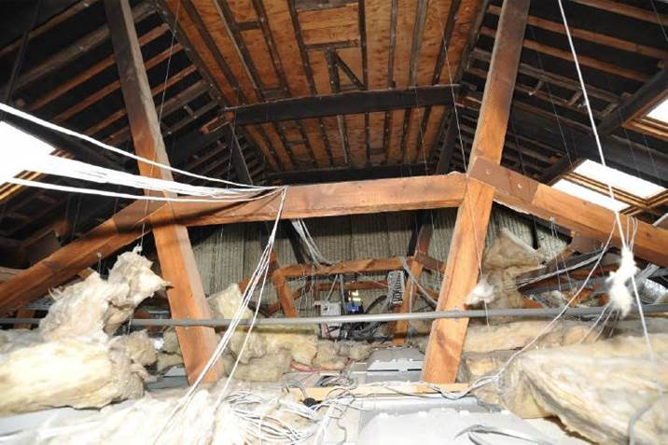

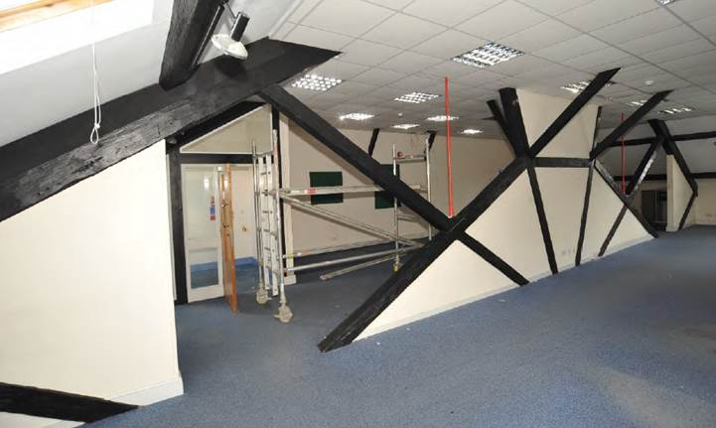

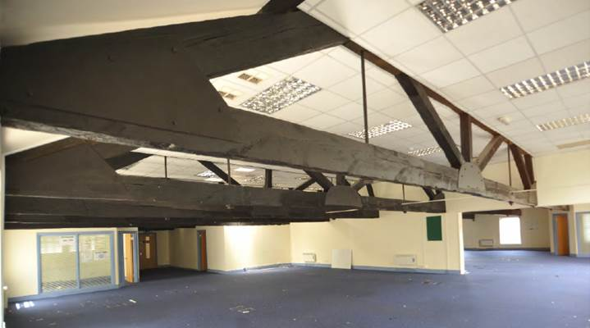

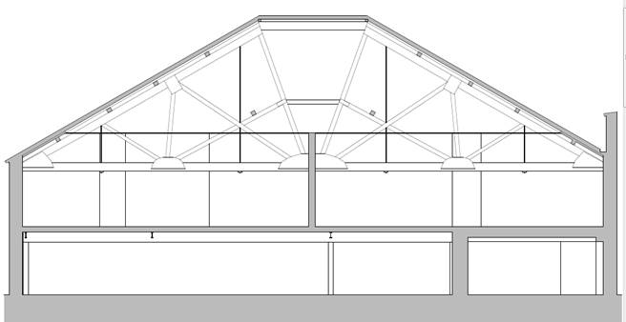

This e-mail message and any attached file is the property of the sender and is sent in confidence to the addressee only.

Internet communications are not secure and RPS is not responsible for their abuse by third parties, any alteration or corruption in transmission or for any loss or damage caused by a virus or by any other means.

RPS Group Plc, company number: 208 7786 (England). Registered office: 20 Western Avenue Milton Park Abingdon Oxfordshire OX14 4SH.  
  
RPS Group Plc web link: [http://www.rpsgroup.com](http://www.rpsgroup.com/)