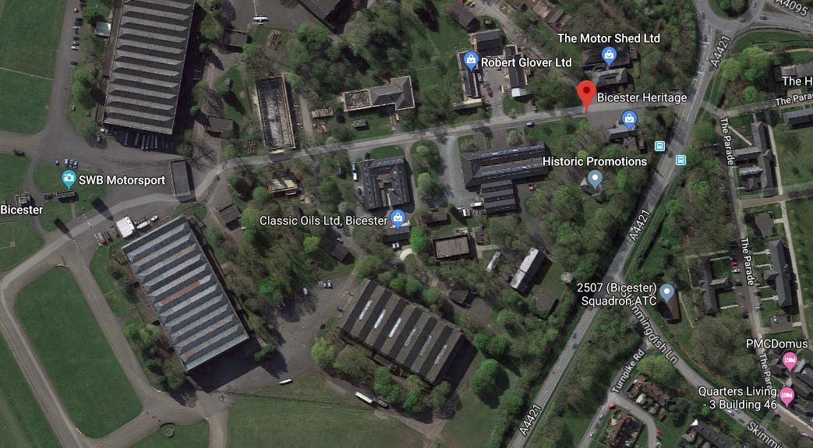
T1 – Blue – 1013 – To fell as it is dead and may cause damage to listed buildings.
T2 – Red – 1119 – To feel as it is dead and may cause damage to listed buildings.

