Date: 02/06/2014
Our ref: 0295jr

Historic and Natural Environment Team
Planning Economy & Transport Policy
Speedwell House
Speedwell Street
Oxford, OX1 1NE

Sue Scane
Director of E & E

Olivia Colson
Bodicote House
Bodicote
Banbury
Oxfordshire
OX15 4AA

Dear Olivia

14/00674/F – Orchard House, Main Street, Sibford Ferris, Banbury

The proposed scheme will not affect any known archaeological features. As such there are no archaeological constraints to this scheme.

Yours sincerely,

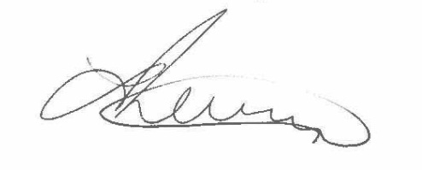

Joanne Robinson
Assistant Archaeological Officer

Email: joanne.robinson@oxfordshire.gov.uk
www.oxfordshire.gov.uk/archaeology

