Annex A
Site Layout

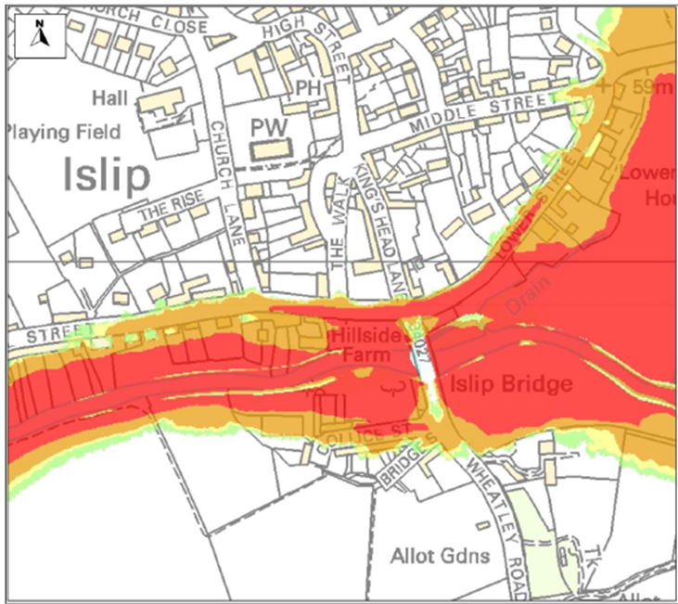

Suggested Pedestrian Egress Routes

