The Red Lion,  Main Street,  Wendlebury,  OX25 2PW |  | 16/01877/LB
Recommendation: Approval
Case Officer: Michelle Jarvis

Applicant: Mrs Sarah Robinson-Smith

Application Description: Retrospective - various amendments to listed building consent 15/00072/LB including alterations to extended barn, alterations to kitchen extension, repositioning of external flues, changes to signage, reinstatement of southern boundary wall and external lighting

1. Site Description, Planning History and Proposed Development

Site description

  - The Red Lion is a Grade II listed building situated on the south east side of Main Street, Wendlebury. The detached property is situated within the centre of the village and dates back to the 18th Century. The building is situated across the road from two other listed buildings (Elm Tree House and Willow Cottage).

  - The building is constructed from coursed limestone rubble under a tile and slate roof. Two extensions protrude from the rear of the main body of the building, one of which is single storey and accommodates the kitchen and the other of which is 1 ½ storey and accommodates a store.

  - The site is used as a public house and restaurant. The building has been refurbished to now include a formal dining area, outside seating area and most recently the removal of a building and proposed replacement with a detached accommodation block (ref 15/00185/F & 15/00186/LB refers). A large tarmac car park is situated to the west of the pub with a small beer garden beyond the tiled dining area.

Planning History

1.4 The site has been the subject of an enforcement investigation when work was being done without any consent. Therefore, many of the applications listed (include this current one) have been as a result of attempts to regularise unauthorised work. The table below illustrates the various applications submitted on this site in the recent past:

APP NUMBER | DESCRIPTION | DECISION
14/01026/F & 14/01027/LB | Single storey rear extensions, internal alterations and extension to parking area | APPROVED
15/00172/F & 15/00072/LB | Amendments to application 14/01026/F | APPROVED
15/00185/F | Detached accommodation block | APPROVED
15/00186/LB | Removal of curtilage listed building | APPROVED
16/01430/F | Proposed accommodation block - Alteration to approval 15/00185/F | APPROVED
16/02581/F | Retrospective – erection of an external coursed stone hearth a stone chimney, grey brick flaunching and | PENDING
16/02582/LB | Retrospective – erection of an external coursed stone hearth a stone chimney, grey brick flaunching and | PENDING

Proposal

1.5 Listed building consent is sought for a variety of amendments to a previously approved application (15/00072/LB). These alterations were also picked up as part of the enforcement investigation when during a site visit to the property, it was noted that a significant number of deviations from the approved plans had occurred. The extent of the retrospective works for which regularisation is now sought is indicated below:

- Step in roof of extended barn. Use of metal cladding to gable end of existing building
- Changes to the roof of the small rear extension to the south of the site
- Changes to side elevation of small rear extension
- Addition of a new window to the new kitchen
- Two existing flues repositioned
- Changes to signage on northern gable with associated lighting and planters
- Reinstatement of southern boundary wall
- Addition of external wall lights mounted on kitchen extension

1.5 A concurrent application for planning permission (16/01876/F) accompanies this application.

1.6 As part of the enforcement investigation, pre-application advice has been given to the applicants both in writing and at a meeting. This application (and its partner one for listed building consent) is one of a series of applications to be submitted following this investigation. The advice provided in relation to this submission did encourage the submission that is subject to this application. It is supported by both the Enforcement Officer and the Conservation Officer.

2. Application Publicity

- The application has been advertised by way of a site notice, advertisement in the local newspaper, and letters sent to immediately adjoining properties. The final date for comment was 03 November 2016. No letters from third parties were received.

3. Consultations

3.1 Wendlebury Parish Council:

The Parish Councillors have considered the applications.

The Councillors believe that whilst the majority of the changes applied for are acceptable, the Councillors do have concerns about the addition of the external wall lights mounted on the kitchen extension and the lighting on the northern gable as they may disturb the neighbours more with the night’s drawing in.

Cherwell District Council Consultees

3.2 Conservation Officer:

This application is to regularise works undertaken as part of the refurbishment of the public house but outside the previous consents.

For the most part the works put forward are those deemed acceptable therefore it is recommended that the application is approved.

External Consultees

3.3 Historic England:

This application should be determined in accordance with national and local policy guidance, and on the basis of your expert conservation advice

4. Relevant National and Local Policy and Guidance

- Development Plan Policy

The Cherwell Local Plan 2011-2031 - Part 1 was formally adopted by Cherwell District Council on 20th July 2015 and provides the strategic planning policy framework for the District to 2031. The Local Plan 2011-2031 – Part 1 replaced a number of the ‘saved’ policies of the adopted Cherwell Local Plan 1996 though many of its policies are retained and remain part of the development plan.

Planning law requires that planning applications must be determined in accordance with the Development Plan unless material considerations indicate otherwise.

The following policies are therefore considered to be relevant:-

Cherwell Local Plan 2011 - 2031 Part 1

ESD15 - The Character of the Built Environment

Cherwell Local Plan 1996 (Saved Policies)

C18: Alterations to listed buildings

4.2 Other Material Policy and Guidance

National Planning Policy Framework

Planning Practice Guidance

5. Appraisal

5.1 The key issue for consideration in this application are:

- Impact on the designated heritage asset

5.2 Section 66(1) of the Planning (Listed Buildings and Conservation Areas) Act 1990 requires that special regard for the desirability of preserving a listed building or its setting should be taken in the carrying out of planning functions.

5.3 Government guidance contained within the NPPF requires LPA’s to take account of the desirability of sustaining and enhancing the significance of heritage assets and putting them to viable uses consistent with their conservation. Paragraph 132 of the NPPF states that: “When considering the impact of a proposed development on the significance of a designated heritage asset, great weight should be given to the assets conservation. The more important the asset, the greater the weight should be. Significance can be harmed or lost through alteration or destruction of the heritage asset or development within its setting. As heritage assets are irreplaceable, any harm or loss should require clear and convincing justification”.

5.5 Guidance contained within Policy ESD15 of the Cherwell Local Plan Part 1 states: “Where development is in the vicinity of any of the District’s distinctive natural or historic assets, delivering high quality design that complements the asset will be essential.” Furthermore, Policy ESD15 states that new development proposals should: “Conserve, sustain and enhance designated and non-designated ‘heritage assets’ (as defined in the NPPF) including buildings, features, archaeology, conservation areas and their settings, and ensure new development is sensitively sited and integrated in accordance with advice in the NPPF and NPPG.”

5.6 Saved Policy C18 of the adopted Cherwell Local Plan states that in determining an application for listed building consent the Council will have special regard to the desirability of preserving the building or its setting or any features of special architectural or historic interest. The Council will normally only approve internal and external alterations or extensions to a listed building which are minor and sympathetic to the architectural and historic character of the building.

5.7 The application seeks retrospective consent for a number of alterations to the building (outlined earlier in this report). Whilst cumulatively they do appear to be a lot of changes, in terms of the impact on the building overall they are very minor. Most of them such as the addition of a slate roof and conservation roof lights on the barn conversion, the re-instatement of the southern boundary wall in stone, the new down light on the extension to the kitchen and an additional window on this building are all considered minor and are not considered to harm the appearance or historic significance of the listed building.

5.8 It is noted that there is some alteration to the northern gable end of the building – visible on the approach into the village. However this alteration relates to painted signage and is considered to be of an appearance that is sympathetic to the building and its historic use as a public house.

5.9 The alteration to the roof of the barn (which now is one of the dining area) on the rear elevation facing into the courtyard could be considered to have slightly more of an impact on the fabric of the existing building. This would be in comparison to items such as the additional window in the kitchen which is on a newer part of the building. The image below shows the current “step down” and link attachment to the barn,
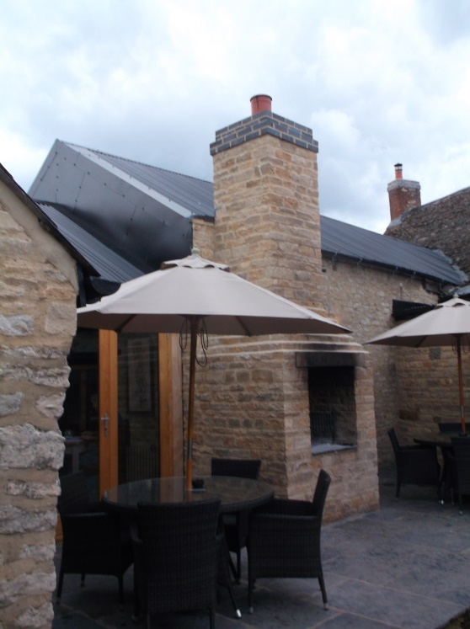

5.10 The addition of the bolted on metal cladding would not necessarily be something that would have been ideal to compliment the appearance of the listed building, given how it is very modern in its appearance. However it has been placed in situ to protect the existing timber structure which was suffering from rainwater erosion, its removal may now cause even more damage to the listed building and on balance this coupled with the fact that it is preventing further erosion of the structure from water ingress means that it is deemed acceptable.

5.11 Whilst the extractor hoods are visually intrusive and do cause some harm, this is less than substantial and the harm has been reduced through their siting to the rear, and finished appearance (painted black). In my view the harm caused is outweighed by the need for the extractor hoods to service the kitchen, as part of the ongoing use of the building as a public house.

Conclusion

5.12 It is considered that the harm resulting to the character, significance and setting of the Grade II listed building would be minimal having regard to the minor nature of the proposed works, and the extent of the permitted works. On balance, this harm is outweighed by the public benefits of securing the continued use of the building as a public house. The proposal would thus comply with Policy ESD15 of the Cherwell Local Plan 2011- 2031 Part 1, saved Policy C18 of the Cherwell Local Plan 1996 and the relevant paragraphs of the NPPF.

6. Recommendation

Approval –

- The development hereby approved is as shown on the following plans and documents: Application forms, site location plan (drawing 001 Rev P1), revised site plan (drawing 070 Rev P1), revised ground floor plan (drawing 071 Rev P1), revised elevations (drawings 075 & 076 Rev P1).

Reason - For the avoidance of doubt, to ensure that the development is carried out only as approved by the Local Planning Authority and to comply with Government guidance contained within the National Planning Policy Framework.

Planning Note

The applicant is reminded that the carrying out of any unauthorised work to a listed building is an offence, punishable by a fine, imprisonment or both, as detailed in Section 9 of the Planning (Listed Buildings & Conservation Areas) Act 1990.

Signed Case Officer: Michelle Jarvis Date: 09/01/2017
Signed SPO/TL: Alex Keen Date: 27/01/2017

