Bicester Heritage
Buckingham Rd
Bicester
OX29 5HA
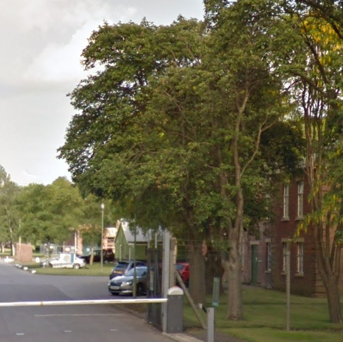
Tree 1523 Sorbus to be removed due to poor condition
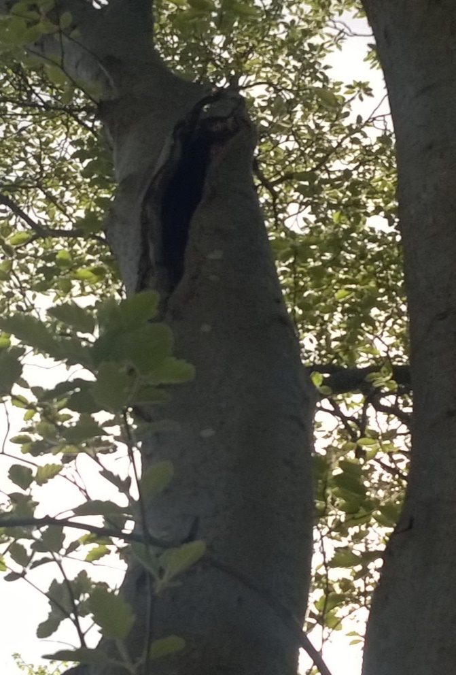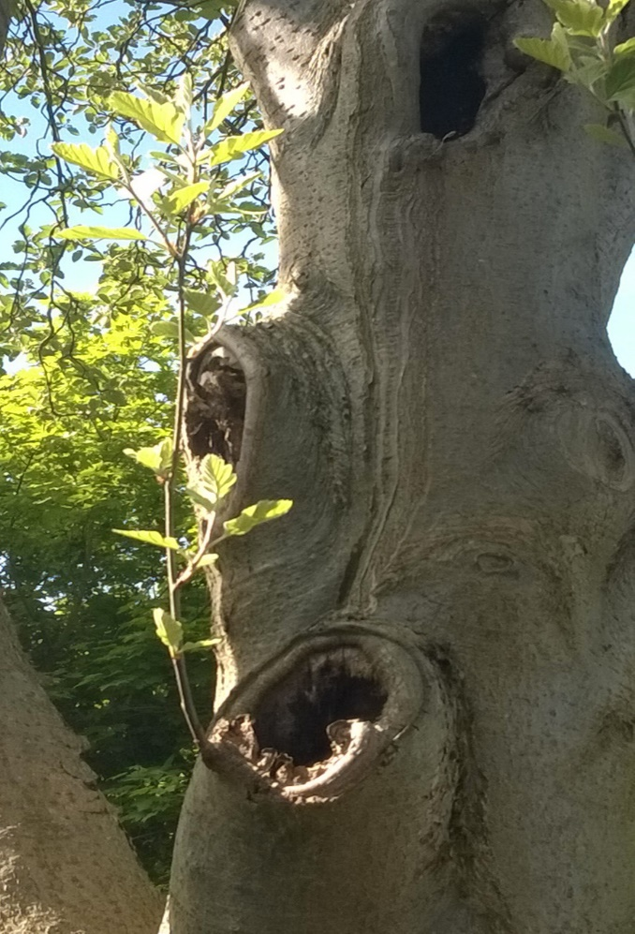
Photos of decline and decay

