Policy ESD 10: Protection and Enhancement of Biodiversity and the Natural Environment
B.233 Development proposals likely to affect a site of international ecological importance will need to be accompanied by a thorough Habitats Regulations Assessment of the potential effects of the development on that site of international importance, to enable the Council to determine whether the development would result in significant adverse effects on the integrity of the site. Any development that is unable to demonstrate that it would not have a significant adverse effect upon the integrity of a European site, having taken account of proposed mitigation, will be refused. This is in accordance with the precautionary principle enshrined in the Habitats Directive. Where there are imperative reasons of over-riding public interest and the Council is unable to conclude no adverse effect on the integrity of the SAC, the authority will notify the Secretary of State to allow the application to be called in for determination. In these situations compensatory measures to protect the site must be put in place.
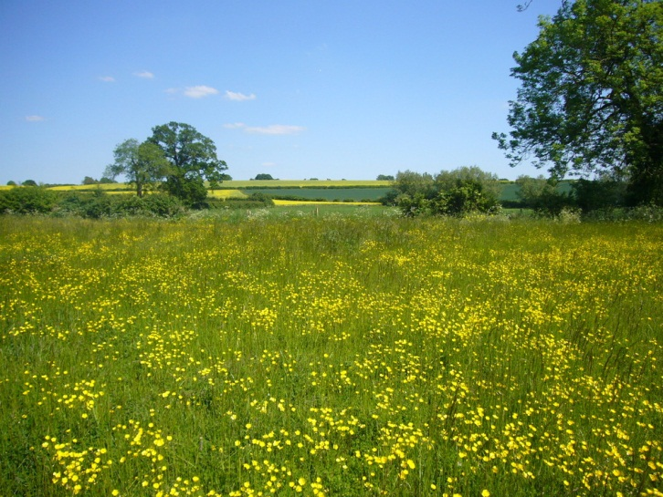

B.234 Sites of national importance comprise Sites of Special Scientific Interest (SSSIs) and National Nature Reserves. Cherwell District has 18 SSSIs but does not contain any National Nature Reserves.
B.235 Sites of regional/local importance comprise Local Geological Sites (LGSs), Local Nature Reserves (LNRs), non-statutory nature reserves and other sites of importance for nature conservation including Local Wildlife Sites (LWSs- formerly known as County Wildlife Sites), ancient woodland, aged or veteran trees and UK Biodiversity Action Plan (BAP) Priority Habitats (habitats of principal importance for the conservation of biodiversity under Section 41 of the NERC Act). Cherwell contains 13 LGSs, 3 LNRs, 83 Local Wildlife sites (completely or partly within the District), 16 proposed LWSs and 8 proposed LWS extensions (as of August 2013). The sites are indicated on the biodiversity map at Appendix 5: Maps, but it must be acknowledged that the number and location of sites changes over time as surveys and re-surveys take place. A living list of Local Wildlife Sites and associated maps are available at http://www.tverc.org. Sites of regional/local importance also include the habitats of those species of principal importance for biodiversity (as identified in Section 41 of the NERC Act).
B.236 It is not just designated sites that are of importance to the biodiversity resource of the District. Areas adjacent to designated sites can be of value as they can form part of the overall ecological unit and may provide important linkages. Also landscape features such as hedgerows, woods, trees, rivers and riverbanks, ponds and floodplains can be of importance both in urban and rural areas, and often form wildlife corridors and stepping stones. Similarly it is not just greenfield sites that can be of value; previously developed land can also make an important contribution to biodiversity. Some development can remediate contaminated land which may be having an adverse impact on ecology. It is important that any features of value are identified early in the planning process so that adequate measures can be taken to secure their protection. Developers will be expected to incorporate and enhance such features within a site wherever possible and adequate measures should be taken to protect them from damage during construction. Networks of habitats will be protected from development and where possible strengthened by it.
B.237 Relevant habitat and species surveys and associated reports will be required to accompany planning applications which may affect a site of known biodiversity value or the biodiversity/natural environment of the local area. A biodiversity survey and report will also be required where it is likely that previously unrecorded biodiversity interest may be present which could be affected by the development. All developments around Bicester will require surveys carried out for the brown hairstreak butterfly. Surveys should include consideration of the site's value as a wildlife corridor and the contribution it makes to ecological networks. In addition to identifying biodiversity impacts, biodiversity surveys and reports should identify opportunities to deliver biodiversity enhancements.
B.238 There are a number of features which can be incorporated into developments to encourage biodiversity including green roofs and walls, SUDs, using native and locally characteristic species in landscaping schemes, using landscaping to link up existing areas supporting biodiversity and including features such as bird and bat boxes. The Council is compiling further guidance on the incorporation of features to encourage biodiversity which will form part of the Sustainable Buildings in Cherwell SPD.
B.239 Consideration will be given to the introduction of a tariff based approach to securing biodiversity improvement through development. Further information on the use of planning obligations to secure contributions from development towards biodiversity will be contained in the final Developer Contributions SPD.
Policy ESD 10: Protection and Enhancement of Biodiversity and the Natural Environment
Protection and enhancement of biodiversity and the natural environment will be achieved by the following:
- In considering proposals for development, a net gain in biodiversity will be sought by protecting, managing, enhancing and extending existing resources, and by creating new resources
- The protection of trees will be encouraged, with an aim to increase the number of trees in the District
- The reuse of soils will be sought
- If significant harm resulting from a development cannot be avoided (through locating on an alternative site with less harmful impacts), adequately mitigated, or as a last resort, compensated for, then development will not be permitted.
- Development which would result in damage to or loss of a site of international value will be subject to the Habitats Regulations Assessment process and will not be permitted unless it can be demonstrated that there will be no likely significant effects on the international site or that effects can be mitigated
- Development which would result in damage to or loss of a site of biodiversity or geological value of national importance will not be permitted unless the benefits of the development clearly outweigh the harm it would cause to the site and the wider national network of SSSIs, and the loss can be mitigated to achieve a net gain in biodiversity/geodiversity
- Development which would result in damage to or loss of a site of biodiversity or geological value of regional or local importance including habitats of species of principal importance for biodiversity will not be permitted unless the benefits of the development clearly outweigh the harm it would cause to the site, and the loss can be mitigated to achieve a net gain in biodiversity/geodiversity
- Development proposals will be expected to incorporate features to encourage biodiversity, and retain and where possible enhance existing features of nature conservation value within the site. Existing ecological networks should be identified and maintained to avoid habitat fragmentation, and ecological corridors should form an essential component of green infrastructure provision in association with new development to ensure habitat connectivity
- Relevant habitat and species surveys and associated reports will be required to accompany planning applications which may affect a site, habitat or species of known or potential ecological value
- Air quality assessments will also be required for development proposals that would be likely to have a significantly adverse impact on biodiversity by generating an increase in air pollution
- Planning conditions/obligations will be used to secure net gains in biodiversity by helping to deliver Biodiversity Action Plan targets and/or meeting the aims of Conservation Target Areas. Developments for which these are the principal aims will be viewed favourably
- A monitoring and management plan will be required for biodiversity features on site to ensure their long term suitable management.

