The Lion  Main Street  Wendlebury  Bicester  OX25 2PW |  |  | 16/02581/F
Case Officer: | Michelle Jarvis | Recommendation: |  | REFUSE
Applicant: | Ms Sarah Robinson-Smith
Proposal: | RETROSPECTIVE – Erection of an external stone hearth with chimney
Report type: | Delegated
Expiry Date: | 16.02.17 | Extension of Time: |  | 27.02.17

1. Site Description, Planning History and Proposed Development

Site description

  - The Lion is a Grade II listed building situated on the south east side of Main Street, Wendlebury. The detached property is situated within the centre of the village and dates back to the 18th Century. The building is situated across the road from two other listed buildings (Elm Tree House and Willow Cottage).

  - The building is constructed from coursed limestone rubble under a tile and slate roof. Two extensions protrude from the rear of the main body of the building, one of which is single storey, flat roofed and accommodates the kitchen and the other of which is 1 ½ storey and accommodates a store.

  - The site is used as a public house and restaurant. The building has been refurbished and extended to now include a formal dining area, outside seating area and most recently has received permission for the removal of a building and proposed replacement with a detached accommodation block (ref 15/00185/F & 15/00186/LB refers). A large tarmac car park is situated to the west of the pub with a small beer garden beyond the tiled dining area.

Planning History

1.4 The site has been the subject of an enforcement investigation when work was being done without any consent. Therefore, many of the applications listed (including this current one) have been as a result of attempts to regularise unauthorised work. The
table below illustrates the various applications submitted on this site in the recent past:

APP NUMBER | DESCRIPTION | DECISION
14/01026/F & 14/01027/LB | Single storey rear extensions, internal alterations and extension to parking area | APPROVED
15/00172/F & 15/0007/LB | Amendments to application 14/01026/F | APPROVED
15/00185/F | Detached accommodation block | APPROVED
15/00186/LB | Removal of curtilage listed building | APPROVED
16/01430/F | Proposed accommodation block - Alteration to approval 15/00185/F | APPROVED
16/01876/F & 16/01877/LB | Retrospective amendments to previous consent | APPROVED
16/02584/F & 16/02585/LB | Amendments to the approved application for retention of permeable paving | APPROVED

Proposal

1.5 Full consent is now being sought for the retention of a stone-built hearth with tall chimney which has been constructed without planning permission to the rear of the pub. The rear of the structure is attached to the wall of the existing building therefore an application for listed building consent accompanies this application (ref 16/2582/LB).

1.6 As part of the enforcement investigation, pre-application advice has been given to the applicants both in writing and at a meeting. This application (and its partner one for listed building consent) is one of a series of applications to be submitted following this investigation. The advice provided in relation to this submission did not encourage the submission and indicated that it would not be supported by either the Enforcement Officer or the Conservation Officer.

2. Application Publicity

- The application has been advertised by way of a site notice and advert in the local newspaper. The final date for comment was 09 February 2017. No letters from third parties were received.

3. Consultations

3.1 Wendlebury Parish Council:

The Parish Council has considered application references 16/02581/F and 16/02582/LB for the ‘Retrospective - erection of an external coursed stone hearth with a stone chimney, grey brick flaunching and clay chimney pot to match existing building’ at The Lion Main Street, OX25 2PW and believes that no approval for any further applications should be given until the remedial works already agreed are completed and the car park permeable surface is installed.

Cherwell District Council Consultees

3.2 Environmental Protection Officer:

No objections to the application – does not consider that there will be any adverse impact from the chimney in terms of smell or noise.

3.3 Conservation Officer

Objects to the application and recommends its refusal. “I am unable to support this application. The chimney is a large and somewhat obtrusive structure and not part of the usual vernacular features you would expect to find on ‘ye average’ 18th century coaching inn. Historically such a feature or its earlier equivalent may well be found within a forge but not constructed on the external wall of the main building”.

External Consultees

3.4 None consulted

3.5 The comments received can be viewed in full on the Council’s website, via the online Planning Register

4. Relevant National and Local Policy and Guidance

4.1 Development Plan Policy

Cherwell Local Plan 2011 - 2031 Part 1

BSC 12: Indoor sport, Recreation and Community Facilities
ESD15: The Character of the Built Environment

Cherwell Local Plan 1996 (Saved Policies)

C28: Development Control Design
ENV1: Development likely to cause detrimental levels of pollution

4.2 Other Material Policy and Guidance

Planning Practice Guidance

National Planning Policy Framework

5. Appraisal

5.1 The key issues for consideration in this application are:

- Visual amenity and Heritage Impact
- Impact on neighbours
- Highway safety

Visual amenity and Heritage Impact

5.2 Government guidance contained within the NPPF attaches great importance to the design of the built environment and states that good design is a key aspect of sustainable development, is indivisible from good planning, and should contribute positively to making places better for people.

5.3 Saved Policy C28 of the adopted Cherwell Local Plan seeks to control new development to ensure that it is sympathetic to the character of its context.

5.4 Section 66 of the Planning (Listed Buildings and Conservation Areas) Act 1990 (as amended) states that: In considering whether to grant planning permission for development which affects a listed building or its setting, the local planning authority…shall have special regard to the desirability of preserving the building or its setting or any features of special architectural or historic interest which it possesses.

5.5 Listed Buildings are designated heritage assets, and Paragraph 132 of the NPPF states that: when considering the impact of a proposed development on the significance of a designated heritage asset, great weight should be given to the asset’s conservation. The more important the asset, the greater the weight should be. Significance can be harmed or lost through alteration or destruction of the heritage asset or development within its setting. As heritage assets are irreplaceable, any harm loss should require clear and convincing justification. Policy ESD15 of the CLP 2031 Part 1 echoes this guidance.

5.6 The application seeks retrospective consent for the erection of a stone built hearth area and tall chimney:

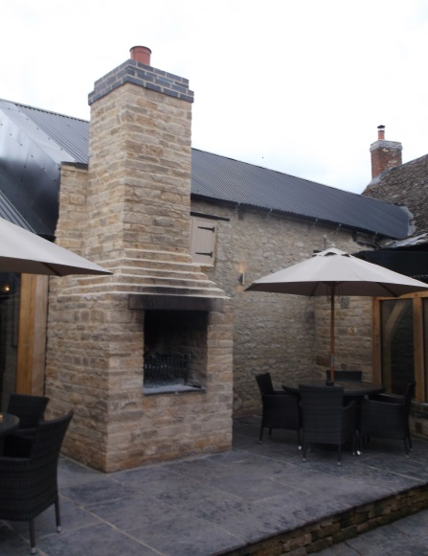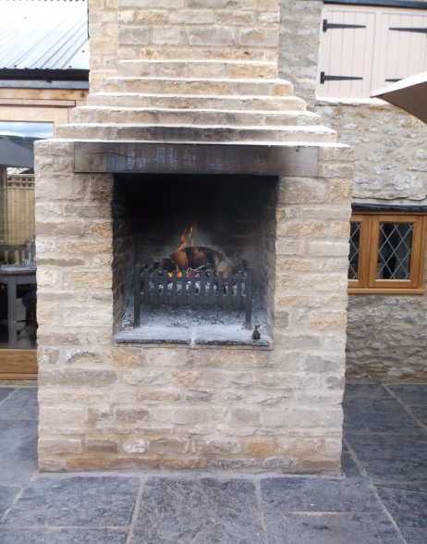

5.7 The structure is located within the rear courtyard and is adjacent to an area where patrons are encouraged to dine outside if they wish – there are tables and chairs for this purpose. The stone built hearth has a very large opening with a fire grate inside. In terms of visual impact it is a very prominent addition. In terms of the visual impact that this structure has, it is extremely large and robust extending some 4.8m (approximately from ground to chimney pot). It does have a significant visual impact on the listed building.

5.8 The Council’s Conservation Officer objects to the proposals commenting:

The chimney is a large and somewhat obtrusive structure and not part of the usual vernacular features you would expect to find on ‘ye average’ 18th century coaching inn. Historically such a feature or its earlier equivalent may well be found within a forge but not constructed on the external wall of the main building

5.9 Whilst the proposal does provide a facility for patrons of the pub to use, this has to be weighed against the impacts on the listed building. I concur with the Conservation Officer in the view that the structure is overly large and prominent and that it is out of keeping with the character and appearance of the listed building.

5.10 The List Entry identifies the building as an early to mid 18th century public house. The original building has a simple, linear plan form with an ancillary projection to the rear. The external chimney is a distinctly modern and bulky feature that appears as an awkward and clumsy addition to the building, disrupting its original form and dominating the original elevation. It also has no functional relationship with the original building, and detracts from its significance by eroding its historic character and form. The development is an alien feature in an already considerably altered building. It is not sympathetic to the context, detracting from the visual amenities of the existing building and its setting within the surrounding area.

5.11 Paragraph 134 of the NPPF advises that where a development proposal will lead to less than substantial harm to the significance of a designated heritage asset, this harm should be weighed against the public benefits of the proposal. In this case it is considered that any public benefits would not be so significant that they outweigh the harm caused to the historic environment in this instance. In particular it has not been argued or demonstrated that securing the ongoing use of the building as a public house is dependent on the external chimney and hearth being provided, and this is unlikely to be the case.

5.12 The proposal is considered to be at odds with Government Guidance contained within the National Planning Policy Framework, Policies C28 of the Cherwell Local Plan 1996 (Saved Policy) and Policy ESD15 of the Cherwell Local Plan 2011-2031 Part 1.

Impact on Neighbours

5.13 Both local and national planning policy seeks to ensure that development does not cause undue harm to the amenity of existing neighbours, including by way of loss of outlook, noise, nuisance or loss of light.

5.14 The Council’s Environmental Protection Officer has been consulted on the application as there is the potential that smoke emanating from the hearth and chimney could be of detriment to neighbouring properties. He has assessed the application and does not have any concerns that would warrant refusal of the application. He considers that the chimney is of a sufficient height for smoke to dissipate from.

5.15 There have been no comments from either neighbouring property. As such there is not considered to be any detrimental impact caused by the chimney to any neighbour. As such the chimney is considered to comply with policy in this respect.

Highway Comments

5.16 As the proposal is at the rear of the site and does not interfere with the local highway network, comments from the local Highway Authority have not been sought in this instance.

Conclusion

5.17 The proposed chimney is an unacceptable addition to this building. It has a clear and demonstrable impact upon the visual integrity and historic character significance of the listed building and in accordance with advice in the NPPF the harm caused is considered to be less than substantial. The public benefits of the proposal are not considered to be significant enough to outweigh the unacceptable impact on the character and appearance of the building. As such the application is contrary to planning policy and should therefore be refused.

6. Recommendation

REFUSAL –

1. The proposed stone built chimney, by virtue of its siting, size, prominence, massing and design, would appear as an awkward and incongruous addition to the listed building detracting from its historic character, form and significance. It is considered that the harm identified is less than substantial but is not outweighed by the public benefit of providing heating for the external patio area via the hearth, which could be secured by other less harmful means. The proposal is therefore contrary to Government guidance contained within the National Planning Policy Framework, saved Policy C28 of the Cherwell Local Plan 1996 and Policy ESD15 of the Cherwell Local Plan 2011-2031 Part 1.

Signed Case Officer: Michelle Jarvis Date: 22nd February 2017
Signed SPO/TL: Alex Keen Date: 24th February 2017

