REF: PLANNING APPLICATION NUMBER 14 / 00120 / REM
TRAFFIC CALMING / CYCLEWAYS & FOOTPATHS
MIDDLETON STONEY ROAD - BICESTER

As a local County, District and Town Councillor for Bicester West I object most strongly to the use of “Pillows” as a proposed traffic calming measure for the Middleton Stoney Road. Both “Pillows” and full width speed “bumps” are known to damage vehicles suspension, steering and tyres plus endanger cyclists and motorcyclists. Emergency vehicles are also hindered in reaching their destination. Cushions and speed bumps are also known to cause damage to nearby buildings from vibrations and damage the road surface in their locale.

I would suggest the use of “Build Outs” with priority traffic signs to control the speed of traffic, with the build outs designed to enhance and soften the visual impact of the road (See copy of the Highway Code Rule 153 and photograph of a real example).

Footpaths and Cycleway are required on either side of the Middleton Stoney Road and need to have their own dedicated routes and are separate from the main highway.

Zebra crossings for pedestrians are required at appropriate locations on the Middleton Stoney Road.

A prompt response would be much appreciated

Regards

Cllr. Les Sibley
Bicester West

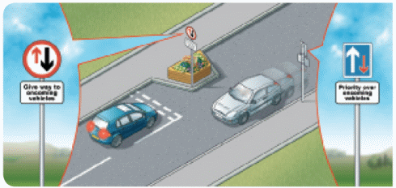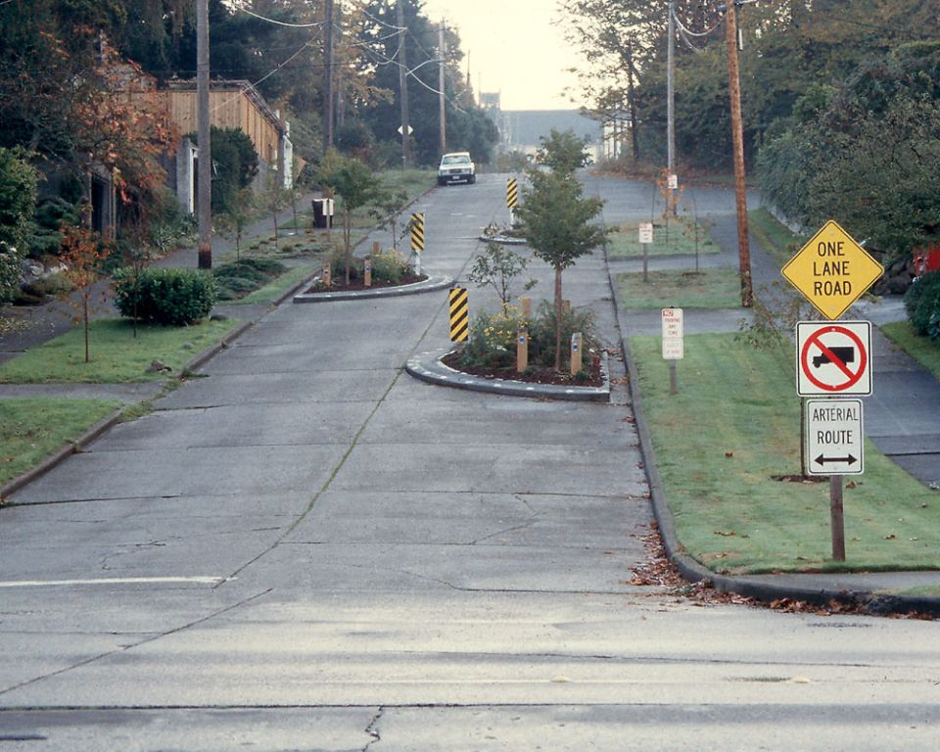
Copy of Highway Code Rule 153 Photograph of a real example

Copies to:
Aron Wisdom – Highways
Jenny Barker – CDC Planning
Linda Griffiths – CDC Planning
Steve Price – Countyside Properties

